Kirinda, Southern Province, Sri Lanka
A sleepy fishing hamlet on Sri Lanka's southeastern coast, Kirinda is best known as the gateway to Yala National Park — home to one of the world's highest concentrations of leopards — and to an ancient rock temple wrapped in royal legend.
⚓ Tender (expedition ships) or transfer from Hambantota · 🕒 Typical call: 7–9 hrs · 💵 Sri Lankan Rupee (LKR); USD accepted by tour operators · 🗣️ Sinhala; limited English in village · 🐆 Wildlife & Safari
✍️ MY DAY IN PORT (FILL IN)
Ship / Date
In port | arrive ______ · all aboard ______
Booked excursion
Notes / meeting point
GETTING ASHORE
- Docking: Large ships dock at Hambantota Port (~68 km / ~1.2 hr by road); expedition ships may tender to Kirinda Fishery Harbour
- Walk to center: Tender arrivals: ~800 m (10–15 min) to temple & village; Hambantota arrivals need transport
- Best For: Yala National Park leopard safari, ancient Buddhist temple, Arthur C. Clarke reef history
- Don't Miss: Kirinda Vihara Maha Devi Temple perched on ocean-facing boulders, and a half-day Yala jeep safari
GETTING AROUND
- 🚕 Taxi: LKR 3,000–5,000 to Tissamaharama; LKR 5,000–8,000 to Yala gate — Local taxis offer the most flexibility for day trips to Tissamaharama, Bundala Bird Sanctuary, or the Yala National Park
TOP THINGS TO DO
- Yala National Park Jeep Safari — Sri Lanka's most famous wildlife reserve hosts the world's highest density of wild leopards alongside Asian elephants, sloth…
- Kirinda Vihara Maha Devi Temple — Perched on massive ocean-facing boulders, this 2,200-year-old Buddhist temple commemorates the legendary Queen Viharamahadevi…
- Bundala National Park Birding — An internationally recognised Ramsar wetland 40 minutes from Kirinda, Bundala is a birdwatcher's paradise with flamingos, painted…
- Tissamaharama & Ancient Stupa — The ancient royal city of Tissamaharama, 20 minutes from Kirinda, is home to a massive 2nd-century BC Buddhist stupa surrounded…
- Great Basses Reef Snorkel or Dive — Ten kilometres offshore, the Great and Little Basses Reefs hide British colonial-era lighthouses and shipwrecks — including the…
BEST WALKS
- Harbour to Kirinda Temple Walk: 0.8 km · 15 min · Easy (flat path to rocky climb) — From the fishery harbour, follow the coastal path south past fishing boats and boulder-strewn beach…
- Village & Beach Stroll: 1.5 km · 25 min · Easy — Wander through the fishing village to watch colourful outrigger boats being repaired, then walk…
WEATHER · DAYLIGHT · MONEY
Month | High °F | Low °F | Rainy days
May | 82 | 71 | 26
Jul | 80 | 71 | 24
Sep | 80 | 70 | 25
Daylight: May 5:50AM–6:17PM · Jul 5:58AM–6:28PM · Sep 5:58AM–6:07PM
cruiseports.org/kirinda · Confirm terminal & all-aboard time with your ship

Kirinda, Southern Province, Sri Lanka — Port Map
Red = walkable sights · Amber = excursions farther out · P = cruise terminal
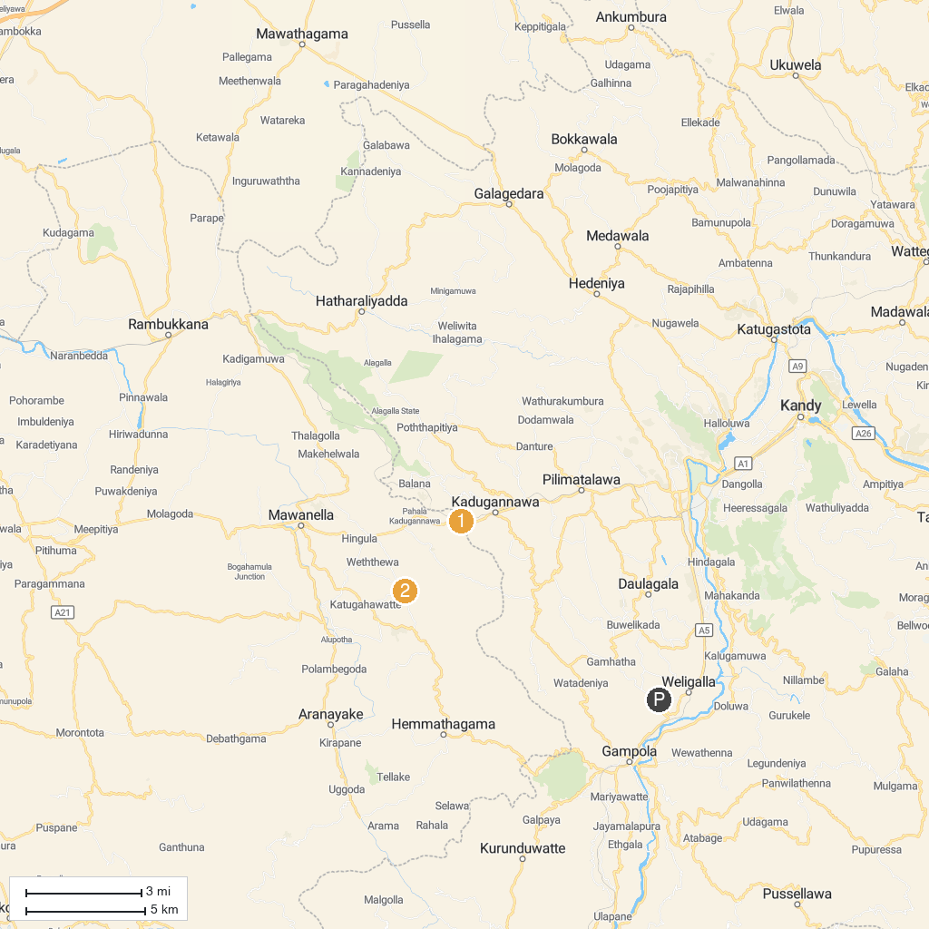
MAP KEY
1. Sri Dalada Maligawa | 4. Kandyan Cultural Centre
2. Lion's Mouth Rock Kadugannawa | 5. Balana Fort | බලන කොටුව
3. Aluthnuwara Rajamaha Viharaya , Aluthnuwara
P. Cruise port / terminal
Map © MapTiler © OpenStreetMap contributors · cruiseports.org

