Kiritimati (Christmas Island), Line Islands, Kiribati
Named by Captain Cook on Christmas Eve 1777, Kiritimati is the world's largest coral atoll — a sun-scorched, breathtakingly remote stop where bonefishing is world-class, seabirds nest by the million, and your ship anchors far offshore.
⚓ Tender port (no cruise pier) · 🕒 Typical call: 6–8 hrs · 💵 Australian Dollar (AUD) — cash only, no ATMs · 🗣️ Gilbertese & English · 🌡️ Equatorial — hot and sunny year-round
✍️ MY DAY IN PORT (FILL IN)
Ship / Date
In port | arrive ______ · all aboard ______
Booked excursion
Notes / meeting point
GETTING ASHORE
- Docking: Tender to London jetty — no cruise berth exists
- Walk to center: On the jetty — London village is immediate
- Best For: Bonefishing, birdwatching, off-the-beaten-path Pacific
- Don't Miss: Cook Island Bird Sanctuary boat tour & the London Post Office stamps
GETTING AROUND
- 🚕 Taxi: Negotiate on arrival (approx. AUD 5–15) — Informal shared minibuses and local vehicles are the main transport. Fares are negotiated directly with the driver — agr
- 📱 Rideshare: ❌ not available
TOP THINGS TO DO
- Cook Island Bird Sanctuary Boat Tour — Cook Island sits inside the lagoon and protects nesting colonies of red-tailed tropicbirds, masked boobies, frigatebirds, and…
- Bonefishing on the Flats — Kiritimati is legendary in fly-fishing circles — its shallow, crystal-clear lagoon flats hold some of the densest bonefish…
- WWII & Nuclear Testing Relics Walk — The UK and US conducted atmospheric nuclear tests here in the 1950s–60s.
- Salt Flats & Lagoon Interior — The vast salt evaporation pans in the island's interior create a surreal white-and-pink landscape.
- London Beach & Lagoon Swimming — A curve of white sand right near the tender pier.
BEST WALKS
- London Village Stroll: 30–45 min · Flat · Free — From the jetty, walk through London's dusty streets past the cooperative stores, the local school…
- London Beach Walk: 20–30 min · Easy · Free — Head from the tender jetty along the lagoon-side beach.
WEATHER · DAYLIGHT · MONEY
Month | High °F | Low °F | Rainy days
May | 82 | 80 | 15
Jul | 82 | 79 | 12
Sep | 81 | 79 | 6
Daylight: May 6:20AM–6:32PM · Jul 6:29AM–6:42PM · Sep 6:21AM–6:28PM
cruiseports.org/kiritimati-christmas-island · Confirm terminal & all-aboard time with your ship

Kiritimati (Christmas Island), Line Islands, Kiribati — Port Map
Red = walkable sights · Amber = excursions farther out · P = cruise terminal
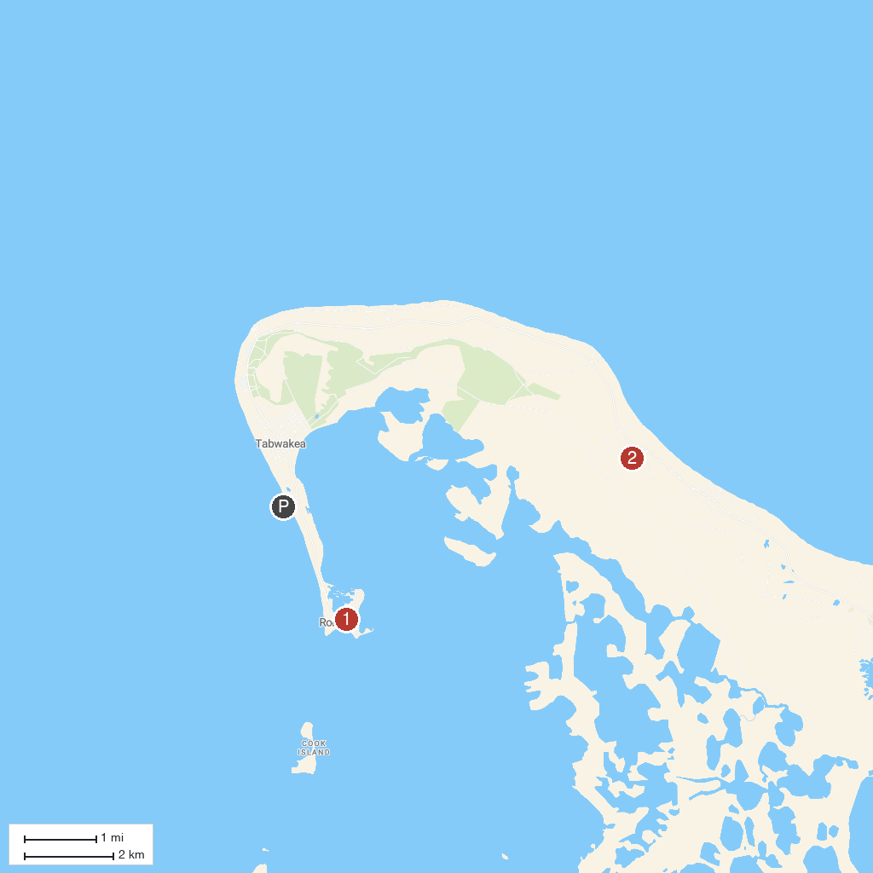
MAP KEY
1. London Bridge (Kiritimati) | 2. Cook Island Wildlife Sanctuary
P. Cruise port / terminal
Map © MapTiler © OpenStreetMap contributors · cruiseports.org

