Kitakyushu, Fukuoka, Japan
Where early-20th-century brick warehouses face the Kanmon Straits and you can walk from Kyushu to Honshu through an underwater tunnel — Kitakyushu rewards the curious shore-day explorer.
⚓ Docked (pier) · 🕒 Typical call: 8-10 hrs · 💴 Japanese Yen (JPY) · 🗣️ Japanese (limited English)
✍️ MY DAY IN PORT (FILL IN)
Ship / Date
In port | arrive ______ · all aboard ______
Booked excursion
Notes / meeting point
GETTING ASHORE
- Docking: Nishikaigan Pier at Moji Port (walkable) or Hibiki Terminal (shuttle required)
- Walk to center: 10-15 min from Moji Pier to Mojiko Retro; 15 min from Kokura Port to Kokura Station
- Best For: History, retro architecture, local food, day-trip to Shimonoseki
- Don't Miss: Yaki Curry in Mojiko, Kokura Castle, and the Kanmon Pedestrian Tunnel
GETTING AROUND
- 🚕 Taxi: ¥4,000–¥6,000 — Taxis from Hibiki Container Terminal to Kokura city center run ¥4,000–¥6,000 (approx. 30–40 min). From Moji Port to Koku
- 📱 Rideshare: ✅ Uber, GO
- 🚌 Hop-on hop-off: ✅
TOP THINGS TO DO
- Mojiko Retro Waterfront Walk — Stroll the preserved early-20th-century port district — ornate customs buildings, the Old Moji Mitsui Club where Einstein stayed…
- Kokura Castle & Tanga Market — Kokura Castle's rare design (5th floor wider than 4th) and the adjacent Edo-period garden make for a great morning.
- Kanmon Pedestrian Tunnel — Walk 780 meters under the sea from Kyushu to Honshu — the only place in Japan you can cross islands on foot.
- Karato Market Fugu & Shimonoseki Day — Hop the 5-minute Kanmon Kisen ferry to Shimonoseki and visit Karato Market — the world capital of fugu (pufferfish).
- Mount Sarakura Night Views — Take the Sarakura cable car and slope car to a summit officially ranked among Japan's New Three Major Night Views.
BEST WALKS
- Mojiko Retro Heritage Walk: 1.5 km · 45–60 min · Easy · From the pier — From the cruise pier, walk north along the waterfront past the Blue Wing Moji drawbridge, take in…
- Kanmon Tunnel Crossing: 2 km round trip · 1 hr · Easy · Free — Walk south from Mojiko along the waterfront to the tunnel entrance, descend the elevator, cross the…
WEATHER · DAYLIGHT · MONEY
Month | High °F | Low °F | Rainy days
May | 72 | 58 | 10
Jul | 84 | 74 | 18
Sep | 79 | 69 | 15
Daylight: May 5:15AM–7:10PM · Jul 5:16AM–7:27PM · Sep 5:59AM–6:23PM
cruiseports.org/kitakyushu · Confirm terminal & all-aboard time with your ship

Kitakyushu, Fukuoka, Japan — Port Map
Red = walkable sights · Amber = excursions farther out · P = cruise terminal
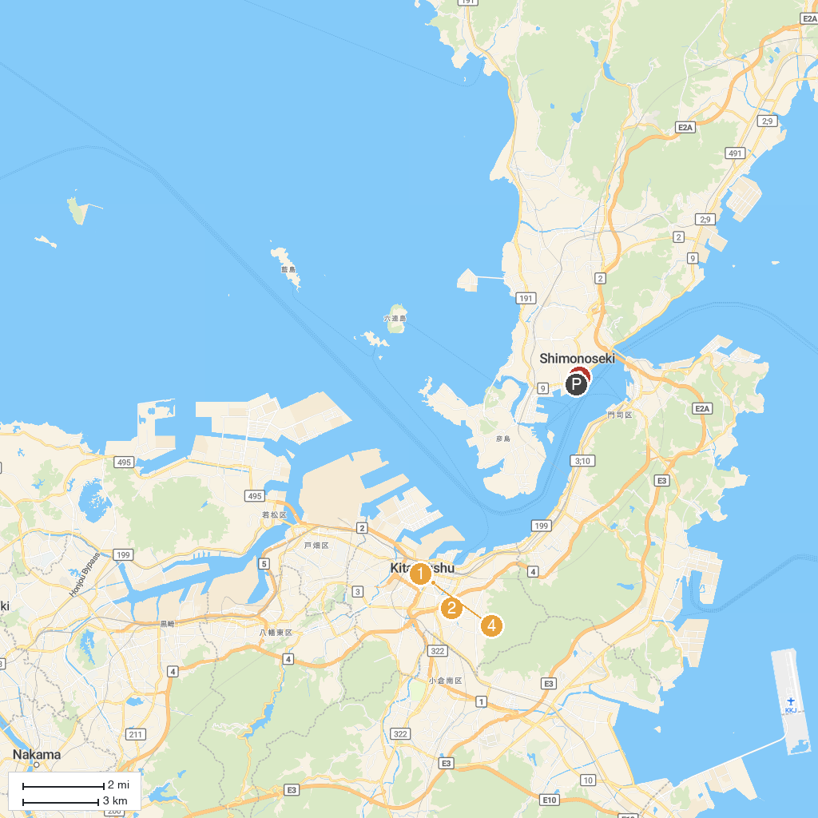
MAP KEY
1. Kokura Castle | 5. Kaikyokan
2. Umeyasutenmangu | 6. Showaike Park
3. Kitakyushu Museum of Natural History & Human History | 7. Tanga Market
4. Kitakyushu Media Dome | 8. Senbutsu Stalactite Cave
P. Cruise port / terminal
Map © MapTiler © OpenStreetMap contributors · cruiseports.org

