Kjøllefjord, Finnmark, Norway
One of Norway's northernmost cruise calls, Kjøllefjord is a working Arctic fishing village where colorful wooden houses ring a sheltered harbor, Sámi reindeer herders live just outside town, and the cathedral-shaped Finnkirka sea cliff guards the fjord entrance.
⚓ Pier (Hurtigrutekaia, 120 m quay) · 🕒 Typical call: 4–8 hrs · 💵 Norwegian Krone (NOK) — nearly cashless, cards everywhere · 🗣️ Norwegian / North Sámi · ☀️ Midnight Sun mid-May to late July
✍️ MY DAY IN PORT (FILL IN)
Ship / Date
In port | arrive ______ · all aboard ______
Booked excursion
Notes / meeting point
GETTING ASHORE
- Docking: Pier — Hurtigrutekaia quay, right in the village center
- Walk to center: 1–5 min (under 300 m from quay to main street)
- Best For: Arctic scenery, Sámi culture, birdwatching, authentic Norway
- Don't Miss: Finnkirka sea cliff from the water & Foldalbruket Museum
GETTING AROUND
- 🚕 Taxi: 200–500 NOK — Local taxi services (e.g. Ferder Taxi) are available for short transfers or excursions onto the Nordkyn Peninsula. Fares
- 📱 Rideshare: ❌ not available
TOP THINGS TO DO
- Sámi Cultural Experience at Davvi Siida — A local Sámi family welcomes you into their lavvu (traditional tent), lights a campfire, serves reindeer broth (bidos), shares…
- RIB Boat Safari to Finnkirka — Speed out to the base of the Finnkirka cathedral sea cliff by rigid inflatable boat.
- King Crab Safari — Head out with local fishermen to pull king crab traps from the cold Barents Sea — then cook and eat your catch on the boat.
- Arctic Snowmobile Safari (Winter/Spring) — Ride snowmobiles across the treeless Arctic plateau of the Nordkynn Peninsula under the Northern Lights or in the soft glow of…
- Foldalbruket Museum — This beautifully preserved 1917 fish processing plant and cod liver oil factory tells the story of the brutal Arctic fishing…
BEST WALKS
- Village Harbor Stroll: 1–2 km • 30–45 min • Easy • Flat — Walk the harbor front from the Hurtigrutekaia quay past Foldalbruket and along the waterfront to…
- Hillside Viewpoint Hike: 2–3 km round trip • 45–60 min • Moderate • Some steep gravel — A short but steep hike out of the village center climbs to a cairn-marked viewpoint above…
WEATHER · DAYLIGHT · MONEY
Month | High °F | Low °F | Rainy days
May | 42 | 35 | 18
Jul | 58 | 49 | 13
Sep | 49 | 43 | 16
Daylight: Sep 5:21AM–6:47PM
cruiseports.org/kjollefjord · Confirm terminal & all-aboard time with your ship

Kjøllefjord, Finnmark, Norway — Port Map
Red = walkable sights · Amber = excursions farther out · P = cruise terminal
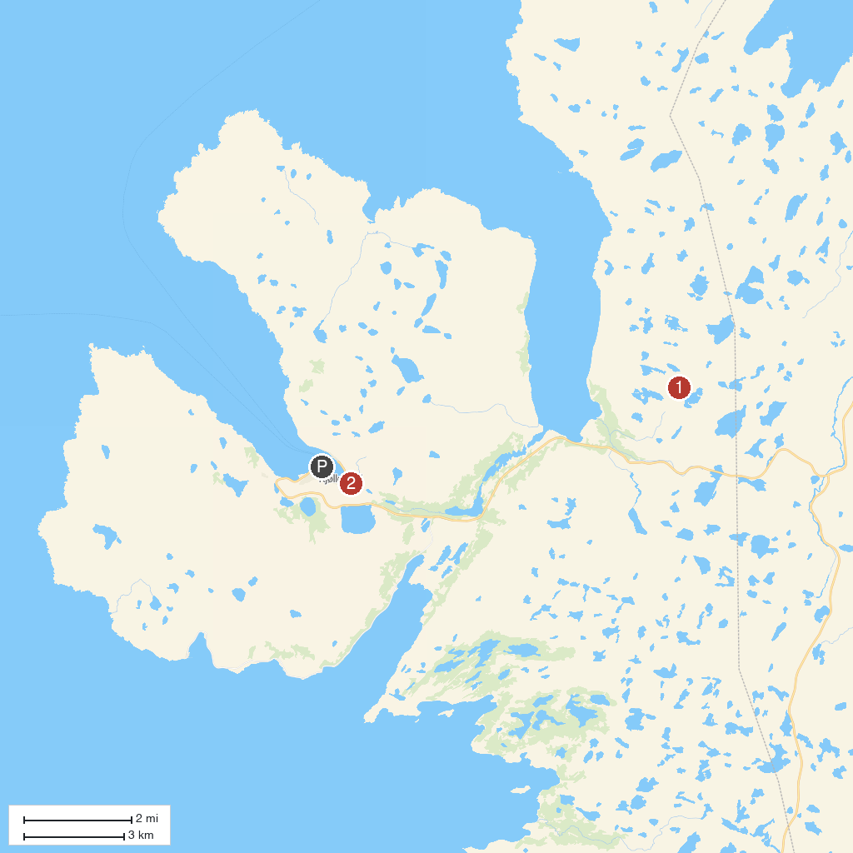
MAP KEY
1. Kjølnes Lighthouse | 3. Kjøllefjord Church
2. Finnkirka
P. Cruise port / terminal
Map © MapTiler © OpenStreetMap contributors · cruiseports.org

