Klaksvík, Faroe Islands, Denmark
Wedged between steep fjords in the heart of the Faroes, Klaksvík is a working fishing town that punches well above its weight — Nordic architecture, panoramic hikes, and easy ferry hops to some of the archipelago's most dramatic islands.
⚓ Docked (pier, 3 km north; free shuttle) · 🕒 Typical call: 6–8 hrs · 💵 Danish Krone (DKK) · 🗣️ Faroese & Danish (English widely spoken)
✍️ MY DAY IN PORT (FILL IN)
Ship / Date
In port | arrive ______ · all aboard ______
Booked excursion
Notes / meeting point
GETTING ASHORE
- Docking: Pier at North Harbour (Anir), ~3 km from town; free shuttle to tourist info
- Walk to Center: ~3 km from North Harbour; 5–10 min from closer Nordborg/Kosin quays
- Best For: Hiking, Nordic scenery, Faroese culture, island-hopping day trips
- Don't Miss: Hike to Klakkur viewpoint; ferry to Kalsoy for the Kallur Lighthouse
GETTING AROUND
- 🚕 Taxi: ~60–75 DKK — Taxis (E-Taxi, Taxi 56) are available but very limited in supply. Pre-booking is strongly recommended, especially when m
- 📱 Rideshare: ❌ not available
TOP THINGS TO DO
- Klakkur Summit Hike — The classic Klaksvík hike — a 2-hour round-trip climb to 413 m with sweeping views of the twin fjords, Kunoy, Kalsoy, and the…
- Ferry to Kalsoy & Kallur Lighthouse — Take the short ferry from Klaksvík harbor to Syðradalur on Kalsoy, then continue by road to Trøllanes and hike out to the…
- Klaksvík Town & Christianskirkjan — Stroll the harbor promenade, visit Christianskirkjan — the Norse-inspired church consecrated in 1963 — and browse the colorful…
- Sea Kayaking the Fjords — Paddle Klaksvík's twin bays — Borðoyarvík and the Borðoyarsund sound toward Kunoy — with guided sea kayak tours that take in…
- Northern Islands Scenic Drive — A guided coach or self-drive loop via the Hvannasund causeway and mountain tunnels to Viðareiði, the northernmost village in the…
BEST WALKS
- Harbor Front Stroll: 1.5 km · 20 min · Easy · Free — Walk the main harbor from the tourist information center past the colorful boat sheds and working…
- Viðarlundin Park & Viewpoint: 30 min · Easy · Free — Follow the signs uphill from the town center to Viðarlundin uti í Grøv, a small landscaped park…
- Klakkur Summit Trail: 4 km · 2–3 hrs · Moderate · Free — From the upper residential streets, follow the marked trail up to the 413 m Klakkur summit.
WEATHER · DAYLIGHT · MONEY
Month | High °F | Low °F | Rainy days
May | 48 | 41 | 16
Jul | 55 | 49 | 17
Sep | 53 | 47 | 17
Daylight: May 4:30AM–10:16PM · Jul 4:07AM–10:55PM · Sep 6:52AM–7:48PM
cruiseports.org/klaksvik · Confirm terminal & all-aboard time with your ship

Klaksvík, Faroe Islands, Denmark — Port Map
Red = walkable sights · Amber = excursions farther out · P = cruise terminal
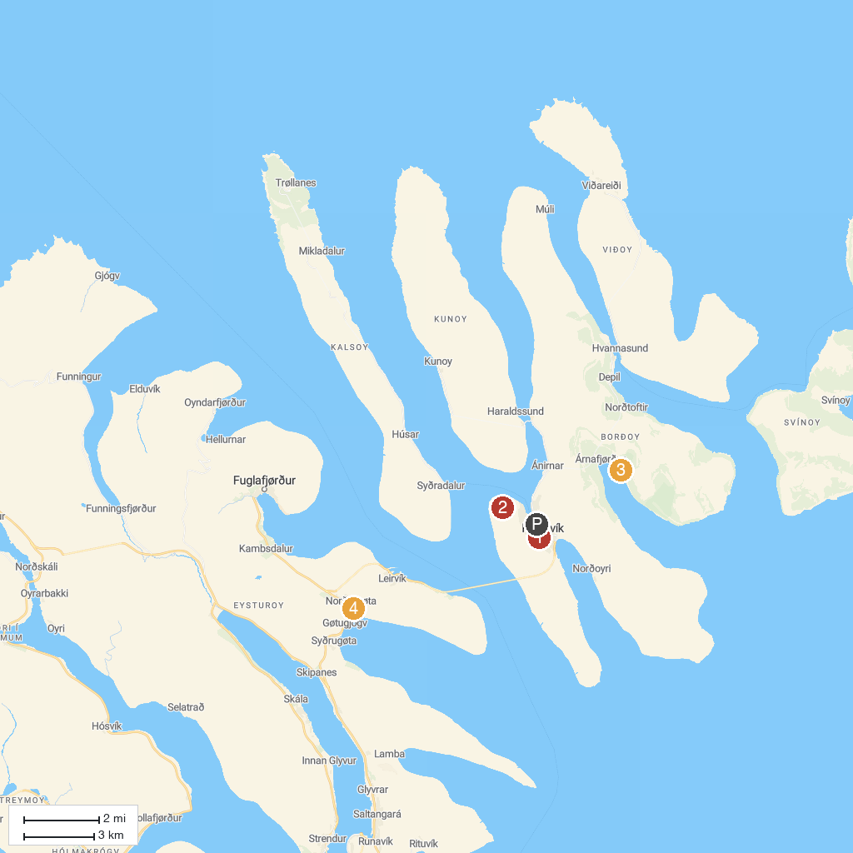
MAP KEY
1. Christianskirkjan | 3. Svartidalurfoss
2. Hiking Klakkur | 4. Gøta Museum
P. Cruise port / terminal
Map © MapTiler © OpenStreetMap contributors · cruiseports.org

