Klawock, Prince of Wales Island, Alaska, USA
One of Alaska's newest cruise destinations, Klawock sits on Prince of Wales Island where an Indigenous-owned floating pier welcomes small ships to a world of authentic totem poles, old-growth rainforest, and world-class sportfishing — with no jewelry chains in sight.
⚓ Docked (floating pier) · 🕒 Typical call: 6-8 hrs · 💵 USD · 🗣️ English / Tlingit heritage · 🌲 Tongass rainforest
✍️ MY DAY IN PORT (FILL IN)
Ship / Date
In port | arrive ______ · all aboard ______
Booked excursion
Notes / meeting point
GETTING ASHORE
- Docking: Floating pontoon pier, Klawock Island — walk off the ship, no tender
- Walk to Totem Park: Free shuttle (5 min) or 1.3-mile walk across the bridge to town
- Best For: Tlingit culture, totem poles, sport fishing, wildlife, authentic Alaska
- Don't Miss: Klawock Totem Park — 21 restored poles overlooking the harbor
GETTING AROUND
- 🚕 Taxi: + (Craig to pier) — Klawock Totem Taxi offers local taxi and tour service on Prince of Wales Island. Useful for flexibility beyond the shutt
- 📱 Rideshare: ❌ not available
TOP THINGS TO DO
- Klawock Totem Park — Twenty-one beautifully restored Tlingit totem poles stand on a hillside overlooking Klawock harbor — replicated from 19th-century…
- Tlingit Carving Shed — Near the Totem Park, master Tlingit carvers work on totems and canoes in an open shed.
- Klawock River Hatchery & Salmon Run — Just outside of town, the Klawock River Salmon Hatchery is a top spot to watch thousands of salmon fighting upstream (best…
- Sport Fishing Charter — Prince of Wales Island is legendary for halibut and salmon.
- Kayak & Skiff Eco-Tour — Guided water tours around the sheltered islands of Klawock Harbor offer excellent chances to spot sea otters, harbor seals…
BEST WALKS
- Pier to Klawock Totem Park: 1.3 miles | 25-30 min | Easy — Walk from the Port Klawock terminal across the bridge onto Prince of Wales Island and uphill to the…
- Totem Park to Carving Shed Loop: 0.5 miles | 15-20 min | Easy — From the Totem Park, walk down to the Klawock Carving Shed where Tlingit artists work on poles and…
WEATHER · DAYLIGHT · MONEY
Month | High °F | Low °F | Rainy days
May | 55 | 44 | 15
Jul | 62 | 53 | 17
Sep | 59 | 49 | 20
Daylight: May 4:41AM–8:57PM · Jul 4:31AM–9:24PM · Sep 6:25AM–7:07PM
cruiseports.org/klawock-ak · Confirm terminal & all-aboard time with your ship

Klawock, Prince of Wales Island, Alaska, USA — Port Map
Red = walkable sights · Amber = excursions farther out · P = cruise terminal
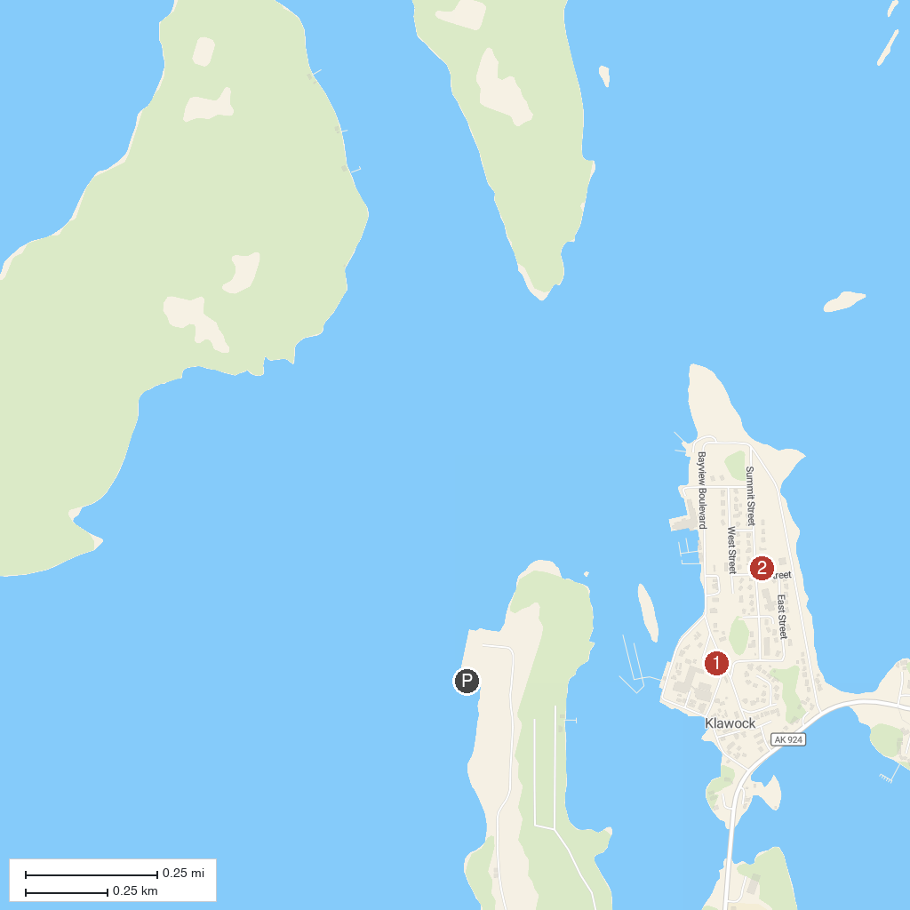
MAP KEY
1. Klawock Totem Park | 2. Klawock Presbyterian Church
P. Cruise port / terminal
Map © MapTiler © OpenStreetMap contributors · cruiseports.org

