Klemtu, British Columbia, Canada
Deep in the Great Bear Rainforest, Klemtu is the living home of the Kitasoo/Xai'xais Nation — one of North America's most authentic expedition port calls, where totem poles line a misty boardwalk and the rare white Spirit Bear roams nearby.
⚓ Tender (most ships) or small dock · 🕒 Typical call: 5–7 hrs · 💵 Canadian Dollar (CAD) — bring cash · 🗣️ English / Kitasoo/Xai'xais
✍️ MY DAY IN PORT (FILL IN)
Ship / Date
In port | arrive ______ · all aboard ______
Booked excursion
Notes / meeting point
GETTING ASHORE
- Docking: Tender to government dock; small expedition vessels may tie up directly
- Walk to Village: Dock to Big House ~500 m; entire village within 15-min walk
- Best For: Indigenous culture, wildlife, old-growth rainforest, Spirit Bear heritage
- Don't Miss: Big House welcoming ceremony and fresh bannock from local vendors
GETTING AROUND
- 🚕 Taxi: By quote — Local water taxis (Kitasoo Xai'xais Water Taxi) serve inter-community routes and charter trips. Not useful for in-villag
TOP THINGS TO DO
- Big House Cultural Welcome — Enter the magnificent red cedar Big House (Lgila.ts'u-is) for a welcoming ceremony with traditional songs, dances, and…
- Spirit Bear & Wildlife Boat Tour — Guided boat excursions explore the channels near Princess Royal Island — prime habitat for the rare white Kermode 'Spirit Bear'…
- Old-Growth Forest Walk with Guardians — Walk into the ancient Great Bear Rainforest with a Kitasoo/Xai'xais Guardian to see Culturally Modified Trees (CMTs) — massive…
- Sea Kayaking the Fjords — Paddle sheltered coves and island-dotted channels in one of the most pristine marine environments in North America.
BEST WALKS
- Waterfront Boardwalk: ~1 km round trip | Flat | 15 min — Stroll the wooden boardwalk from the government dock along the shoreline to the Big House and beyond.
WEATHER · DAYLIGHT · MONEY
Month | High °F | Low °F | Rainy days
May | 61 | 44 | 13
Jul | 68 | 53 | 13
Sep | 63 | 50 | 18
Daylight: May 5:37AM–9:24PM · Jul 5:30AM–9:49PM · Sep 7:09AM–7:47PM
cruiseports.org/klemtu-bc · Confirm terminal & all-aboard time with your ship

Klemtu, British Columbia, Canada — Port Map
Red = walkable sights · Amber = excursions farther out · P = cruise terminal
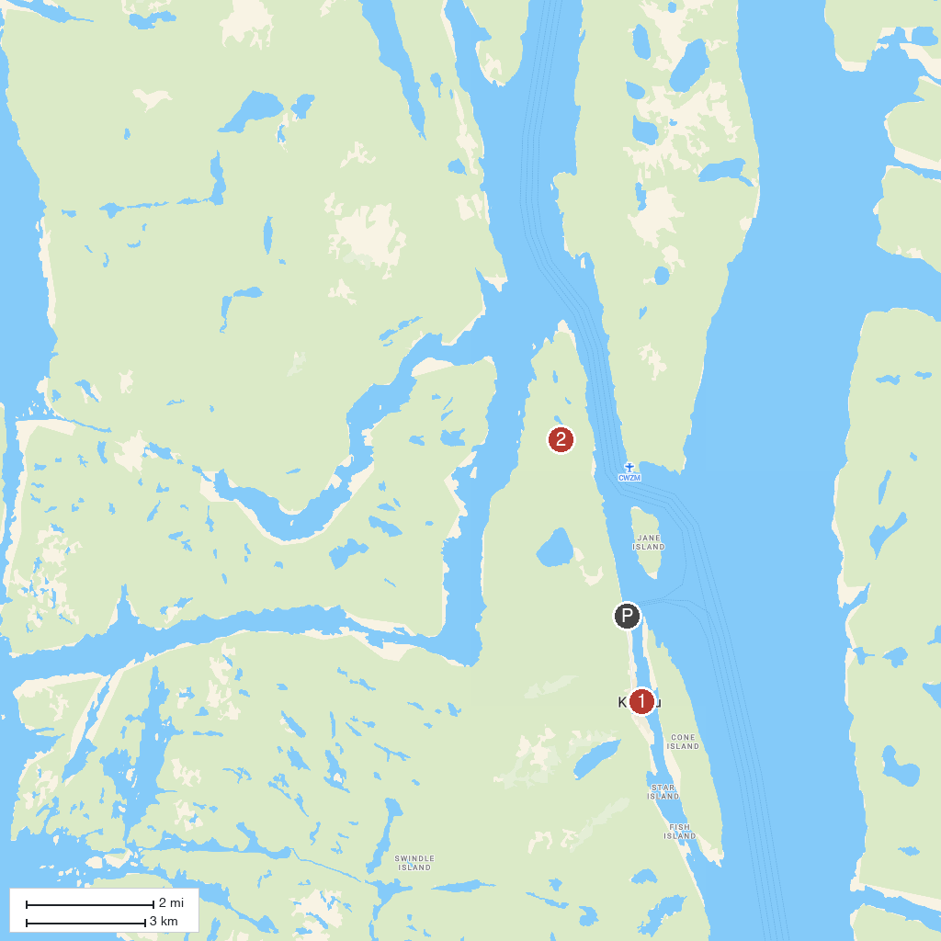
MAP KEY
1. Big House (Klemtu) | 2. Great Bear Rainforest
P. Cruise port / terminal
Map © MapTiler © OpenStreetMap contributors · cruiseports.org

