Koblenz, Rhineland-Palatinate, Germany
At the world-famous confluence of the Rhine and Moselle rivers, Koblenz rewards every river cruiser with a sky-high fortress reached by gondola, a monumental riverside headland, and a wine-soaked old town — all reachable on foot from the pier.
⚓ Docked (no tender) · 🕒 Typical call: 8–10 hrs · 💶 Euro (€) · 🗣️ German (English widely spoken) · 🍷 Rhine & Moselle wine country
✍️ MY DAY IN PORT (FILL IN)
Ship / Date
In port | arrive ______ · all aboard ______
Booked excursion
Notes / meeting point
GETTING ASHORE
- Docking: Pier-side on Rhine (Konrad-Adenauer-Ufer) or Moselle (Peter-Altmeier-Ufer) — always docked, never tendered
- Walk to centre: 2–10 min flat walk from either dock to Deutsches Eck and the Altstadt
- Best For: History, Rhine wine, fortress views, scenic cable-car crossing
- Don't Miss: Ehrenbreitstein Fortress via cable car — best panorama of the river confluence
GETTING AROUND
- 🚕 Taxi: €8–12 — Standard metered taxis: €4.00 base fare plus €2.30–4.00/km. A short ride to the city center or train station typically r
- 📱 Rideshare: ✅ Uber
TOP THINGS TO DO
- Ehrenbreitstein Fortress & Cable Car — Glide across the Rhine in a gondola (look for Cabin 17 with its glass floor) to Europe's second-largest preserved fortress, 118 m…
- Deutsches Eck & Altstadt Walk — Stand at the tip of the headland where the Moselle slides into the Rhine beneath Kaiser Wilhelm's towering equestrian statue.
- Weindorf & Moselle Wine Tasting — Head to the Koblenz Wine Village — a half-timbered courtyard built for the 1925 German Wine Exhibition — for glasses of crisp…
- Stolzenfels Castle — A textbook example of Rhine Romanticism, this neo-Gothic hilltop castle sits about 5 km south of the city.
- Moselle River Cruise to Cochem — Many operators offer a half-day boat excursion up the winding Moselle to Cochem, past terraced vineyards and medieval villages.
BEST WALKS
- Promenade to Deutsches Eck & Altstadt: 1.5 km · 25 min · flat — From the Rhine pier, follow the promenade north past the Electoral Palace gardens to the Deutsches…
- Cable Car & Fortress Loop: Easy walk + cable car · 2–3 hrs — Walk from the pier to the cable car station (3 min), cross the Rhine to Ehrenbreitstein Fortress…
WEATHER · DAYLIGHT · MONEY
Month | High °F | Low °F | Rainy days
May | 66 | 49 | 12
Jul | 77 | 60 | 11
Sep | 70 | 54 | 9
Daylight: May 5:42AM–9:10PM · Jul 5:36AM–9:34PM · Sep 7:05AM–7:42PM
cruiseports.org/koblenz · Confirm terminal & all-aboard time with your ship

Koblenz, Rhineland-Palatinate, Germany — Port Map
Red = walkable sights · Amber = excursions farther out · P = cruise terminal
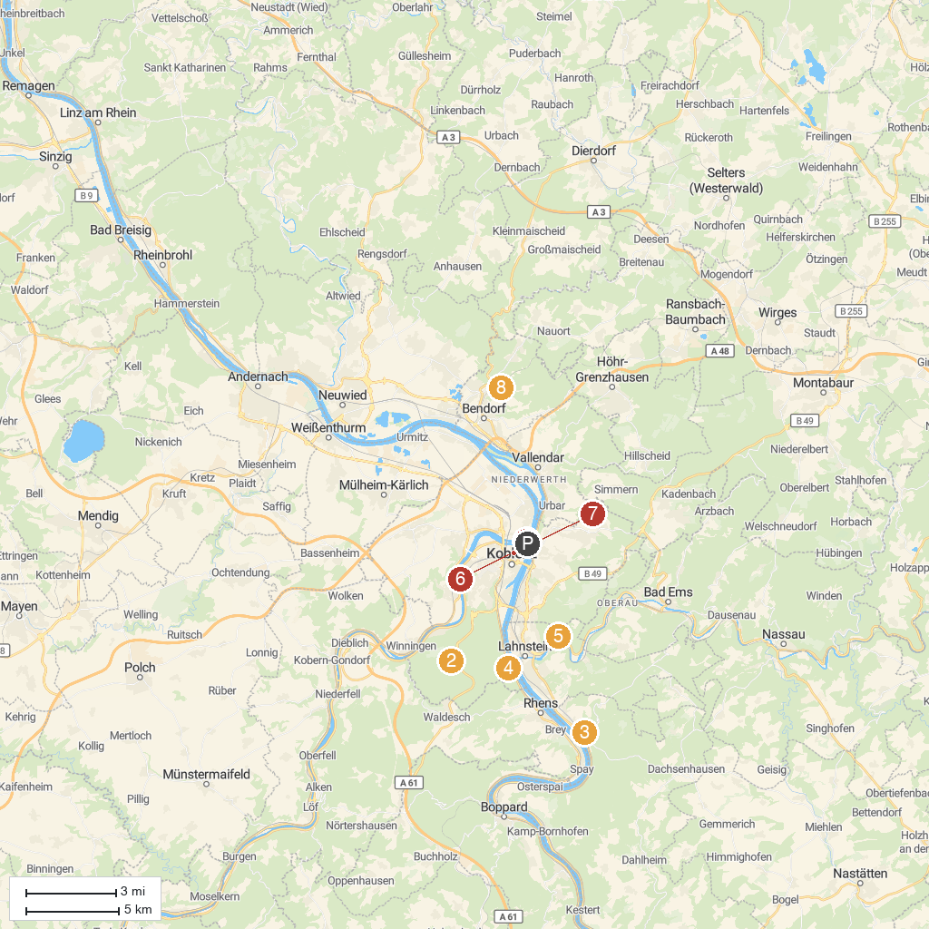
MAP KEY
1. Deutsches Eck | 5. Ruppertsklamm
2. Remstecken | 6. Mittelrheinmuseum Koblenz
3. Marksburg | 7. Ehrenbreitstein Fortress
4. Stolzenfels Castle | 8. Abtei Sayn
P. Cruise port / terminal
Map © MapTiler © OpenStreetMap contributors · cruiseports.org

