Kodiak Island, Alaska, USA
The 'Emerald Isle of Alaska' — a rugged, working fishing port where bald eagles perch on dock pilings, giant brown bears roam the interior, and Russian Orthodox domes rise above a harbor still thick with crab boats.
⚓ Pier (Pier II downtown / Pier III with shuttle) · 🕒 Typical call: 7–9 hrs · 💵 USD · 🗣️ English
✍️ MY DAY IN PORT (FILL IN)
Ship / Date
In port | arrive ______ · all aboard ______
Booked excursion
Notes / meeting point
GETTING ASHORE
- Docking: Pier II (Kelsey Dock, downtown edge) or Pier III (1.5 mi out, shuttle provided)
- Walk to center: Steps from Pier II; free shuttle from Pier III
- Best For: Wildlife, history, authentic Alaskan fishing culture
- Don't Miss: Alutiiq Museum, Holy Resurrection Cathedral, Fort Abercrombie WWII ruins
GETTING AROUND
- 🚕 Taxi: $10–$25 — Local taxis (Kodiak City Cab, Kodiak Rides) operate in town. Flag drop ~$2.75 + $3/mile. City center from port runs roug
- 📱 Rideshare: ✅ Uber, Lyft
TOP THINGS TO DO
- Kodiak Bear Flightseeing — The island's famous brown bears — largest in the world — live deep in the Kodiak National Wildlife Refuge.
- Fort Abercrombie State Historical Park — About 4 miles northeast of downtown (a ~10-minute taxi ride), this WWII coastal defense site hides concrete bunkers, gun…
- Alutiiq Museum & Baranov Museum — Two of Alaska's finest small museums sit within a short walk of each other downtown.
- Halibut & Salmon Fishing Charter — Kodiak is world-renowned for sport fishing.
- Near Island Bridge & Harbor Walk — A free, self-guided walk from downtown across the Near Island Bridge (the Fred Zharof Memorial Bridge — open to cars, bikes, and…
BEST WALKS
- Downtown Harbor Loop: 1.5 miles · Easy · ~45 min — From Pier II, stroll along the harbor past St.
- Near Island Bridge Walk: 1 mile · Easy · ~30 min — Head northeast from downtown across the Near Island Bridge (the Fred Zharof Memorial Bridge)…
WEATHER · DAYLIGHT · MONEY
Month | High °F | Low °F | Rainy days
May | 49 | 41 | 17
Jul | 60 | 52 | 14
Sep | 55 | 47 | 15
Daylight: May 5:45AM–10:27PM · Jul 5:33AM–10:56PM · Sep 7:41AM–8:26PM
cruiseports.org/kodiak-island · Confirm terminal & all-aboard time with your ship

Kodiak Island, Alaska, USA — Port Map
Red = walkable sights · Amber = excursions farther out · P = cruise terminal
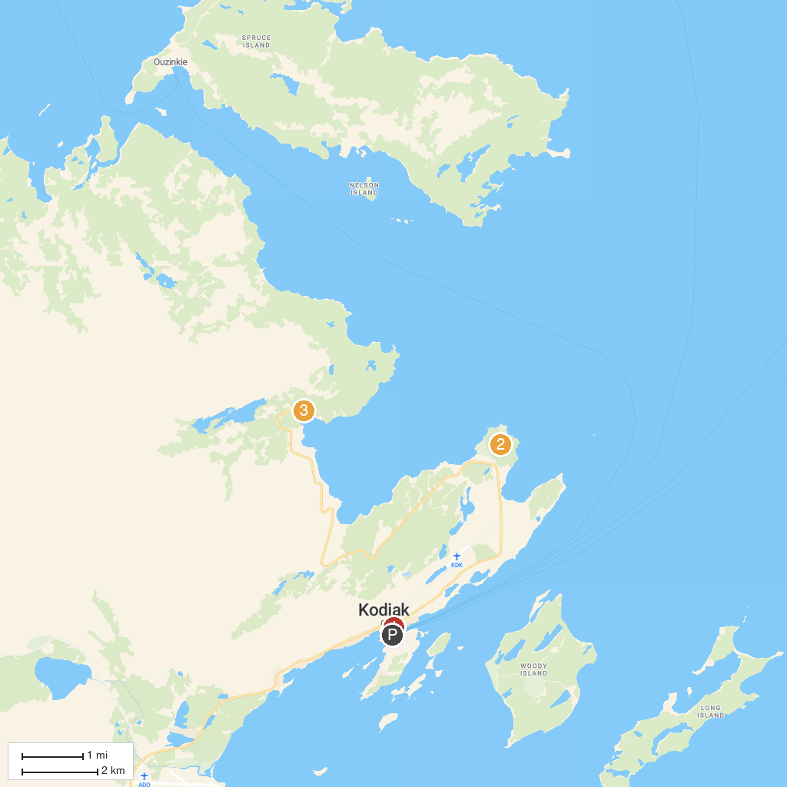
MAP KEY
1. Alutiiq Museum | 3. White Sands Beach
2. Fort Abercrombie State Historic Park
P. Cruise port / terminal
Map © MapTiler © OpenStreetMap contributors · cruiseports.org

