Koh Samui, Surat Thani, Thailand
Thailand's laid-back island paradise — golden Buddhas, palm-fringed beaches, and one of the Gulf's most dazzling marine parks, all within a single shore day.
⚓ Tender port (Nathon Pier) · 🕒 Typical call: 8–10 hrs · 💵 Thai Baht (THB) · 🗣️ Thai (English widely spoken in tourist areas)
✍️ MY DAY IN PORT (FILL IN)
Ship / Date
In port | arrive ______ · all aboard ______
Booked excursion
Notes / meeting point
GETTING ASHORE
- Docking: Tender to Nathon Pier (~15–20 min ride)
- Walk to Center: Immediate — Nathon town begins at the pier
- Best For: Temples, beaches, ethical elephant encounters
- Don't Miss: Big Buddha (Wat Phra Yai) and Ang Thong Marine Park
GETTING AROUND
- 🚕 Taxi: 600–1,000 THB (~$18–30 USD) — Taxis operate from Nathon Pier on fixed, negotiated rates — no meters. Agree on fare before boarding; Chaweng Beach runs
- 📱 Rideshare: ✅ Grab, inDrive
TOP THINGS TO DO
- Ang Thong National Marine Park — Speed-boat day trip to a 42-island archipelago of limestone cliffs, emerald lagoons, and pristine reefs.
- Big Buddha & Wat Plai Laem Temple Tour — Visit the iconic 12-meter golden Big Buddha (Wat Phra Yai) on its rocky causeway island, then walk to nearby Wat Plai Laem — a…
- Samui Elephant Sanctuary — An award-winning ethical sanctuary where rescued elephants roam freely — no riding.
- Chaweng or Lamai Beach Day — Koh Samui's two flagship beaches.
- Koh Tao Snorkel Day Trip — Speed-boat to Koh Tao and Koh Nang Yuan — two of the Gulf's top dive destinations.
BEST WALKS
- Nathon Pier Stroll: 15–20 min | Flat | Free — From the pier, walk north along the main street past souvenir stalls, local cafes, and 7-Elevens.
- Bophut Fisherman's Village: Walk the village: 20 min | Flat | Free to wander — Taxi 30 min north to Bophut Beach, then walk the charming lane of preserved wooden Chinese…
WEATHER · DAYLIGHT · MONEY
Month | High °F | Low °F | Rainy days
May | 87 | 80 | 20
Jul | 87 | 79 | 17
Sep | 85 | 78 | 20
Daylight: May 5:59AM–6:32PM · Jul 6:07AM–6:44PM · Sep 6:09AM–6:20PM
cruiseports.org/koh-samui-island-thailand · Confirm terminal & all-aboard time with your ship

Koh Samui, Surat Thani, Thailand — Port Map
Red = walkable sights · Amber = excursions farther out · P = cruise terminal
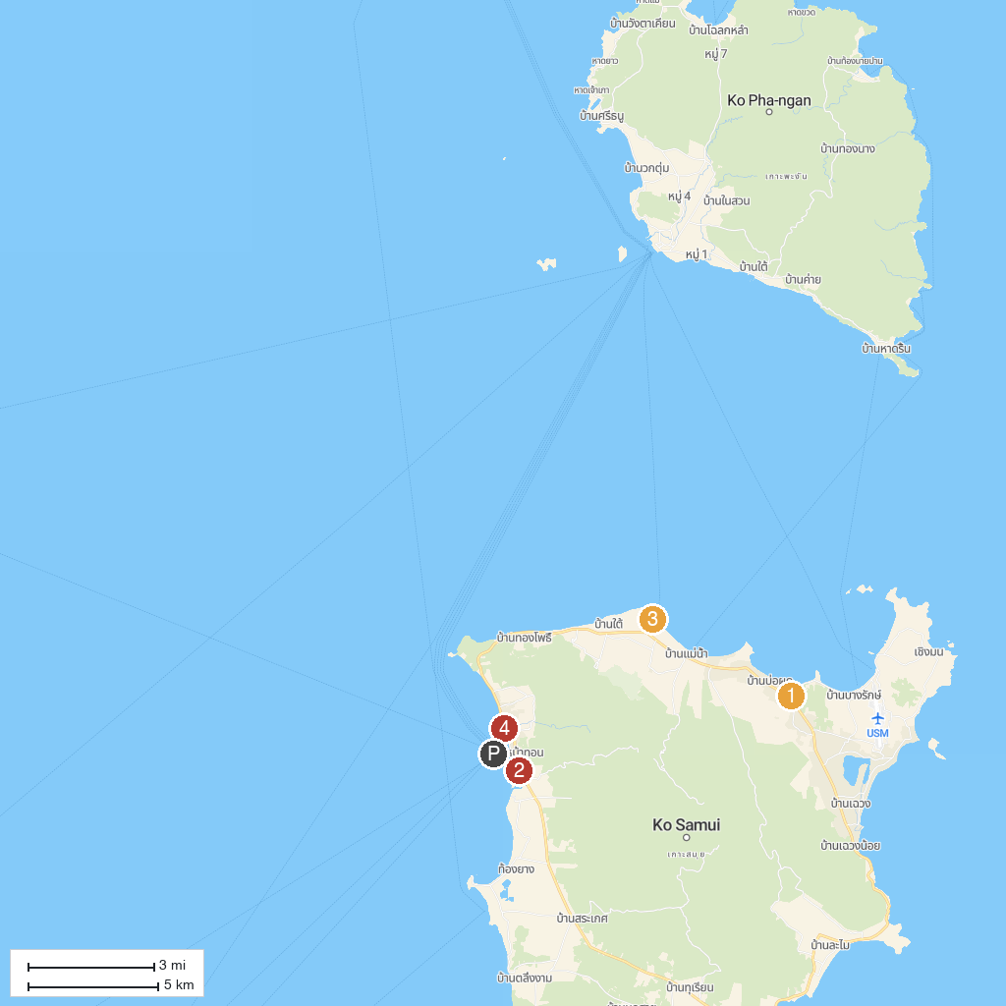
MAP KEY
1. Wat Laem Suwannaram | 5. Wat Na Phra Lan
2. Chedi Phra That Sila Ngu | 6. Wat Si Thaweep
3. Wat Bo Phuttharam | 7. ישרא תור תאילנד
4. Wat Chaeng | 8. Ice Bar Samui
P. Cruise port / terminal
Map © MapTiler © OpenStreetMap contributors · cruiseports.org

