Koror, Palau
Palau is one of the Pacific's great secrets — a living reef, ancient jellyfish, and turquoise lagoons that look painted. Koror is your gateway to all of it.
⚓ Tender (most large ships) · 🕒 Typical call: 8-10 hrs · 💵 US Dollar (USD) · 🗣️ English & Palauan · 🤿 World-class diving
✍️ MY DAY IN PORT (FILL IN)
Ship / Date
In port | arrive ______ · all aboard ______
Booked excursion
Notes / meeting point
GETTING ASHORE
- Docking: Tender for most large ships; small/mid-size vessels may dock at Malakal pier
- Walk to center: ~2 miles (3 km) from Malakal Port — taxi or shuttle recommended
- Best For: Snorkeling, diving, Rock Islands boat tours, Jellyfish Lake
- Don't Miss: Jellyfish Lake (permit required) and the Rock Islands Southern Lagoon
GETTING AROUND
- 🚕 Taxi: $2–$8 USD — Taxis are available at Malakal Harbour and operate on a fixed-rate zone system — no meters. Confirm the fare before you
- 📱 Rideshare: ❌ not available
TOP THINGS TO DO
- Jellyfish Lake & Rock Islands Lagoon — Swim among millions of harmless golden jellyfish in a landlocked marine lake, then snorkel the brilliant waters of the Rock…
- Scuba Diving — Blue Corner & German Channel — Blue Corner is consistently ranked among the world's top dive sites: strong currents, wall diving, sharks, and massive schools of…
- The Milky Way — A shallow cove within the Rock Islands where the water turns brilliant turquoise over a white limestone mud seabed.
- WWII Wrecks & Peleliu Battlefield — Palau saw fierce fighting in 1944.
- Etpison Museum & Downtown Koror — A highly rated private museum showcasing Palauan history, traditional canoes, giant clamshells, and historic photography.
BEST WALKS
- Downtown Koror Stroll: 1-2 hrs · Easy · Cultural — From the WCTC Shopping Center, walk the main road through central Koror.
- KB Bridge Waterfront Park: 30-60 mins · Easy · Views — Take a taxi to the base of the Japan-Palau Friendship Bridge on the Koror side.
WEATHER · DAYLIGHT · MONEY
Month | High °F | Low °F | Rainy days
May | 84 | 78 | 28
Jul | 83 | 77 | 28
Sep | 84 | 78 | 27
Daylight: May 5:45AM–6:11PM · Jul 5:53AM–6:23PM · Sep 5:52AM–6:01PM
cruiseports.org/koror-palau · Confirm terminal & all-aboard time with your ship

Koror, Palau — Port Map
Red = walkable sights · Amber = excursions farther out · P = cruise terminal
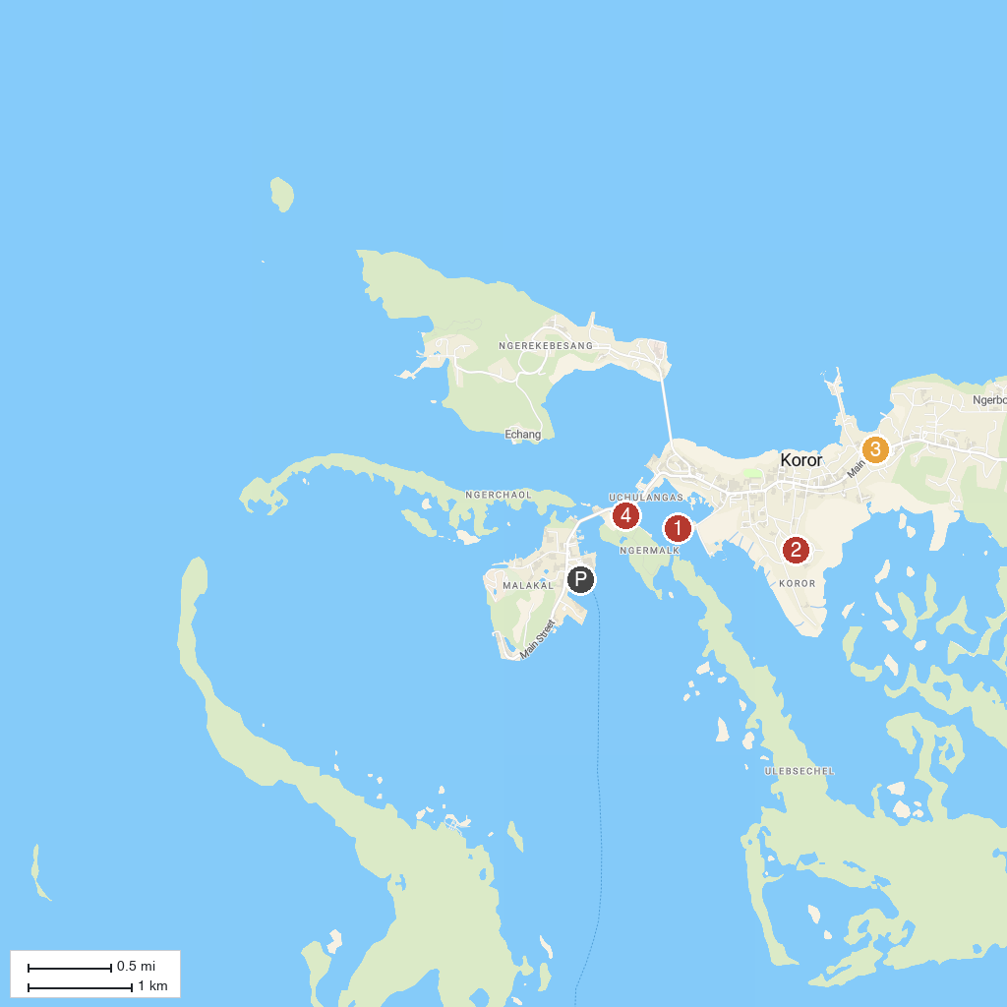
MAP KEY
1. Palau Aquarium | 3. Etpison Museum
2. Belau National Museum | 4. Long Island Park
P. Cruise port / terminal
Map © MapTiler © OpenStreetMap contributors · cruiseports.org

