Kortrijk, Flanders, Belgium
Where medieval guildsmen defeated French knights in 1302, Kortrijk still wears its history lightly — cobbled beguinage lanes, twin Leie towers, and some of Belgium's finest local beer steps from the dock.
⚓ Docked (river pier) · 🕒 Typical call: 6–8 hrs · 💶 Euro (€) · 🗣️ Dutch (Flemish) / English widely spoken
✍️ MY DAY IN PORT (FILL IN)
Ship / Date
In port | arrive ______ · all aboard ______
Booked excursion
Notes / meeting point
GETTING ASHORE
- Docking: River ships dock at Handelskaai or near Budabrug on the Leie — right in the city
- Walk to center: 5–10 min to Grote Markt; nearly everything within 15 min on foot
- Best For: Medieval history, Flemish heritage, craft beer, UNESCO sites
- Don't Miss: The Sint-Elisabethbegijnhof (UNESCO) and a Omer Vander Ghinste blond at the Grote Markt
GETTING AROUND
- 🚕 Taxi: €9–€13 — Metered taxis are available at stands near the port. Short hops within the city are inexpensive; fares are regulated by
- 📱 Rideshare: ✅ Uber, Bolt
TOP THINGS TO DO
- Battle of the Golden Spurs — Kortrijk 1302 Experience — Inside the Church of Our Lady, an immersive multimedia experience recreates the 1302 battle where Flemish guildsmen routed French…
- UNESCO Beguinage — Sint-Elisabethbegijnhof — One of Flanders' most enchanting beguinages: 40 whitewashed 17th-century houses on cobbled lanes, frozen in time.
- Texture Museum — Flax & Linen Heritage — Housed in an authentic flax depot, this interactive museum explains how the Leie Valley became the linen capital of Europe — from…
- Day Trip to Ypres (Ieper) — WWI Battlefields — Take a 30-minute train to Ypres for the Menin Gate Last Post ceremony, In Flanders Fields Museum, and the preserved WWI trenches…
- Broel Towers & Medieval Waterfront Walk — The twin Broeltorens are Kortrijk's signature sight — the last surviving towers of the medieval city walls, flanking the Leie.
BEST WALKS
- River to Grote Markt Historic Loop: 1.5 km · ~45 min · flat cobblestones — From the dock, stroll the Leieboorden promenade past the Broel Towers, cross the Broelbrug…
- Buda Island Art & Design Walk: 1 km · 30 min · flat — Cross to Buda Island via the Budabrug and explore the creative quarter — art studios, design…
WEATHER · DAYLIGHT · MONEY
Month | High °F | Low °F | Rainy days
May | 64 | 48 | 11
Jul | 73 | 58 | 10
Sep | 68 | 54 | 9
Daylight: May 5:57AM–9:29PM · Jul 5:51AM–9:54PM · Sep 7:22AM–8:00PM
cruiseports.org/kortrijk · Confirm terminal & all-aboard time with your ship

Kortrijk, Flanders, Belgium — Port Map
Red = walkable sights · Amber = excursions farther out · P = cruise terminal
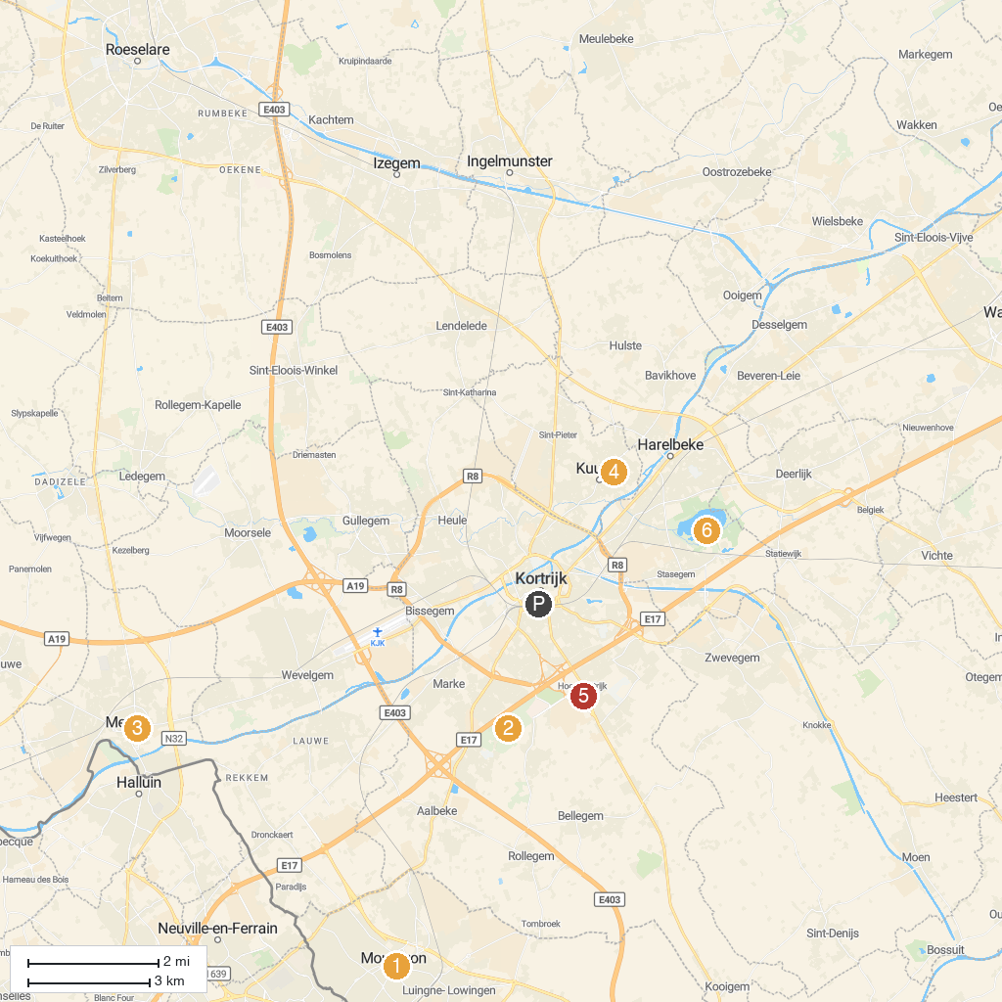
MAP KEY
1. Église catholique Saint-Barthélémy à Mouscron | 5. Flanders Field American Cemetery
2. Rumbeke Castle | 6. Groene Long
3. Dragonfly | 7. International Rose Garden Courtrai
4. Brouwerspark | 8. Zwemzone Provinciedomein De Gavers Harelbeke
P. Cruise port / terminal
Map © MapTiler © OpenStreetMap contributors · cruiseports.org

