Kos, Dodecanese, Greece
Birthplace of Hippocrates and one of the Mediterranean's most walkable cruise ports, Kos offers ancient ruins, a medieval castle, and bike lanes leading straight to the beach — all without leaving town.
⚓ Pier (docked) · 🕒 Typical call: 8-10 hrs · 💶 Euro (€) · 🗣️ Greek / English widely spoken · 🚲 Cycling island
✍️ MY DAY IN PORT (FILL IN)
Ship / Date
In port | arrive ______ · all aboard ______
Booked excursion
Notes / meeting point
GETTING ASHORE
- Docking: Pier — ships dock at Kos Town cruise terminal, steps from the Castle of the Knights
- Walk to center: 5-10 min flat walk to the ancient Agora and Eleftherias Square
- Best For: Ancient history, cycling, beaches, Ottoman-Greek architecture
- Don't Miss: The Asklepieion — Hippocrates' healing temple with sweeping views to Turkey
GETTING AROUND
- 🚕 Taxi: €3–€5 — Metered taxis are available at the port. The short ride to the town center costs €3–€5; surcharges apply at night and on
- 📱 Rideshare: ❌ not available
TOP THINGS TO DO
- The Asklepieion — The ancient world's most celebrated healing temple, where Hippocrates reportedly taught.
- Kos Town Walking Tour — In one short walk you'll pass a 14th-century crusader castle, a 2nd-century Roman odeon, a Hellenistic-era agora, an Ottoman…
- Tigaki Beach — A 10 km stretch of powdery white sand and shallow turquoise water, 11 km west of the port.
- Therma Volcanic Hot Springs — At Empros Therme beach, hot sulfurous spring water bubbles up through the sand and mixes with the sea in a natural rock pool — a…
- Cycling the Coast — Kos is one of the rare Greek islands where cycling is genuinely practical.
BEST WALKS
- Ancient Kos Town Loop: 1.5 km · 30-45 min · easy · free — From the pier, walk past the Castle of Neratzia to the Tree of Hippocrates and the ancient Agora…
- Waterfront to Lambi Beach by Bike: 3 km one way · 15 min by bike · flat · free — Follow the dedicated red bike lane north from the port along the seafront to Lambi Beach.
WEATHER · DAYLIGHT · MONEY
Month | High °F | Low °F | Rainy days
May | 73 | 64 | 4
Jul | 85 | 76 | 0
Sep | 81 | 73 | 2
Daylight: May 6:03AM–8:11PM · Jul 6:03AM–8:30PM · Sep 6:53AM–7:19PM
cruiseports.org/kos-island · Confirm terminal & all-aboard time with your ship

Kos, Dodecanese, Greece — Port Map
Red = walkable sights · Amber = excursions farther out · P = cruise terminal
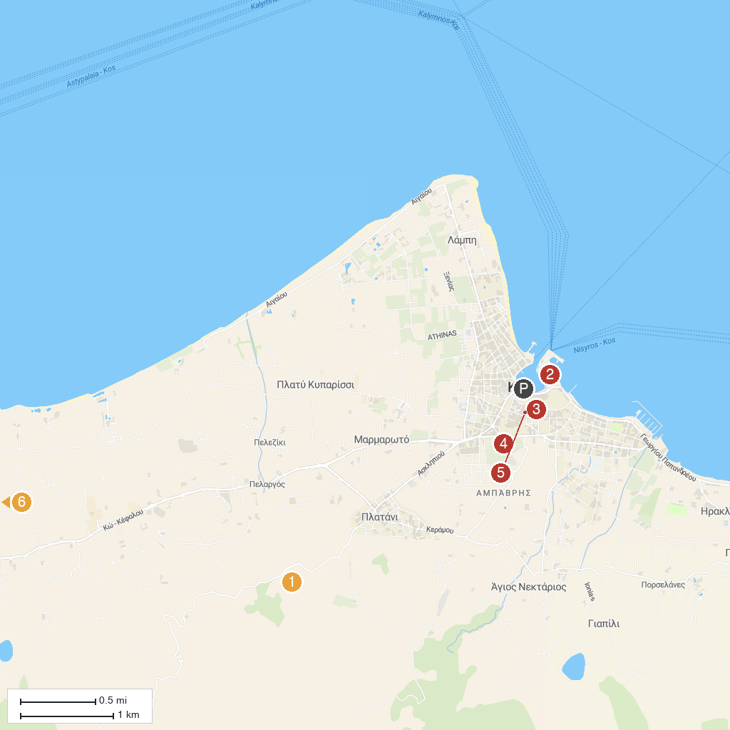
MAP KEY
1. Asclepieion at Kos | 4. Roman Odeon of Kos
2. Nerantzia Castle | 5. Kos Old Town
3. Kos Municipal Market | 6. Salt Lake Stables Horse Riding Kos
P. Cruise port / terminal
Map © MapTiler © OpenStreetMap contributors · cruiseports.org

