Krems an der Donau, Lower Austria, Austria
Krems marks the eastern gateway to the Wachau, where Danube ships tie up beside medieval Stein, vineyard slopes, apricot shops, and a compact cluster of serious art museums. It is one of the easiest Austrian river ports to explore independently.
⚓ Docked (Danube landing stages) · 🕒 Typical call: 5–8 hrs · 💶 Currency: Euro (€) · 🗣️ Language: German · 🍷 Wachau wine country
✍️ MY DAY IN PORT (FILL IN)
Ship / Date
In port | arrive ______ · all aboard ______
Booked excursion
Notes / meeting point
GETTING ASHORE
- Docking: River ships dock at Krems/Stein Danube landing stages; no tendering
- Walk to center: 5–10 min to Stein, 20–30 min to Krems old town
- Best For: Wachau wine, art museums, abbey excursions, Danube cycling
- Don't Miss: Steiner Tor, Kunstmeile Krems, and the hilltop Göttweig Abbey view
GETTING AROUND
- 🚕 Taxi: €7–€12 — Taxis are available at the port. Base fare is €4.50 plus ~€1.90/km; the short ride to the Altstadt typically costs €7–€1
- 📱 Rideshare: ✅ Uber, Bolt
TOP THINGS TO DO
- Göttweig Abbey — A vast Benedictine abbey on a hill across the Danube, famous for its imperial staircase, baroque church, museum rooms, and…
- Kunstmeile Krems — A compact museum district beside the river in Stein, including Kunsthalle Krems, the twisting Landesgalerie Niederösterreich…
- Wachau Wine & Apricot Tasting — Taste Grüner Veltliner, Riesling, Marillenschnaps, and apricot sweets in one of Austria's most distinctive wine regions.
- Dürnstein and the Wachau Valley — Follow the Danube west to Dürnstein, the blue-towered village below castle ruins linked to Richard the Lionheart.
- Krems Old Town Walk — Enter Krems through the 15th-century Steiner Tor, then follow Obere Landstraße past painted townhouses, courtyards, churches…
BEST WALKS
- Stein Old Town and Kunstmeile Loop: 1–2 km | 45–90 min | Easy, cobblestones — From the landing stages, walk into Stein's old town lanes, then loop past the Minoritenkirche and…
- Riverfront to Steiner Tor: 3–4 km round trip | 1.5–2 hrs | Mostly flat — Follow the Danube-side route and town streets from Stein toward Krems Altstadt, finishing at the…
- Piaristenkirche Viewpoint: 2–3 km | 1–1.5 hrs | Uphill final section — From Krems old town, climb to Piaristenkirche for one of the best close-in views over the roofs…
WEATHER · DAYLIGHT · MONEY
Month | High °F | Low °F | Rainy days
May | 67 | 50 | 14
Jul | 81 | 62 | 12
Sep | 71 | 54 | 10
Daylight: May 5:17AM–8:31PM · Jul 5:12AM–8:54PM · Sep 6:34AM–7:09PM
cruiseports.org/krems-an-der-donau · Confirm terminal & all-aboard time with your ship

Krems an der Donau, Lower Austria, Austria — Port Map
Red = walkable sights · Amber = excursions farther out · P = cruise terminal
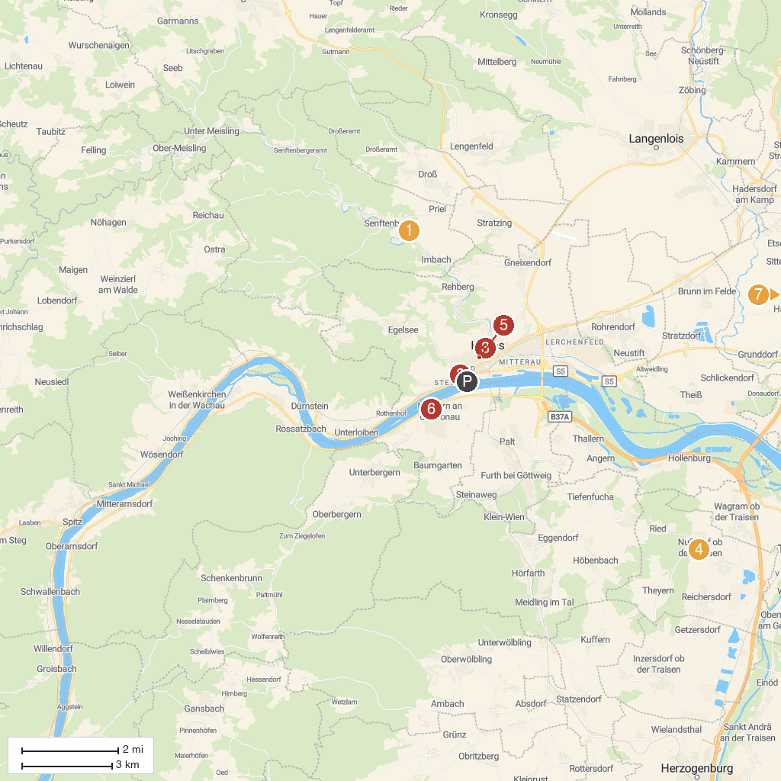
MAP KEY
1. Burgruine Senftenberg | 5. Steinertor
2. Karikaturmuseum Krems | 6. Schloss Traismauer
3. Piarist Church of Our Lady | 7. Römermuseum Mautern/Favianis
4. Urzeitmuseum Nussdorf-Traisental | 8. Grafenegg Castle
P. Cruise port / terminal
Map © MapTiler © OpenStreetMap contributors · cruiseports.org

