Kristiansand, Vest-Agder, Norway
Norway's sunniest city earns its "smiling south" nickname with a compact walkable center, sandy Blue Flag beaches, and a lively fish market just steps from the pier.
⚓ Pier (Kai 10, downtown) · 🕒 Typical call: 6–9 hrs · 💳 Cashless — card everywhere (NOK) · 🗣️ Norwegian / English widely spoken · 🌊 Best urban beach in Norway
✍️ MY DAY IN PORT (FILL IN)
Ship / Date
In port | arrive ______ · all aboard ______
Booked excursion
Notes / meeting point
GETTING ASHORE
- Docking: Kai 10 pier — ships dock directly, 500 m from city center
- Walk to center: ~10 min flat walk to Markens Gate pedestrian street
- Best For: Strolling historic white-house lanes, fresh shrimp, city beach
- Don't Miss: Fiskebrygga fish market — buy peel-and-eat shrimp off the boats
GETTING AROUND
- 🚕 Taxi: 110–140 NOK to city center — Taxis are available at the port but expensive by global standards. Useful for reaching destinations outside the walkable
- 📱 Rideshare: ✅ Uber, Bolt
- 🚌 Hop-on hop-off: ✅
TOP THINGS TO DO
- Fiskebrygga & Posebyen Walking Tour — Explore the lively fish-market canal district, then wind through Posebyen's 18th-century white wooden houses — one of Northern…
- Kristiansand Cannon Museum (Møvik Fort) — The world's second-largest land-based gun — a 38 cm naval cannon installed by the German Kriegsmarine's Batterie Vara in WWII…
- Kristiansand Dyrepark Zoo & Park — Norway's number-one family attraction: a high-quality zoo, amusement park, and waterpark 12 km east of the city.
- Bystranda City Beach — A genuine Blue Flag sandy beach 15–20 minutes' flat walk from the pier, complete with volleyball courts, a playground, and palm…
- Odderøya Island Loop — The former military island right next to the pier is now a car-free nature park with pine forest trails, fjord-view cliffs, and…
BEST WALKS
- Pier to Posebyen Historic Quarter: 1.5 km · ~20 min · Flat — Walk from Kai 10 past the Kilden Performing Arts Centre, through Fiskebrygga canal district, then…
- Waterfront Promenade to Bystranda Beach: 1.8 km · ~25 min · Flat seafront — Follow the Strandpromenaden east from the city center past Christiansholm Fortress (1672) along the…
- Odderøya Island Nature Loop: 3 km loop · ~50 min · Easy trail — Cross the footbridge from the cruise pier onto Odderøya, the car-free former military island.
WEATHER · DAYLIGHT · MONEY
Month | High °F | Low °F | Rainy days
May | 58 | 45 | 11
Jul | 68 | 56 | 13
Sep | 61 | 52 | 15
Daylight: May 5:02AM–9:47PM · Jul 4:48AM–10:18PM · Sep 6:58AM–7:46PM
cruiseports.org/kristiansand · Confirm terminal & all-aboard time with your ship

Kristiansand, Vest-Agder, Norway — Port Map
Red = walkable sights · Amber = excursions farther out · P = cruise terminal
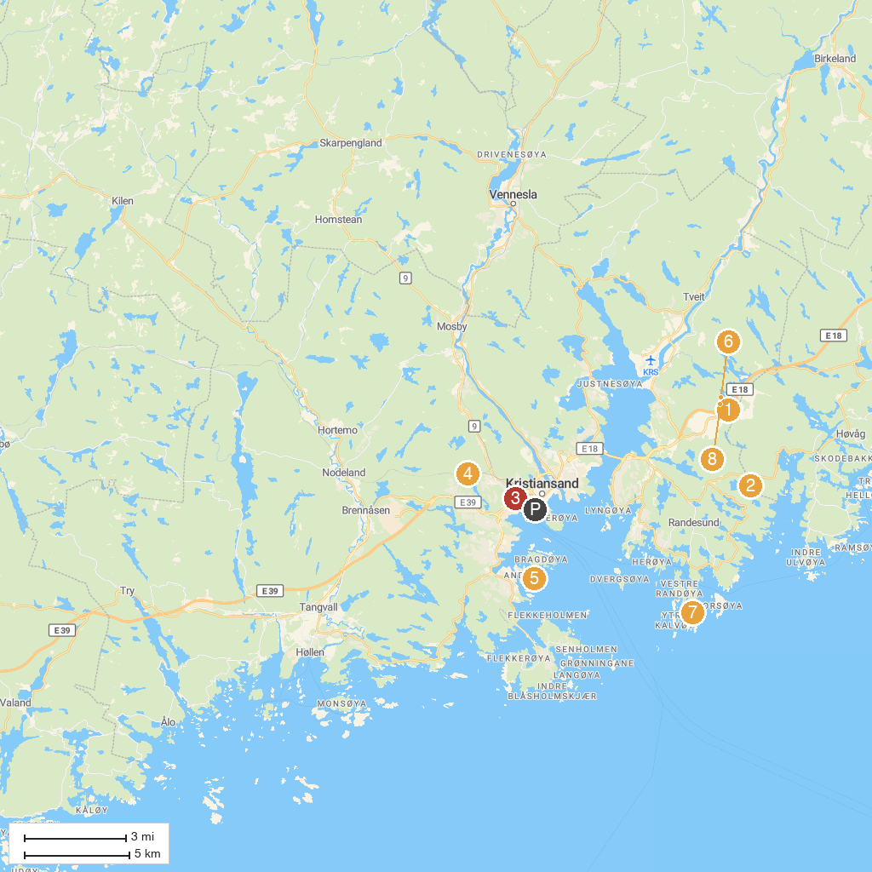
MAP KEY
1. Kristiansand Zoo and Amusement Park | 5. D / S Hestmanden
2. Bronseplassen | 6. Cardamom Town
3. Dueknipen | 7. Randøya fort
4. Høyt & Lavt Kristiansand | 8. Ku Toppen
P. Cruise port / terminal
Map © MapTiler © OpenStreetMap contributors · cruiseports.org

