Kupreanof Island, Southeast Alaska, USA
One of the Inside Passage's most authentic escapes — no souvenir shops, no crowds, just Tlingit history, towering old-growth forest, and black bears fishing the creeks. Small ships only.
⚓ Tender (anchor & skiff ashore) · 🕒 Typical call: 5–7 hrs · 💵 USD · 🗣️ English / Tlingit · 🌲 Small expedition ships only
✍️ MY DAY IN PORT (FILL IN)
Ship / Date
In port | arrive ______ · all aboard ______
Booked excursion
Notes / meeting point
GETTING ASHORE
- Docking: Tender / skiff — ships anchor; no large pier
- Walk to center: Dock opens directly onto Kake village; totem pole ~5 min walk
- Best For: Tlingit culture, bear viewing, wilderness hiking
- Don't Miss: Kake's 132-ft totem pole & Gunnuk Creek bear platform
GETTING AROUND
- 🚕 Taxi: From ~$80/person — Water taxis connect Kupreanof State Dock to nearby Petersburg (Mitkof Island). Book in advance; services accommodate sma
- 📱 Rideshare: ❌ not available
TOP THINGS TO DO
- Gunnuk Creek Bear Viewing — Watch black bears fishing for salmon from a dedicated viewing platform at the old Gunnuk Creek Fish Hatchery.
- Tlingit Cultural Experience at Keex' Kwaan Lodge — Witness traditional Tlingit regalia and dance performances by the Keex' Kwaan dancers at the lodge.
- Kake's 132-Foot Totem Pole — Standing 132 feet, this pole — raised in 1971 and long celebrated as the tallest totem pole carved by a Native carver and raised…
- Logging Road Exploration by Vehicle — Over 120 miles of logging roads wind through Kupreanof Island's Tongass National Forest, offering access to mountain vistas…
- Tlingit Canoe Trip — Paddle with local Tlingit guides in traditional-style canoes from near the cruise dock.
BEST WALKS
- Kake Village & Totem Pole Walk: 0.5 mi · Easy · 20–30 min — From the Kake dock, walk into the village to see Kake's 132-ft ceremonial totem pole, the historic…
- Kake Waterfront & Eagle Watching: 0.5–1 mi · Easy · 30–45 min — Stroll the Kake waterfront along the inlet.
WEATHER · DAYLIGHT · MONEY
Month | High °F | Low °F | Rainy days
May | 54 | 44 | 14
Jul | 62 | 53 | 14
Sep | 56 | 48 | 17
Daylight: May 4:36AM–9:08PM · Jul 4:25AM–9:37PM · Sep 6:27AM–7:12PM
cruiseports.org/kupreanof-island · Confirm terminal & all-aboard time with your ship

Kupreanof Island, Southeast Alaska, USA — Port Map
Red = walkable sights · Amber = excursions farther out · P = cruise terminal
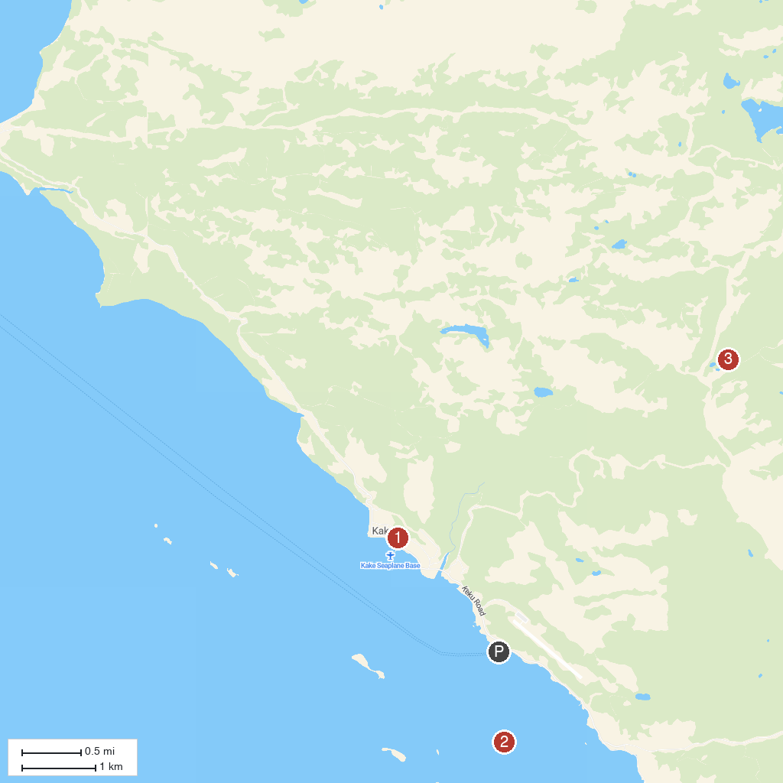
MAP KEY
1. Kake Totem Pole | 3. Gunnuk Creek
2. Keku Islets
P. Cruise port / terminal
Map © MapTiler © OpenStreetMap contributors · cruiseports.org

