Kusadasi, Aegean, Turkey
The Aegean's busiest cruise stop, Kusadasi punches above its size: ancient Ephesus is 20 km away, the bazaar starts at the dock gate, and turquoise water laps every direction. A shore day here has layers.
⚓ Docked (cruise terminal) · 🕒 Typical call: 7–10 hrs · 💵 Currency: Turkish Lira (TL) · 🗣️ Language: Turkish · 🏛️ UNESCO Ephesus nearby
✍️ MY DAY IN PORT (FILL IN)
Ship / Date
In port | arrive ______ · all aboard ______
Booked excursion
Notes / meeting point
GETTING ASHORE
- Docking: Ships berth at Kusadasi Cruise Port, a short walk from the town center and bazaar.
- Walk to center: 5 min on foot to the old bazaar; Pigeon Island causeway is a 10-min walk along the seafront.
- Best For: History lovers (Ephesus), shoppers, beach seekers, and Turkish cuisine.
- Don't Miss: The Library of Celsus at Ephesus — one of the most photographed ruins in the world.
GETTING AROUND
- 🚕 Taxi: 50–100 TRY in-city; €80–100 return to Ephesus — Taxis queue at the port exit. Short city rides are cheap on the meter; agree on a price for longer trips. Taxi to Ephesu
- 📱 Rideshare: ✅ Uber
TOP THINGS TO DO
- Ancient Ephesus — Walk the marble-paved Curetes Street past the Library of Celsus, the Great Theatre (capacity 25,000), and the Temple of Hadrian.
- Sirince Village — A hilltop Greek-founded village known for its fruit wines (peach, pomegranate, strawberry), stone houses, and panoramic Aegean…
- Dilek National Park & Beaches — Aegean National Park beaches with crystal-clear water, pine forests, and minimal crowds compared to town.
- Pamukkale Thermal Terraces — Turkey's famous white calcium terraces and warm thermal pools (Hierapolis).
- Kusadasi Town & Pigeon Island — Stroll the seafront promenade to Pigeon Island (Güvercin Adası), a small fortified island connected by a causeway with an Ottoman…
BEST WALKS
- Waterfront & Pigeon Island Loop: 2–3 km · Easy · 45–60 min — From the cruise terminal, head north along the promenade past cafés and souvenir stalls to Güvercin…
- Bazaar & Old Town: 1.5 km · Easy · 30–45 min — Exit the port gate and enter the bazaar immediately.
- Port to Pigeon Island Waterfront Walk: 2.5 km | 30 min one-way | Easy | Paved promenade — Exit the port gate and head north along the waterfront promenade past the marina and seafront…
WEATHER · DAYLIGHT · MONEY
Month | High °F | Low °F | Rainy days
May | 77 | 62 | 6
Jul | 93 | 75 | 0
Sep | 85 | 70 | 2
Daylight: May 6:01AM–8:14PM · Jul 6:01AM–8:32PM · Sep 6:53AM–7:18PM
cruiseports.org/kusadasi · Confirm terminal & all-aboard time with your ship

Kusadasi, Aegean, Turkey — Port Map
Red = walkable sights · Amber = excursions farther out · P = cruise terminal
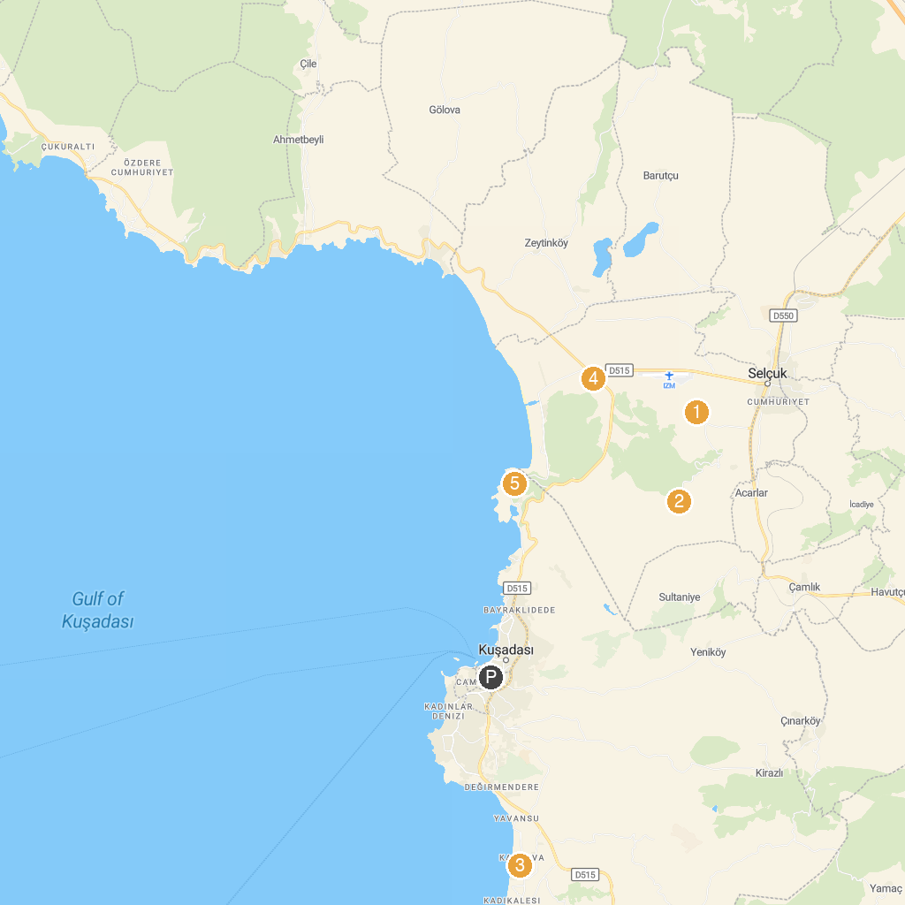
MAP KEY
1. Library of Celsus | 5. The Temple of Artemis
2. House of Virgin Mary | 6. Selçuk Hamamı
3. Tortuga Pirate Island Theme & Water Park | 7. Cittantica Ephesus Park
4. Cetin Model Village | 8. Adaland
P. Cruise port / terminal
Map © MapTiler © OpenStreetMap contributors · cruiseports.org

