Kyle of Lochalsh, Scottish Highlands, Scotland
A small Highland village with an outsized doorstep — the Isle of Skye is literally steps away across the iconic Skye Bridge, with the world-famous Eilean Donan Castle just 8 miles down the loch.
⚓ Tender (small ships may dock) · 🕒 Typical call: 6-8 hrs · 💷 British Pound (GBP) · 🗣️ English / Scottish Gaelic
✍️ MY DAY IN PORT (FILL IN)
Ship / Date
In port | arrive ______ · all aboard ______
Booked excursion
Notes / meeting point
GETTING ASHORE
- Docking: Tender for most ships; small expedition vessels can dock at Lochalsh Railway Pier
- Walk to centre: 2–5 min flat walk from tender pontoon to village shops and station
- Best For: Isle of Skye day trips, Eilean Donan Castle, scenic railway to Plockton
- Don't Miss: Walking the Skye Bridge and a Seaprobe Atlantis glass-bottom boat tour
GETTING AROUND
- 🚕 Taxi: £7–£15 — Several local firms serve the area including Kyle Taxi Company, Alan's Taxi Kyle, and Lochalsh Taxis. Short village hops
- 📱 Rideshare: ❌ not available
TOP THINGS TO DO
- Isle of Skye Highlights Tour — Cross the Skye Bridge and explore Skye's dramatic landscapes — the Old Man of Storr, Trotternish Ridge, Portree harbour, or…
- Eilean Donan Castle — Eight miles east in Dornie, this photogenic 13th-century castle sits where three sea lochs meet.
- Seaprobe Atlantis Glass-Bottom Boat — Board Scotland's premier semi-submersible right from the Kyle Pontoon for views of kelp forests, seals, otters, and the WWII…
- Scenic Railway to Plockton — Jump on the Kyle Line — one of Britain's most beautiful railways — for a 15-minute ride to Plockton, a picture-perfect village…
- Walk to Kyleakin & Castle Moil — Cross the Skye Bridge on foot (free, ~45 min one-way) to Kyleakin village on Skye.
BEST WALKS
- The Plock Viewpoint: 1.5 km round-trip | Easy–Moderate | 30–40 min — From the village centre, a 10–15 minute uphill walk brings you to The Plock, a community-owned…
- Skye Bridge Walk: 2.4 km one-way | Easy | 30–45 min one-way — Walk the full length of the Skye Bridge on its dedicated pedestrian path.
WEATHER · DAYLIGHT · MONEY
Month | High °F | Low °F | Rainy days
May | 55 | 45 | 18
Jul | 61 | 53 | 21
Sep | 58 | 50 | 19
Daylight: May 5:02AM–9:36PM · Jul 4:49AM–10:07PM · Sep 6:54AM–7:40PM
cruiseports.org/kyle-of-lochalsh · Confirm terminal & all-aboard time with your ship

Kyle of Lochalsh, Scottish Highlands, Scotland — Port Map
Red = walkable sights · Amber = excursions farther out · P = cruise terminal
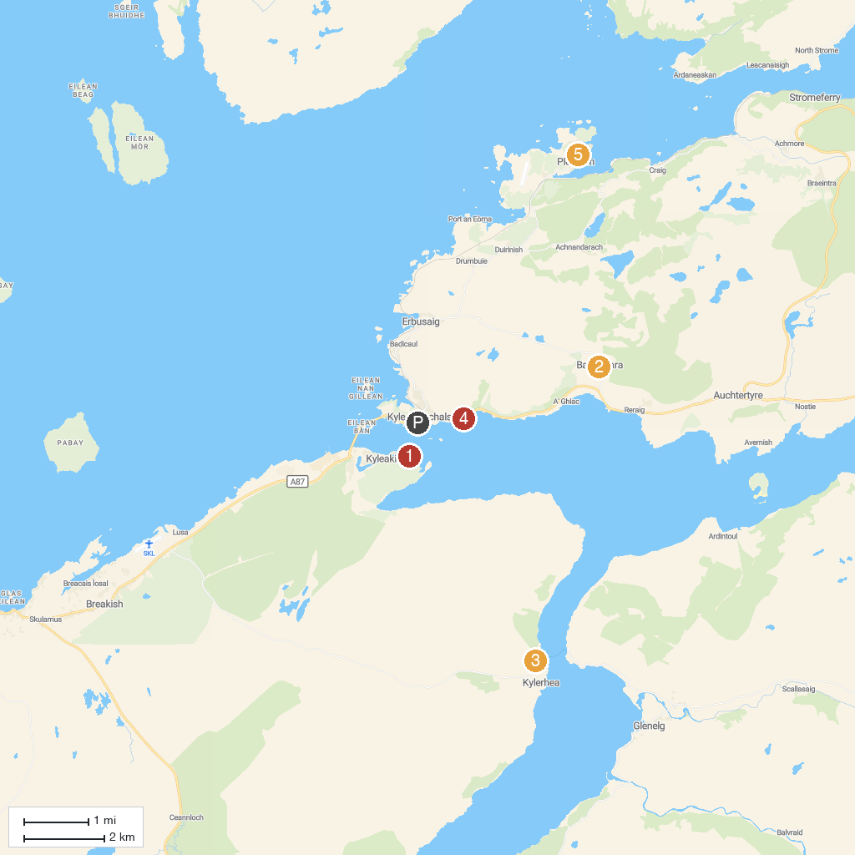
MAP KEY
1. Castle Moil | 5. Loch Alsh Viewpoint
2. Balmacara Estate Visitor Centre (National Trust for Scotland) | 6. Calum's Seal Trips.(Free if no seals)
3. Otter Hide | 7. Eilean Donan Lookout
4. Strome Castle
P. Cruise port / terminal
Map © MapTiler © OpenStreetMap contributors · cruiseports.org

