Kythira Island, Ionian Islands, Greece
Mythological birthplace of Aphrodite, Kythira slumbers between the Aegean and Ionian seas — a cliff-top Venetian castle, turquoise-lagoon beaches, and zero crowds make it the Greece the crowds haven't found yet.
⚓ Tender port · 🕒 Typical call: 6-8 hrs · 💶 Euro (EUR) · 🗣️ Greek
✍️ MY DAY IN PORT (FILL IN)
Ship / Date
In port | arrive ______ · all aboard ______
Booked excursion
Notes / meeting point
GETTING ASHORE
- Docking: Tender — ships anchor off Diakofti (east) or Kapsali (south)
- Walk to Center: Kapsali tender: 2 min to beach, 40 min uphill to Chora; Diakofti: car/taxi needed
- Best For: Authentic Greece, Venetian history, secluded beaches, local honey
- Don't Miss: Chora's Venetian castle with 360° views over three seas
GETTING AROUND
- 🚕 Taxi: €30–50 — Taxis meet ships at Diakofti port during the tourist season. The capital Chora is ~24 km away; pre-booking is strongly r
- 📱 Rideshare: ❌ not available
TOP THINGS TO DO
- Chora & the Venetian Castle — The island's white-and-blue capital crowns a ridge above Kapsali Bay.
- Paleochora — Kythira's Ghost Byzantine Capital — Perched on a sheer cliff in the northwest, this ruined Byzantine town was sacked by pirate Barbarossa in 1537 and never rebuilt.
- Mylopotamos Waterfall & Kato Chora Ruins — Follow the lush gorge to the 'Fonissa' waterfall surrounded by old watermills, then step next door to Kato Chora — a perfectly…
- Kaladi or Chalkos Beach — Kaladi's three crystal coves (reached by ~150 stone steps) and Chalkos's dramatic clifftop bay are two of the Ionian's most…
- Chora Archaeological Museum — A compact but well-curated collection spanning prehistoric to Venetian eras, including the famous marble lion of Kythira and…
BEST WALKS
- Kapsali Waterfront to Chora Castle: 2.5 km one-way | ~40 min uphill | Strenuous — Walk the winding road from Kapsali quay up to Chora town, continue through the alley-maze to the…
- Diakofti Beach Stroll: ~1 km loop | 15 min | Easy — If your ship tenders to Diakofti, a short walk along the turquoise lagoon-style beach is the…
WEATHER · DAYLIGHT · MONEY
Month | High °F | Low °F | Rainy days
May | 71 | 62 | 4
Jul | 85 | 75 | 1
Sep | 80 | 71 | 3
Daylight: May 6:22AM–8:27PM · Jul 6:22AM–8:45PM · Sep 7:10AM–7:35PM
cruiseports.org/kythira-island · Confirm terminal & all-aboard time with your ship

Kythira Island, Ionian Islands, Greece — Port Map
Red = walkable sights · Amber = excursions farther out · P = cruise terminal
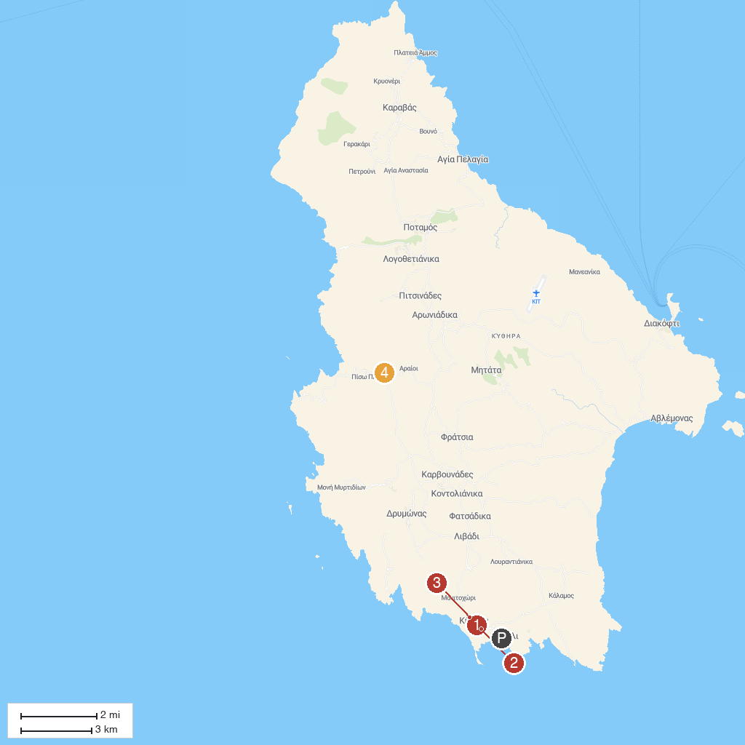
MAP KEY
1. Il Mercato Bar | 3. Archaeological Museum of Kythera
2. Castle of Chora Kithira | 4. Neraida Waterfall
P. Cruise port / terminal
Map © MapTiler © OpenStreetMap contributors · cruiseports.org

