La Crosse, Wisconsin, USA
Perched where Wisconsin, Minnesota, and Iowa meet, La Crosse greets river cruisers with towering bluffs, a lively historic downtown, and genuine Midwest hospitality right off the dock.
⚓ Docked (Riverside Park pier) · 🕒 Typical call: 6-8 hrs · 💵 US Dollar · 🗣️ English
✍️ MY DAY IN PORT (FILL IN)
Ship / Date
In port | arrive ______ · all aboard ______
Booked excursion
Notes / meeting point
GETTING ASHORE
- Docking: Docked at Riverside Park, central downtown
- Walk to Center: 5 min on foot to Main Street shops
- Best For: Bluff views, craft beer, river history
- Don't Miss: Grandad Bluff overlook & cheese curds
GETTING AROUND
- 🚕 Taxi: $6-$18 — Local cabs (Bee Cab, Bullet Cab, Coulee Region Taxi) serve the area. The short distance to downtown means fares will be
- 📱 Rideshare: ✅ Uber, Lyft
TOP THINGS TO DO
- Grandad Bluff Overlook — At 600 feet above the city, Grandad Bluff delivers sweeping views of the Mississippi River valley stretching into three states.
- Riverside Park & River Heritage — The park at the dock is home to the beautiful paddlewheel boat La Crosse Queen and interpretive displays on Mississippi River…
- Historic Downtown Walk — Five minutes from the dock, La Crosse's downtown blends Victorian storefronts with craft breweries, local boutiques, murals, and…
- Blufflands Trail Hike — For the active crowd, the City of La Crosse maintains bluff-side trails accessible from Grandad Bluff Park with moderate hiking…
- Wisconsin Food & Drink Trail — La Crosse is the perfect place to try Wisconsin staples: deep-fried cheese curds at a downtown pub, a Spotted Cow farmhouse ale…
BEST WALKS
- Riverside Park to Downtown: 0.5 miles · 10 min · Flat · Easy — Walk east from the dock along the Riverside Park path to the heart of downtown.
- Downtown Heritage Loop: 1.5 miles · 30 min · Flat · Easy — Explore the compact historic downtown: walk along 3rd and 4th Streets past Victorian architecture…
WEATHER · DAYLIGHT · MONEY
Month | High °F | Low °F | Rainy days
May | 68 | 50 | 12
Jul | 81 | 65 | 11
Sep | 73 | 58 | 10
Daylight: May 5:39AM–8:23PM · Jul 5:37AM–8:44PM · Sep 6:44AM–7:14PM
cruiseports.org/la-crosse-wi · Confirm terminal & all-aboard time with your ship

La Crosse, Wisconsin, USA — Port Map
Red = walkable sights · Amber = excursions farther out · P = cruise terminal
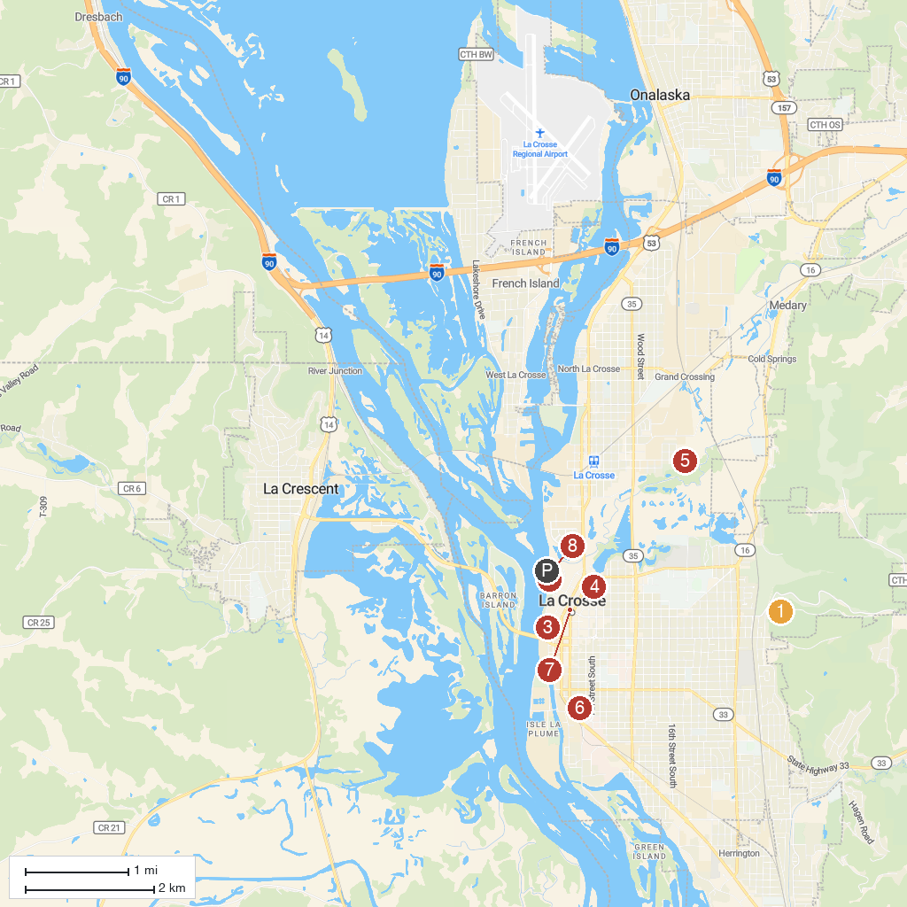
MAP KEY
1. Grandad Bluff Park | 5. Red Cloud Park
2. Riverside Park | 6. Poage Park
3. Pump House Regional Arts Center | 7. La Crosse Escape Room
4. Historic Hixon House Museum | 8. Riverside International Friendship Gardens
P. Cruise port / terminal
Map © MapTiler © OpenStreetMap contributors · cruiseports.org

