La Spezia, Liguria, Italy
The gateway to Cinque Terre, Tuscany, and the Gulf of Poets — La Spezia punches well above its size. Whether you train into the five villages or explore the city's own waterfront, markets, and castle, this Ligurian port rewards the curious.
⚓ Docked (Molo Garibaldi) · 🕒 Typical call: 8-10 hrs · 💵 Currency: Euro (€) · 🗣️ Language: Italian
✍️ MY DAY IN PORT (FILL IN)
Ship / Date
In port | arrive ______ · all aboard ______
Booked excursion
Notes / meeting point
GETTING ASHORE
- Docking: Ships dock at Molo Garibaldi; free shuttle to terminal exit — walking the port is not permitted
- Walk to centre: ~20 min flat walk from terminal exit, or short taxi (≈€15); train station is 25 min walk
- Best For: Cinque Terre day-trippers, Tuscany excursions, Ligurian seafood and local walks
- Don't Miss: Cinque Terre by train or ferry, Portovenere, or Passeggiata Morin waterfront stroll
GETTING AROUND
- 🚕 Taxi: €8–€15 — Taxis wait outside the cruise terminal. About €8–11 to La Spezia Centrale train station (7 min) and roughly €15 to the c
TOP THINGS TO DO
- Cinque Terre by Train — Hop the regional train from La Spezia Centrale to explore the five colorful clifftop villages — Riomaggiore, Manarola, Corniglia…
- Pisa & the Leaning Tower — A direct train from La Spezia reaches Pisa Centrale in about 55 minutes.
- Florence — Cradle of the Renaissance — Two hours by train, Florence rewards the early riser.
- Portovenere & Gulf of Poets — A short ferry or 20-minute drive south leads to Portovenere, a medieval village on the promontory with colorful houses, San…
- La Spezia City & Waterfront — Skip the crowds and stay local: stroll Passeggiata Morin, visit Castello San Giorgio (14th-century fortress with archaeology…
BEST WALKS
- Waterfront to Old Town: 2.5 km · ~45 min · flat · easy — Exit the terminal and follow the palm-lined Passeggiata Costantino Morin along the bay, taking in…
- Castello San Giorgio Climb: 3 km · ~1 hr · some uphill · moderate — From the city centre, follow signs uphill to the 14th-century Castello San Giorgio.
WEATHER · DAYLIGHT · MONEY
Month | High °F | Low °F | Rainy days
May | 68 | 56 | 12
Jul | 81 | 68 | 6
Sep | 75 | 63 | 10
Daylight: May 5:54AM–8:40PM · Jul 5:51AM–9:01PM · Sep 7:00AM–7:30PM
cruiseports.org/la-spezia · Confirm terminal & all-aboard time with your ship

La Spezia, Liguria, Italy — Port Map
Red = walkable sights · Amber = excursions farther out · P = cruise terminal
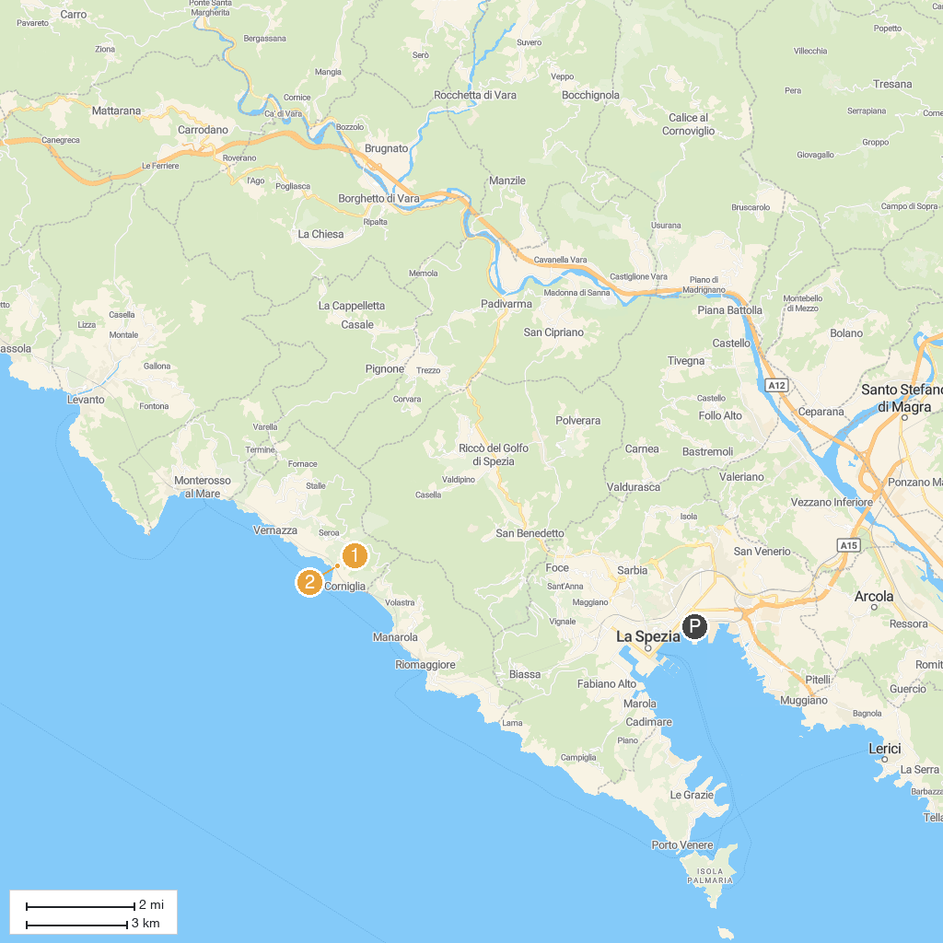
MAP KEY
1. Parco Nazionale delle Cinque Terre | 5. Spiaggia Libera Deiva Marina
2. Sentiero Monterosso - Vernazza | 6. Sentiero Azzurro
3. Punta Mesco | 7. Sanctuary N.S. di Roverano
4. Oratorio Mortis et Orationis - Confraternita dei Neri | 8. D.Ranch Horse Riding Cinque Terre
P. Cruise port / terminal
Map © MapTiler © OpenStreetMap contributors · cruiseports.org

