Labadee, Nord, Haiti
A mountain-fringed peninsula leased exclusively by Royal Caribbean, Labadee delivers turquoise coves, jungle ziplines, and all-inclusive beach days without ever leaving the resort perimeter.
⚓ Pier (docked) · 🕒 Typical call: 7-9 hrs · 💵 USD (SeaPass on-site; cash for Straw Market) · 🗣️ French / Haitian Creole · 🏖️ Private resort — Royal Caribbean exclusive
✍️ MY DAY IN PORT (FILL IN)
Ship / Date
In port | arrive ______ · all aboard ______
Booked excursion
Notes / meeting point
GETTING ASHORE
- Docking: Pier — ships dock directly, no tender
- Walk to beaches: 3–15 min from pier; free tram available
- Best For: Families, beach days, adrenaline seekers
- Don't Miss: Dragon's Breath Flight Line zipline & the Labadoozie cocktail
GETTING AROUND
- 📱 Rideshare: ❌ not available
TOP THINGS TO DO
- Dragon's Breath Flight Line — The longest overwater zipline in the world: 2,600 ft at up to 50 mph from a 500-ft mountain summit straight to the beach.
- Dragon's Tail Alpine Coaster — A gravity-powered alpine coaster winding 2,230 ft down the forested hillside, with dips, curves, and a 360° loop.
- Waterfront Cabana at Nellie's Beach — Premium waterfront cabanas set along the turquoise cove at Nellie's Beach, with sun loungers, shade, floating mats, and personal…
- Snorkel Safari — Guided snorkel tour along Labadee's coral-fringed coastline, with equipment provided.
- Jet Ski & Watersports — Rent jet skis, kayaks, paddle boards, or floating mats along the calmer cove beaches.
BEST WALKS
- Pier to Columbus Cove Loop: ~1.5 km | Easy | 20-30 min — Walk from the pier entrance past the Dragon's Cafe buffet, through Nellie's Beach, and all the way…
- Adrenaline Beach Blowhole Walk: ~0.5 km | Easy | 10-15 min — From Adrenaline Beach, follow the paved coastal path east toward the natural blowhole rock formation.
WEATHER · DAYLIGHT · MONEY
Month | High °F | Low °F | Rainy days
May | 84 | 75 | 19
Jul | 86 | 78 | 12
Sep | 87 | 78 | 22
Daylight: May 6:13AM–7:17PM · Jul 6:18AM–7:31PM · Sep 6:36AM–6:51PM
cruiseports.org/labadee-haiti · Confirm terminal & all-aboard time with your ship

Labadee, Nord, Haiti — Port Map
Red = walkable sights · Amber = excursions farther out · P = cruise terminal
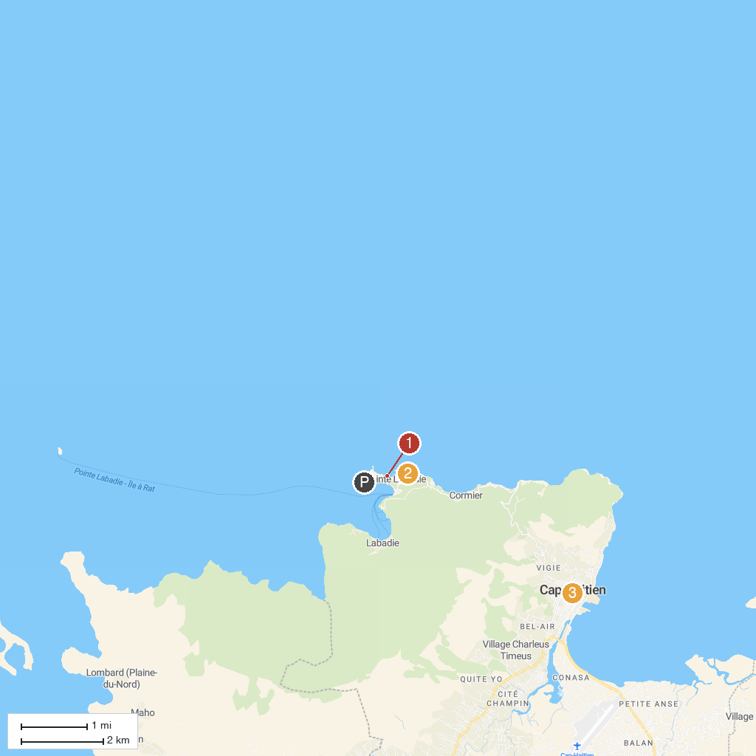
MAP KEY
1. Labadee Beach | 3. Notre-Dame of Cap-Haïtien Cathedral
2. Dragon's Breath Flight Line
P. Cruise port / terminal
Map © MapTiler © OpenStreetMap contributors · cruiseports.org

