Ladbergen, North Rhine-Westphalia, Germany
A quiet Münsterland canal stop where riverside cycling meets half-timbered villages, sandstone cliffs, and the unhurried rhythm of inland Germany.
⚓ Docked (canal berth) · 🕒 Typical call: 4–6 hrs · 💶 Euro (EUR) · 🗣️ German
✍️ MY DAY IN PORT (FILL IN)
Ship / Date
In port | arrive ______ · all aboard ______
Booked excursion
Notes / meeting point
GETTING ASHORE
- Docking: Canal berth on the Dortmund-Ems Canal; ships dock directly in town
- Walk to Centre: Village centre is a short 5-min walk from the canal berth
- Best For: Cycling the canal towpath, Dörenther Cliffs, nearby Tecklenburg old town
- Don't Miss: The Dörenther Klippen sandstone cliffs and the Crouching Woman rock formation
GETTING AROUND
- 🚕 Taxi: €12–€18 — Local taxis (Taxi Osterhaus, Taxi Stern) serve the area. Steinfurt district regulated fares: ~€4.30 base + €2.60/km. Pre
TOP THINGS TO DO
- Dörenther Cliffs & Crouching Woman — Hike to the Dörenther Klippen, dramatic sandstone cliffs up to 40 m high in the Teutoburg Forest.
- Tecklenburg Medieval Old Town — The nearby hilltop town of Tecklenburg is one of the prettiest in Westphalia — cobbled lanes, well-preserved half-timbered…
- Canal Towpath Cycling — Follow the flat, scenic towpath of the Dortmund-Ems Canal on two wheels.
- Ladbergen Village & Heimatmuseum — Explore the village centre's half-timbered houses, photograph the old water mill, and visit the Heimatmuseum for a glimpse into…
BEST WALKS
- Village Centre & Old Water Mill: 1–2 km · 30 min · Easy — A short stroll from the canal berth into the village centre, past half-timbered farmhouses and the…
- Canal Towpath Walk: 2–4 km · 45–90 min · Easy — Head north or south along the Dortmund-Ems Canal towpath for a tranquil walk through Münsterland…
WEATHER · DAYLIGHT · MONEY
Month | High °F | Low °F | Rainy days
May | 65 | 48 | 11
Jul | 74 | 58 | 13
Sep | 68 | 53 | 10
Daylight: May 5:34AM–9:17PM · Jul 5:26AM–9:42PM · Sep 7:03AM–7:43PM
cruiseports.org/ladbergen · Confirm terminal & all-aboard time with your ship

Ladbergen, North Rhine-Westphalia, Germany — Port Map
Red = walkable sights · Amber = excursions farther out · P = cruise terminal
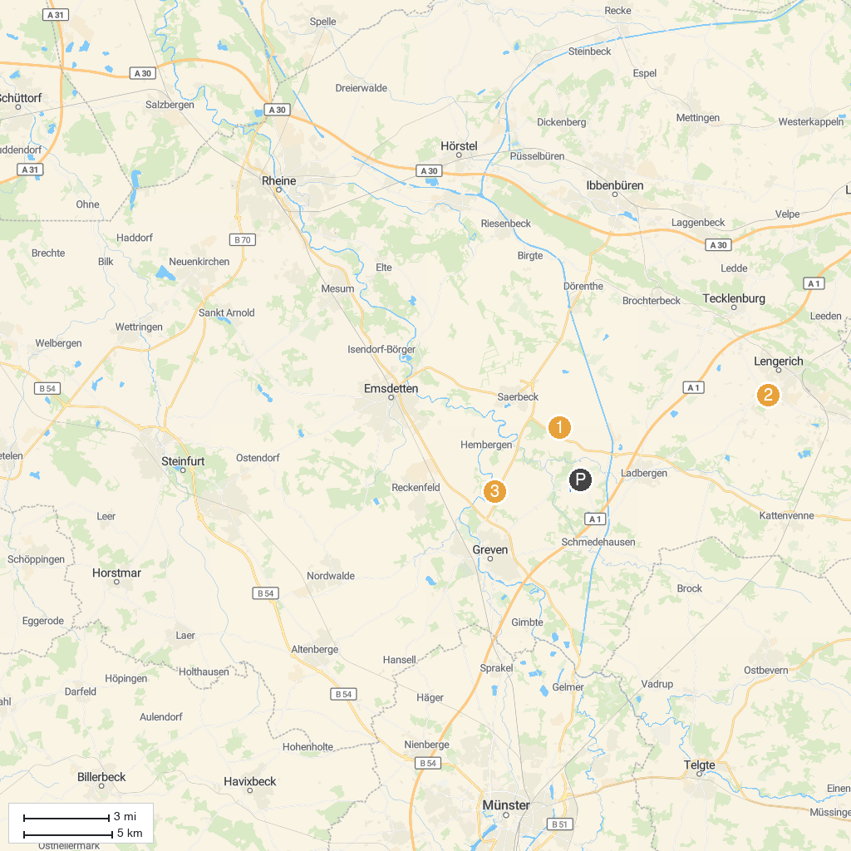
MAP KEY
1. Wildfreigehege Nöttler Mountain | 4. Haus Vortlage
2. Vogelschutzgebiet 'Rieselfelder Münster' | 5. Sachsenhof
3. Amusement park Sommerrodelbahn Ibbenbüren
P. Cruise port / terminal
Map © MapTiler © OpenStreetMap contributors · cruiseports.org

