Laem Chabang, Chonburi, Thailand
Thailand's industrial gateway port packs a punch — Bangkok's Grand Palace, Pattaya's wooden Sanctuary of Truth, and floating markets are all within striking distance on a well-planned shore day.
⚓ Docked (cruise terminal) · 🕒 Typical call: 8-10 hrs · 💵 Thai Baht (THB) · 🗣️ Thai (English widely spoken in tourist areas)
✍️ MY DAY IN PORT (FILL IN)
Ship / Date
In port | arrive ______ · all aboard ______
Booked excursion
Notes / meeting point
GETTING ASHORE
- Docking: Berthed at Terminal A1, Laem Chabang International Terminal — large industrial port, nothing walkable nearby
- To Bangkok: ~120 km, 1.5–2.5 hrs by private taxi/van (allow 3+ hrs in heavy traffic)
- Best For: Bangkok temples and palaces, Pattaya day trips, floating markets, Thai massage
- Don't Miss: Grand Palace & Wat Phra Kaew, Wat Pho, Sanctuary of Truth in Pattaya
GETTING AROUND
- 🚕 Taxi: ฿210–฿260 (~$6–$7) — Metered public taxis available at the port gate to Pattaya city center (~26 km, ~28 min). Most reliable option for nearb
- 📱 Rideshare: ✅ Grab, Bolt
TOP THINGS TO DO
- Grand Palace & Bangkok Temples — The essential Bangkok day: Grand Palace and the dazzling Emerald Buddha (Wat Phra Kaew), then Wat Pho's 46-metre gold reclining…
- Ayutthaya Ancient Capital — Day trip to the UNESCO-listed ruins of Siam's ancient capital — crumbling prangs, headless Buddhas, and riverside temples that…
- Sanctuary of Truth, Pattaya — An extraordinary all-teak temple rising 105 metres from the sea cliffs of Pattaya, covered floor-to-ceiling in intricate…
- Floating Market Day — Thailand's famous floating markets make for a vivid half-day: vendors in wooden boats selling fresh fruit, pad thai, and…
- Koh Larn (Coral Island) Beach Day — From Bali Hai Pier in Pattaya, speedboats reach Koh Larn in 15 minutes — clear water, white sand, snorkelling, and parasailing.
BEST WALKS
- Pattaya Beachfront Stroll: Easy • 2 km • Flat — Pattaya Beach Road runs the length of the bay — good for a casual walk with ocean views, beach…
- Bangkok Riverside & Temple Walk: Moderate • 3-4 km • Flat — Start at Tha Tien pier near Wat Pho, walk to the Grand Palace entrance, then return to the pier for…
cruiseports.org/laem-chabang · Confirm terminal & all-aboard time with your ship

Laem Chabang, Chonburi, Thailand — Port Map
Red = walkable sights · Amber = excursions farther out · P = cruise terminal
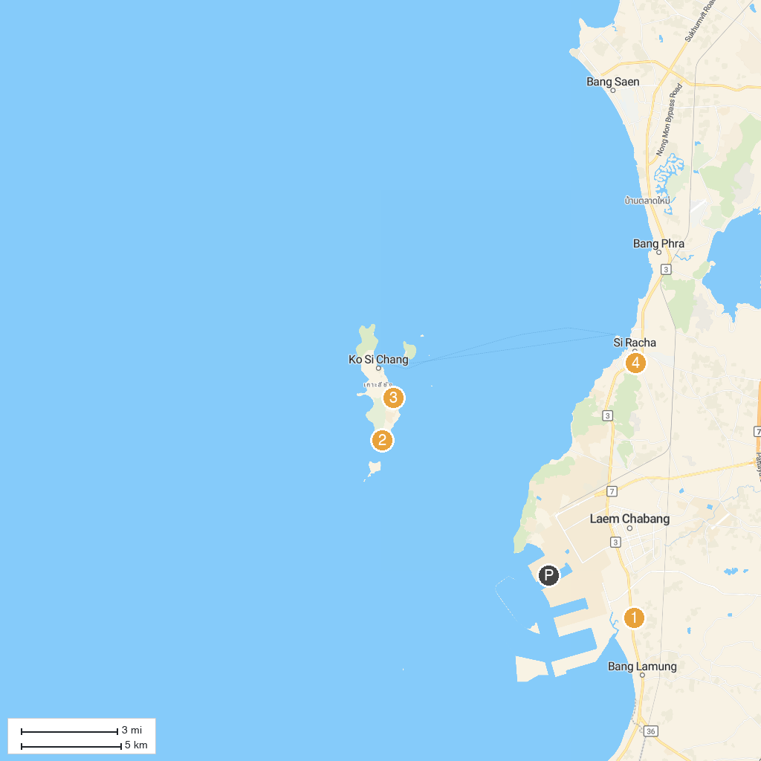
MAP KEY
1. Wat Tha Kradan | 5. Mini Siam
2. Ta Yai Tim | 6. Wat Santikham
3. Burapha Golf Club | 7. HarborLand
4. วัดอัษฎางคนิมิตร : Asdang Temple | 8. Sacred Heart Catholic Church
P. Cruise port / terminal
Map © MapTiler © OpenStreetMap contributors · cruiseports.org

