Laggan Locks, Scottish Highlands, Scotland
Laggan is a tiny Great Glen canal stop, not a conventional cruise port: small ships tie up beside Thomas Telford's waterway between Loch Lochy and Loch Oich. The reward is immediate Highland quiet, pine-scented towpaths, lock watching, and one of Scotland's most unusual pub stops.
⚓ Canal mooring (direct docking) · 🕒 Typical call: overnight or half day · 💷 British Pound (GBP) · 🗣️ English
✍️ MY DAY IN PORT (FILL IN)
Ship / Date
In port | arrive ______ · all aboard ______
Booked excursion
Notes / meeting point
GETTING ASHORE
- Docking: Direct canal mooring at or near Laggan Locks — no tender
- Walk to sights: 0–5 min to locks, towpath, and Eagle Barge
- Best For: Canal scenery, quiet walks, cycling, Highland landscapes
- Don't Miss: Laggan Avenue and a drink aboard the Eagle Barge Inn
GETTING AROUND
- 🚕 Taxi: £45–£60 to Fort William; £90–£110 to Inverness — No taxis base in Laggan itself — book ahead via Fort William or Spean Bridge taxi firms. Fort William (≈21 miles) is the
TOP THINGS TO DO
- Laggan Locks & Canal Watching — Stay right by the mooring and watch boats rise or drop through the Caledonian Canal locks, with swing bridges, lock gates, and…
- Laggan Avenue & Loch Oich Towpath — Walk or cycle the tree-lined canal section toward Loch Oich, one of the prettiest stretches of the Great Glen Way and a calm…
- Eagle Barge Inn — A converted Dutch barge moored at Laggan Locks, serving pub food, ales, and whisky in a floating canal setting popular with…
- Invergarry Castle Ruins — A ruined stronghold of the MacDonells of Glengarry on Loch Oich, usually seen from the outside as part of a longer walk, cycle…
- Loch Oich Paddling — When offered by local operators or ship excursions, kayaking or canoeing on Loch Oich gives a close-up look at the Great Glen's…
BEST WALKS
- Laggan Locks to Eagle Barge Inn: 0.2 mi | 5 min | Easy | Towpath — The simple first walk from the lock area to the floating pub, with good views of the canal, moored…
- Laggan Avenue Towpath: 2–4 mi out and back | 1–2 hrs | Easy | Gravel path — Follow the Great Glen Way along the Caledonian Canal through Laggan Avenue toward Loch Oich.
- Invergarry Castle View: Longer outing | 2–3 hrs on foot | Easy to moderate — A longer canal-and-loch walk or cycle toward Invergarry Castle ruins, best for passengers with a…
cruiseports.org/laggan · Confirm terminal & all-aboard time with your ship

Laggan Locks, Scottish Highlands, Scotland — Port Map
Red = walkable sights · Amber = excursions farther out · P = cruise terminal
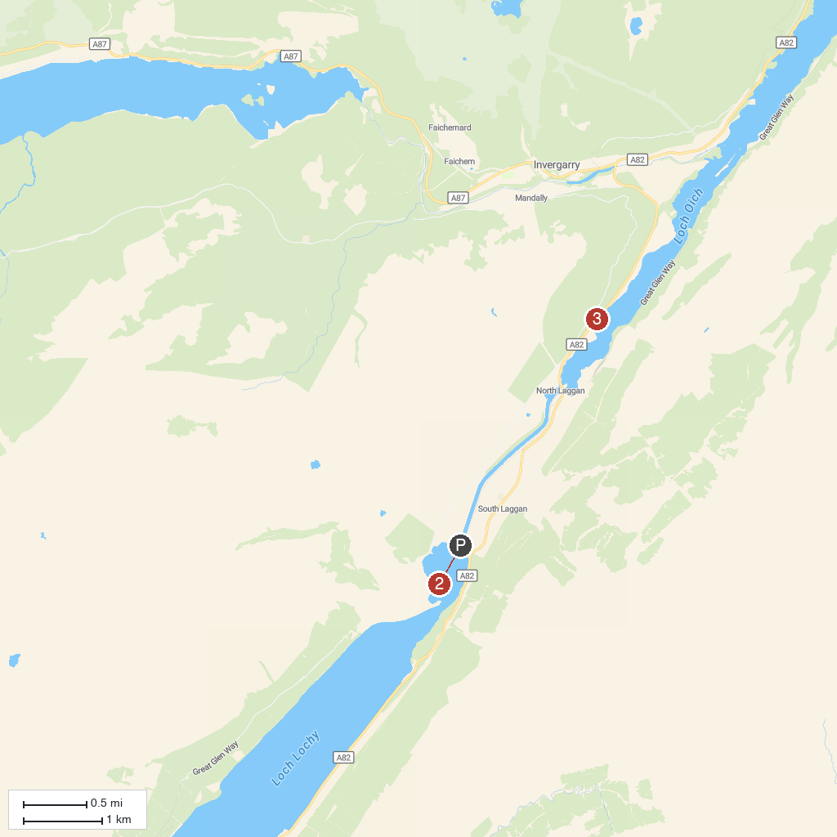
MAP KEY
1. Laggan Locks | 3. Well of the Heads Monument
2. Great Glen Way
P. Cruise port / terminal
Map © MapTiler © OpenStreetMap contributors · cruiseports.org

