Lahaina, Maui, Hawaii, USA
Maui's West Shore is open for business — the resort beaches of Kaanapali and Kapalua shine as brightly as ever, even as historic Lahaina town rebuilds from the 2023 wildfire.
⚓ Pier — docks at Kahului Harbor · 🕒 Typical call: 8-10 hrs · 💵 USD · 🗣️ English / Hawaiian · 🔥 Lahaina town rebuilding post-2023 wildfire
✍️ MY DAY IN PORT (FILL IN)
Ship / Date
In port | arrive ______ · all aboard ______
Booked excursion
Notes / meeting point
GETTING ASHORE
- Docking: Pier at Kahului Harbor — no tendering
- Walk to center: Kahului port is not walkable to attractions; West Maui (Kaanapali) is ~27 miles/45–60 min by car
- Best For: Beaches, snorkeling, whale watching (Dec–Apr), golf, resort dining
- Don't Miss: Kaanapali Beach, snorkeling at Kapalua Bay, Molokini Crater tour
GETTING AROUND
- 🚕 Taxi: $12–$20 — Local taxis (e.g. West Maui Taxi) are available for point-to-point trips around West Maui. Useful if rideshare availabil
- 📱 Rideshare: ✅ Uber, Lyft
TOP THINGS TO DO
- Molokini Crater Snorkel — A partially submerged volcanic crater 3 miles off the south coast, with crystal-clear water and 150+ fish species.
- Whale Watching (December–April) — The Au'au Channel between Maui, Lana'i, and Moloka'i is one of the world's best humpback whale nurseries.
- Kaanapali & Kapalua Beaches — Kaanapali Beach is consistently ranked among America's best — four miles of golden sand backed by luxury resorts.
- Road to Hana Drive — Hawaii's most scenic road: 64 miles of rainforest, waterfalls, black-sand beaches, and bamboo groves winding along Maui's rugged…
- Haleakala Sunrise or Summit — Drive or tour to the 10,023-ft summit of Haleakala volcano for sunrise above the clouds or crater views.
BEST WALKS
- Kaanapali Beachfront Walk: 2 miles one-way · Flat & paved · Free — A paved oceanfront path runs the length of Kaanapali Beach, threading between the sand and the…
- Kapalua Coastal Trail: 1.7 miles one-way · Lava & boardwalk · Free — A stunning trail from Kapalua Bay to D.T.
WEATHER · DAYLIGHT · MONEY
Month | High °F | Low °F | Rainy days
May | 82 | 72 | 4
Jul | 85 | 75 | 3
Sep | 85 | 75 | 4
Daylight: May 5:48AM–6:56PM · Jul 5:53AM–7:09PM · Sep 6:13AM–6:28PM
cruiseports.org/lahaina · Confirm terminal & all-aboard time with your ship

Lahaina, Maui, Hawaii, USA — Port Map
Red = walkable sights · Amber = excursions farther out · P = cruise terminal
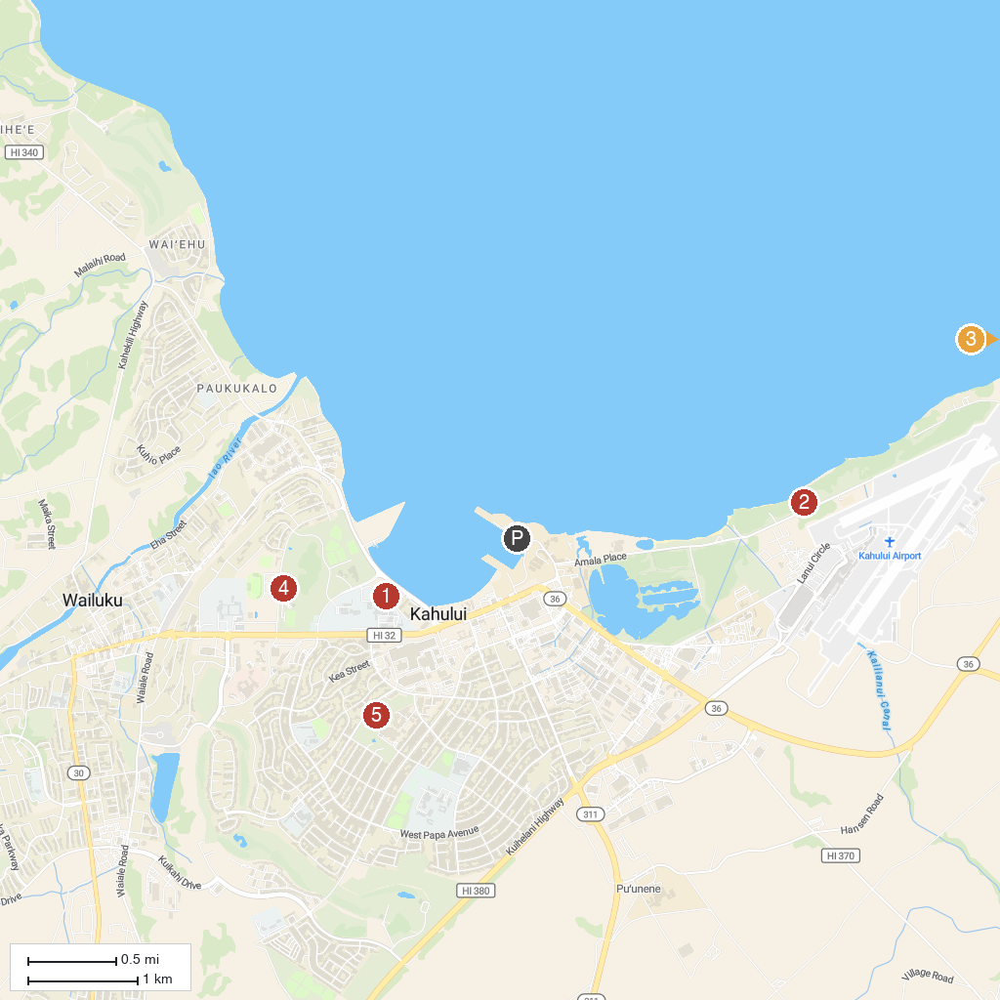
MAP KEY
1. Maui Ocean Center, The Aquarium of Hawaii | 5. Ho'okipa Beach Park
2. Maui Exposition | 6. Baldwin Beach Park
3. Kanaha Beach Park | 7. Maui Nui Botanical Gardens
4. PacWhale Eco-Adventures | 8. Kahului Community Center Park
P. Cruise port / terminal
Map © MapTiler © OpenStreetMap contributors · cruiseports.org

