Långnäs, Åland Islands, Finland
A deep-water Baltic gateway tucked inside a pine-fringed bay, Långnäs unlocks the Swedish-speaking Åland archipelago — medieval fortresses, a legendary windjammer, and some of the flattest, most bike-friendly islands in Europe.
⚓ Pier (deep-water dock) · 🕒 Typical call: 4–8 hrs · 💶 Euro (card accepted everywhere) · 🗣️ Swedish / English · 🏝️ Island-hopping base
✍️ MY DAY IN PORT (FILL IN)
Ship / Date
In port | arrive ______ · all aboard ______
Booked excursion
Notes / meeting point
GETTING ASHORE
- Docking: Pier — deep-water quay, no tendering
- Walk to center: No town at port; Mariehamn is 30 km (taxi/bus ~35 min)
- Best For: Cycling, medieval history, Baltic island scenery
- Don't Miss: Museum Ship Pommern & Åland Maritime Museum in Mariehamn
GETTING AROUND
- 🚕 Taxi: ~€75 one-way — Mariehamns Taxi serves the route (28–30 km). Base fare €7.30 + distance rate €2.21–2.78/km; expect surcharges for non-Ma
- 📱 Rideshare: ❌ not available
TOP THINGS TO DO
- Mariehamn City & Museum Ship Pommern — The Åland capital is 30 km west and punches well above its size.
- Kastelholm Castle & Jan Karlsgården — Åland's 14th-century royal fortress — where Swedish kings including Gustav Vasa once stayed — is beautifully restored.
- Bomarsund Fortress Ruins — The ruins of a massive Russian imperial fortress blown up by Anglo-French forces during the Crimean War in 1854.
- Lumparland Cycling Loop — Rent a bike and explore Lumparland — Åland's smallest and quietest municipality.
- Island Hopping by Ferry — Långnäs is the departure point for local ferries to Föglö, Sottunga, Kökar, and Kumlinge — outer islands with medieval churches…
BEST WALKS
- Mariehamn Esplanaden Walk: 2 km · Flat · 30 min · Free — After the shuttle drops you in Mariehamn, walk the Esplanaden — the town's signature tree-lined…
- Lumparland Church Road Walk: ~5 km · Flat · 1 hr · Free — On foot or by bike from the port, take the quiet country road toward Klemetsby to reach St.
WEATHER · DAYLIGHT · MONEY
Month | High °F | Low °F | Rainy days
May | 54 | 37 | 10
Jul | 68 | 55 | 12
Sep | 56 | 45 | 10
Daylight: Sep 5:54AM–6:59PM
cruiseports.org/langnas-aland · Confirm terminal & all-aboard time with your ship

Långnäs, Åland Islands, Finland — Port Map
Red = walkable sights · Amber = excursions farther out · P = cruise terminal
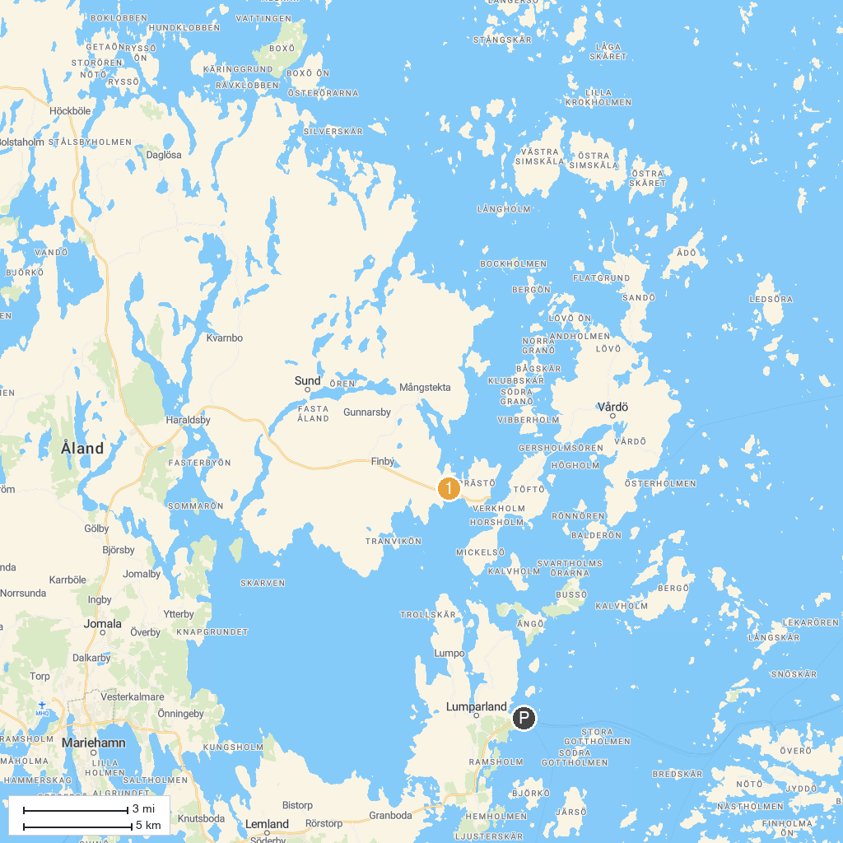
MAP KEY
1. Bomarsund Fortress Area | 2. Notvikstornet
P. Cruise port / terminal
Map © MapTiler © OpenStreetMap contributors · cruiseports.org

