L'Anse aux Meadows, Newfoundland, Canada
Stand where Viking explorer Leif Erikson stood around 1000 CE — the first known European settlement in the Americas. This remote UNESCO site delivers wind-swept history, floating icebergs, and wild Newfoundland scenery with almost no tourist crowds.
⚓ Tender (no pier) · 🕒 Typical call: 6-8 hrs · 💵 Canadian Dollar (CAD) · 🗣️ English (Newfoundland dialect) · 🧊 Iceberg Alley (June–July)
✍️ MY DAY IN PORT (FILL IN)
Ship / Date
In port | arrive ______ · all aboard ______
Booked excursion
Notes / meeting point
GETTING ASHORE
- Docking: Tender only — ships anchor offshore, Zodiacs/tenders to local wharf
- Walk to site: ~5 min walk from tender wharf to Parks Canada Visitor Centre
- Best For: History buffs, expedition travelers, iceberg watchers
- Don't Miss: Norstead Viking replica village; Norseman Restaurant wild game & seafood
GETTING AROUND
- 🚕 Taxi: Varies — A small number of local taxi operators serve the broader Great Northern Peninsula region. Availability is not guaranteed
TOP THINGS TO DO
- L'Anse aux Meadows National Historic Site — Parks Canada's flagship site includes the authentic archaeological remains of the Norse settlement, reconstructed sod longhouses…
- Norstead Viking Village — Just 2 km from the Parks Canada site, Norstead is a living-history replica of a Viking port of trade circa 1000 CE.
- Iceberg & Whale Watching Boat Tour — L'Anse aux Meadows sits on Iceberg Alley — from late May through July, enormous bergs drift past the coast.
- Coastal Hiking Trails — The Birchy Nuddick Trail starts near the Parks Canada visitor centre and winds along dramatic Atlantic coastline, through…
- Newfoundland Wild Food & Screech-In — Dine on fresh Atlantic cod, wild moose, local scallops, and bakeapple (cloudberry) desserts at the Norseman Restaurant on the…
BEST WALKS
- Tender Wharf to Viking Ruins: 0.8 km · 10 min · Easy · Flat gravel path & boardwalk — A flat, well-signed walk from the local tender wharf to the Parks Canada Visitor Centre and then…
- Birchy Nuddick Trail Loop: 3 km · 1 hr · Easy-moderate · Coastal cliffs & bog — Starting at the visitor centre, this loop trail traces the rocky Atlantic shoreline through…
WEATHER · DAYLIGHT · MONEY
Month | High °F | Low °F | Rainy days
May | 52 | 34 | 13
Jul | 71 | 54 | 14
Sep | 63 | 48 | 12
Daylight: May 5:32AM–8:47PM · Jul 5:27AM–9:10PM · Sep 6:50AM–7:24PM
cruiseports.org/lanse-aux-meadows · Confirm terminal & all-aboard time with your ship

L'Anse aux Meadows, Newfoundland, Canada — Port Map
Red = walkable sights · Amber = excursions farther out · P = cruise terminal
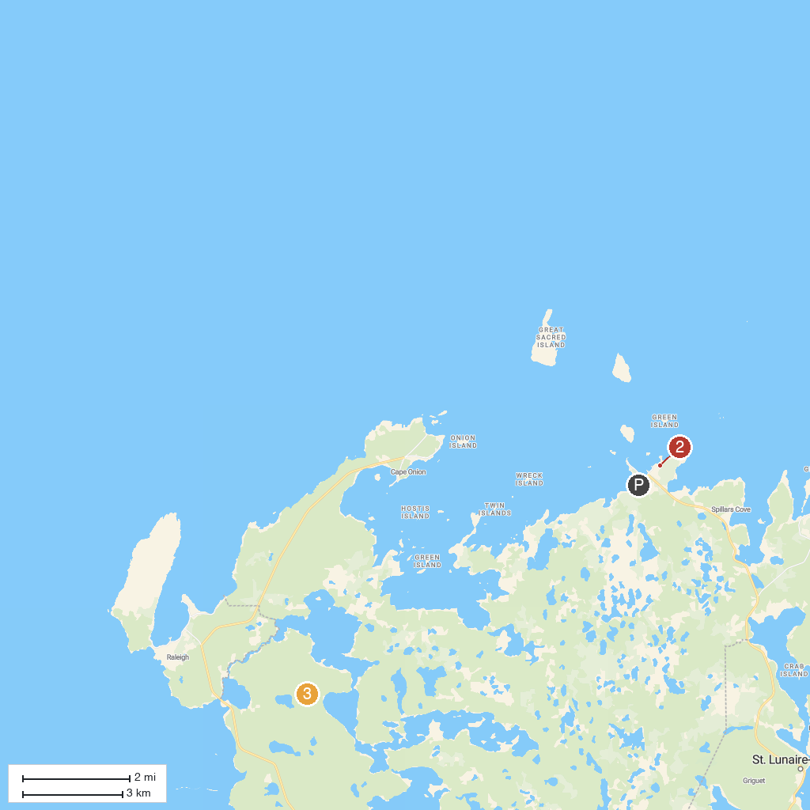
MAP KEY
1. L'Anse aux Meadows National Historic Site | 3. Pistolet Bay Provincial Park
2. Norstead
P. Cruise port / terminal
Map © MapTiler © OpenStreetMap contributors · cruiseports.org

