Larne, County Antrim, Northern Ireland
A compact working port on the Antrim coast, Larne punches well above its size as a launchpad for Northern Ireland's most spectacular scenery — the Giant's Causeway, the Causeway Coastal Route, and the Titanic Quarter in Belfast are all within striking distance.
⚓ Pier (docked) · 🕒 Typical call: 8-10 hrs · 💷 GBP (British Pound) · 🗣️ English · 🚂 Train to Belfast ~50 min
✍️ MY DAY IN PORT (FILL IN)
Ship / Date
In port | arrive ______ · all aboard ______
Booked excursion
Notes / meeting point
GETTING ASHORE
- Docking: Alongside at Port of Larne (MacKean Quay); no tendering required
- Walk to center: ~25-30 min on foot (1.5 miles); port shuttle usually provided
- Best For: Giant's Causeway day trips, Belfast city, Antrim coast drives
- Don't Miss: The Gobbins Cliff Path or a DIY train to Carrickfergus Castle
GETTING AROUND
- 🚕 Taxi: £6–£8 — Local taxis can take you from Larne Port to Larne town centre in about 4 minutes. Pre-book or hail at the port.
TOP THINGS TO DO
- Giant's Causeway & Carrick-a-Rede — Northern Ireland's UNESCO World Heritage Site — 40,000 interlocking basalt columns shaped by ancient volcanism.
- Titanic Belfast & City Tour — Belfast is 35-40 minutes south by road or 50 minutes by train.
- The Gobbins Cliff Path — A dramatic Edwardian cliff-face path 15 minutes south of Larne on the Islandmagee peninsula — bridges, tunnels, and staircases…
- Carrickfergus Castle — One of the best-preserved Norman castles in Ireland, dominating the shoreline since 1177 and just 20 minutes south of Larne by…
- Antrim Coastal Drive (A2) — The famous coastal road begins right at Larne and winds north through the Glens of Antrim — cliff-top scenery, fishing villages…
BEST WALKS
- Harbour to Chaine Memorial & Olderfleet Castle: 2 km round-trip · Easy · 40 min — Walk the flat seafront promenade from the port shuttle drop-off toward the Chaine Memorial Tower…
- Larne Town Center Stroll: 1.5 km one way · Easy · 25 min walk — From the port shuttle drop at the harbour station, walk into Larne town center via Main Street.
WEATHER · DAYLIGHT · MONEY
Month | High °F | Low °F | Rainy days
May | 57 | 47 | 15
Jul | 64 | 55 | 17
Sep | 61 | 53 | 14
Daylight: May 5:16AM–9:24PM · Jul 5:06AM–9:51PM · Sep 6:56AM–7:39PM
cruiseports.org/larne · Confirm terminal & all-aboard time with your ship

Larne, County Antrim, Northern Ireland — Port Map
Red = walkable sights · Amber = excursions farther out · P = cruise terminal
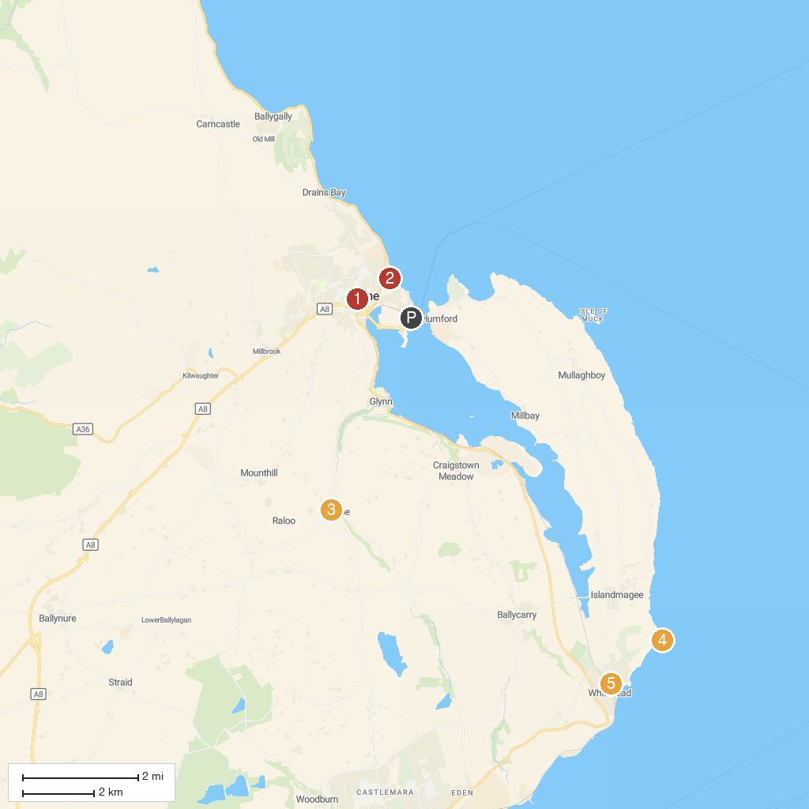
MAP KEY
1. Larne Museum & Arts Centre | 5. Whitehead Railway Museum
2. Larne Town Park | 6. Carrickfergus Urban Farm
3. National Trust - Gleno | 7. Oakfield Glen and Bashfordsland Wood
4. Blackhead Lighthouse | 8. JVC
P. Cruise port / terminal
Map © MapTiler © OpenStreetMap contributors · cruiseports.org

