Larvik, Vestfold, Norway
A quietly compelling Norwegian town where the legacy of Thor Heyerdahl meets Viking trading roots, world-class spa culture, and the world's most northerly beech forest.
⚓ Pier (ferry/cruise quay) · 🕒 Typical call: 6–8 hrs · 💵 NOK — cashless society, card everywhere · 🗣️ Norwegian (English widely spoken)
✍️ MY DAY IN PORT (FILL IN)
Ship / Date
In port | arrive ______ · all aboard ______
Booked excursion
Notes / meeting point
GETTING ASHORE
- Docking: Pier — ships berth at Larvik Harbour (Revet), adjacent to Color Line ferry terminal
- Walk to centre: ~20 min (1.5 km) along the flat waterfront to Torget square
- Best For: History buffs, spa lovers, nature walkers, Viking archaeology
- Don't Miss: Kaupang Viking site, Bøkeskogen beech forest, Farris Bad spa day pass
GETTING AROUND
- 🚕 Taxi: NOK 120–200 — Taxis are available at the port. The short 2 km ride to the center takes 3–5 minutes; Norwegian 2025 fare caps apply wit
- 📱 Rideshare: ✅ Uber
TOP THINGS TO DO
- Kaupang Viking Town — Norway's oldest town (c.
- Farris Bad Spa Day Pass — One of Scandinavia's most acclaimed spa hotels, built on pillars over the fjord above Norway's only natural mineral spring.
- Bøkeskogen — The Great Beech Forest — The world's northernmost beech forest is one of Norway's oldest protected recreation areas (Norway's first, from 1884).
- Larvik Museum & Herregården Manor — The baroque Herregården manor (1677) is one of Norway's finest wooden buildings, built for a Danish-Norwegian count.
- Stavern — Artists' Village — Ten minutes from Larvik by bus or taxi, Stavern is a postcard-perfect coastal village of white wooden houses, galleries, and…
BEST WALKS
- Harbour & Inner Town Stroll: 2 km · 30–40 min · Flat, paved — Walk the waterfront from the pier along Indre Havn to Torget square, then north past Tollerodden…
- Bøkeskogen Forest Loop: 3–5 km · 1–1.5 hrs · Gentle hills — Head uphill from Storgata into Bøkeskogen — the world's northernmost beech forest.
WEATHER · DAYLIGHT · MONEY
Month | High °F | Low °F | Rainy days
May | 58 | 45 | 10
Jul | 68 | 57 | 12
Sep | 61 | 51 | 12
Daylight: May 4:48AM–9:45PM · Jul 4:32AM–10:17PM · Sep 6:49AM–7:39PM
cruiseports.org/larvik · Confirm terminal & all-aboard time with your ship

Larvik, Vestfold, Norway — Port Map
Red = walkable sights · Amber = excursions farther out · P = cruise terminal
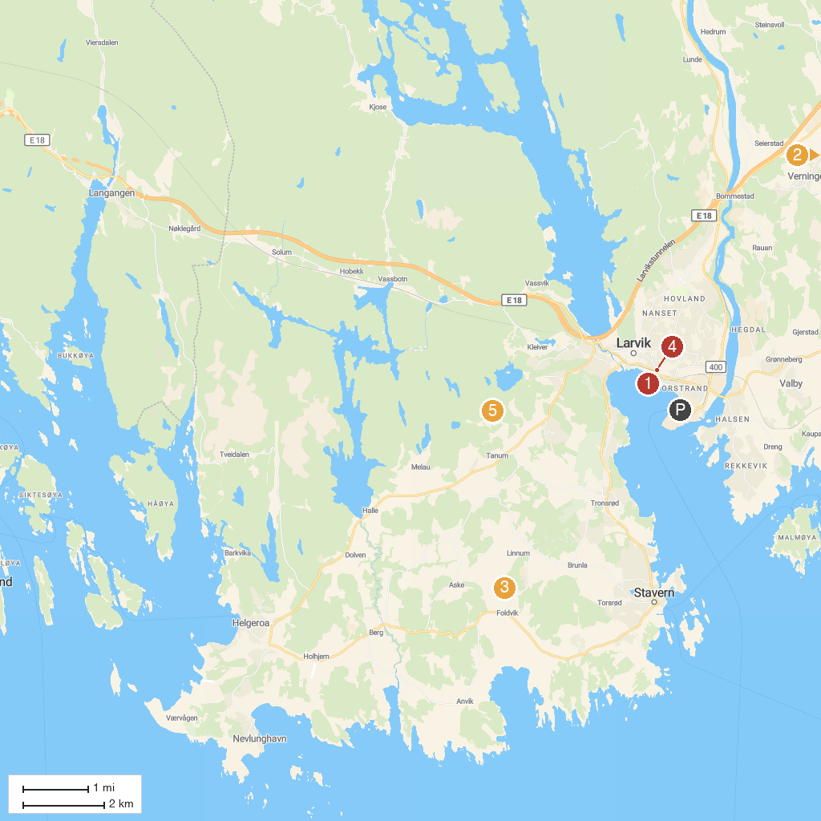
MAP KEY
1. Tollerodden | 5. Hvalfangstmonumentet
2. Istrehågan, Iron age Cemetery | 6. Foldvik Family Park
3. HKB 5/980 Vesterøen | 7. Herregården i Larvik
4. Gokstad Coastal Association | 8. Salsås
P. Cruise port / terminal
Map © MapTiler © OpenStreetMap contributors · cruiseports.org

