Las Palmas, Gran Canaria, Spain
A sun-soaked Atlantic crossroads where Columbus once anchored, Las Palmas pairs a centuries-old colonial quarter with one of Europe's finest city beaches — all within reach of a single shore day.
⚓ Docked (Puerto de la Luz) · 🕒 Typical call: 8-10 hrs · 💵 Euro (€) · 🗣️ Spanish · ☀️ Year-round sunshine
✍️ MY DAY IN PORT (FILL IN)
Ship / Date
In port | arrive ______ · all aboard ______
Booked excursion
Notes / meeting point
GETTING ASHORE
- Docking: Docked at Puerto de la Luz cruise terminal — no tender required
- Walk to centre: ~15 min walk or short taxi to Las Canteras beach; Vegueta old town ~4 km (taxi recommended)
- Best For: History buffs, beach lovers, day trips to Maspalomas dunes
- Don't Miss: Casa de Colón, Playa de Las Canteras, Maspalomas sand dunes
GETTING AROUND
- 🚕 Taxi: €6–€20 — Regulated taxis queue at the port. Short ride to city center (Parque Santa Catalina) is ~€6–€10; old town (Vegueta, ~6 k
- 🚌 Hop-on hop-off: ✅ · from 29
TOP THINGS TO DO
- Maspalomas Dunes & Beach — The rolling sand dunes of Maspalomas in the island's south are a nature reserve unlike anything else in Europe.
- Vegueta Old Town & Casa de Colón — Gran Canaria's historic old quarter — the city's oldest district, founded in 1478 — is where Columbus stopped to repair his ships…
- Roque Nublo & Mountain Interior — Drive up into Gran Canaria's volcanic core to Roque Nublo, an 80-metre volcanic rock monolith whose top sits 1,813 m above sea…
- Playa de Las Canteras — One of Europe's best urban beaches — a 3 km crescent of golden sand protected by a natural reef just a 15-minute walk from the…
- Mercado del Puerto & Canarian Lunch — The Mercado del Puerto food hall near the waterfront is the best place to try papas arrugadas (wrinkled potatoes with mojo…
BEST WALKS
- Las Canteras Promenade Walk: 2.5 km · Flat · 30-45 min · Walk from port — From the port gate head west to the start of Playa de Las Canteras, then stroll the full beachfront…
- Vegueta Old Town Loop: 1.5 km · Flat cobblestones · 1-1.5 hrs · Taxi/bus to start — Start at the Plaza de Santa Ana in front of the cathedral, explore the colonial-era streets, stop…
WEATHER · DAYLIGHT · MONEY
Month | High °F | Low °F | Rainy days
May | 71 | 63 | 6
Jul | 77 | 68 | 2
Sep | 78 | 70 | 5
Daylight: May 7:11AM–8:44PM · Jul 7:15AM–8:59PM · Sep 7:47AM–8:06PM
cruiseports.org/las-palmas · Confirm terminal & all-aboard time with your ship

Las Palmas, Gran Canaria, Spain — Port Map
Red = walkable sights · Amber = excursions farther out · P = cruise terminal
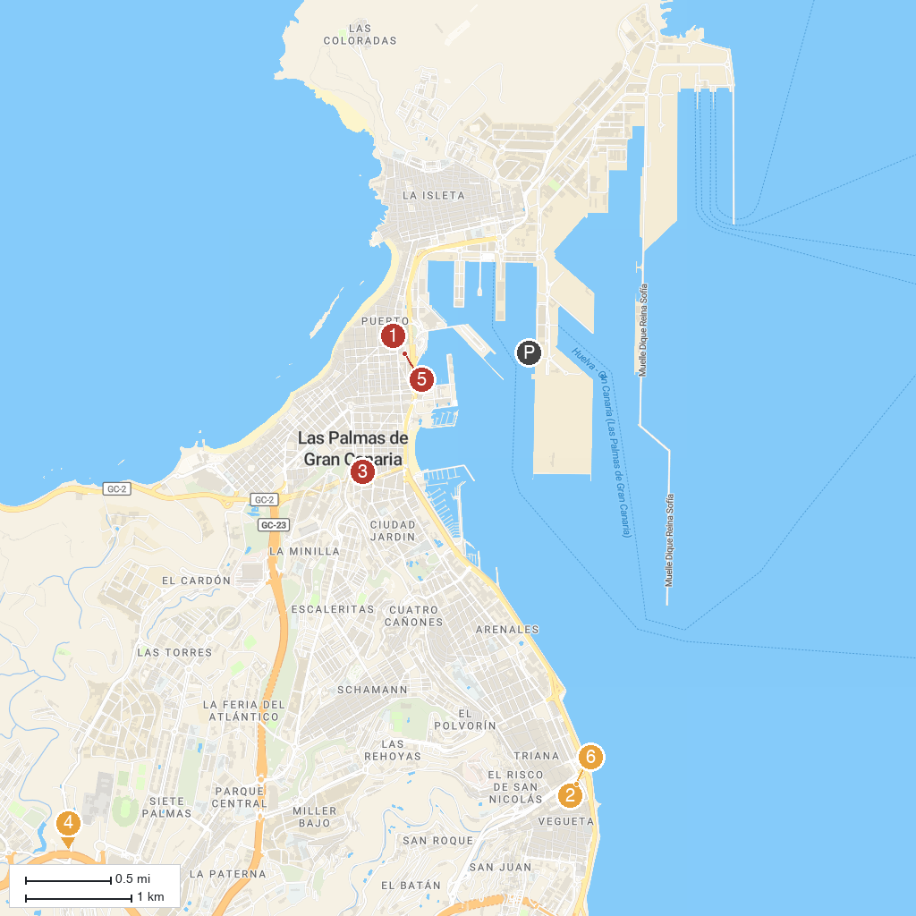
MAP KEY
1. Casa-Museo León y Castillo | 5. Estadio Insular Park
2. Santa Catalina Park | 6. Jardín Botánico Viera y Clavijo
3. Casa de Colón | 7. Casino Las Palmas
4. Real Club de Golf De Las Palmas | 8. Mercado De Vegueta
P. Cruise port / terminal
Map © MapTiler © OpenStreetMap contributors · cruiseports.org

