Lauenburg an der Elbe, Schleswig-Holstein, Germany
Step off the gangway directly into one of Northern Germany's best-preserved river towns — 150 half-timbered houses, a medieval castle tower, and the Elbe flowing right past your feet.
⚓ Pier (riverside quay) · 🕒 Typical call: 5–8 hrs · 💶 Euro (€) — carry cash · 🗣️ German
✍️ MY DAY IN PORT (FILL IN)
Ship / Date
In port | arrive ______ · all aboard ______
Booked excursion
Notes / meeting point
GETTING ASHORE
- Docking: Pier at Ruferplatz, Lower Town — steps from the old town
- Walk to centre: 0–2 min (Lower Town); 10–15 min up to Upper Town
- Best For: Historic architecture, river heritage, leisurely strolling
- Don't Miss: Elbschifffahrtsmuseum & the panoramic view from the Fürstengarten
GETTING AROUND
- 🚕 Taxi: €7–€11 — Local taxis use a €5 base fare plus ~€2.50/km (day rate). The compact town means most rides are 1–2 km, costing roughly
- 📱 Rideshare: ✅ Uber
TOP THINGS TO DO
- Elbschifffahrtsmuseum (Elbe Shipping Museum) — Trace 800 years of Elbe river commerce in this hands-on museum at Elbstraße 59.
- Schlossturm & Fürstengarten Panorama — Climb the sole surviving tower of the medieval Ascanian castle for a bird's-eye view over the Elbe and three German states.
- Elbstraße Half-Timbered House Walk — Stroll Lauenburg's Lower Town main street — the largest continuous ensemble of historic Fachwerk houses in Schleswig-Holstein.
- Paddle Steamer Kaiser Wilhelm (seasonal) — One of the world's last coal-fired paddle steamers, built in 1900 and still running summer weekend excursions.
- Elbe-Lübeck Canal Lock Walk — Walk east along the waterfront to where the historic Elbe-Lübeck Canal meets the Elbe River.
BEST WALKS
- Lower Town Promenade Walk: 1.5 km · 30–45 min · Easy · Flat — From Ruferplatz, walk the length of Elbstraße east toward the canal lock, admiring half-timbered…
- Upper Town Castle Climb: 2.5 km loop · 1–1.5 hrs · Moderate · Steep ascent — From Ruferplatz head up the Kuhberg steps to the Upper Town.
cruiseports.org/lauenburg-elbe · Confirm terminal & all-aboard time with your ship

Lauenburg an der Elbe, Schleswig-Holstein, Germany — Port Map
Red = walkable sights · Amber = excursions farther out · P = cruise terminal
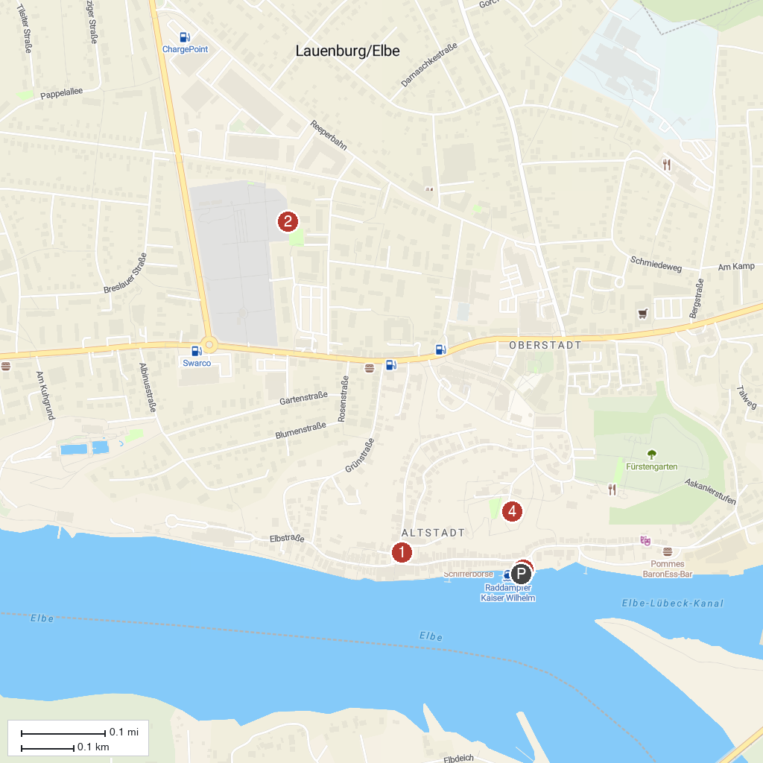
MAP KEY
1. Elbschifffahrtsmuseum | 3. Der Lauenburger Rufer
2. Lauenburg Altstadt | 4. Schloss Lauenburg
P. Cruise port / terminal
Map © MapTiler © OpenStreetMap contributors · cruiseports.org

