Lautoka, Viti Levu, Fiji
Fiji's second city earned its nickname from the sugar cane that perfumes the air — especially during crushing season. Skip the polish of Nadi and discover an everyday Fijian town with soulful Indo-Fijian food, a giant produce market, and easy taxi rides to hot springs and orchid gardens.
⚓ Docked (Queens Wharf) · 🕒 Typical call: 7-9 hrs · 💵 Fijian Dollar (FJD) · 🗣️ English & Fijian
✍️ MY DAY IN PORT (FILL IN)
Ship / Date
In port | arrive ______ · all aboard ______
Booked excursion
Notes / meeting point
GETTING ASHORE
- Docking: Pier — Queens Wharf, working industrial port
- Walk to Center: ~1.5 km, but hot & dusty; take a taxi or shuttle
- Best For: Authentic markets, hot springs, orchid gardens, Indo-Fijian food
- Don't Miss: Lautoka Open-Air Market and Garden of the Sleeping Giant
GETTING AROUND
- 🚕 Taxi: FJ$5–10 to city center — Taxis wait at the port gate and are the most convenient option. Agree on a fare before departing; meters are standard bu
- 📱 Rideshare: ❌ not available
TOP THINGS TO DO
- Garden of the Sleeping Giant — Founded by actor Raymond Burr, this stunning hillside garden holds over 2,000 Asian orchid varieties and a boardwalk through…
- Sabeto Hot Springs & Mud Pool — Slather on warm volcanic mud, let it dry in the sun, then rinse in natural geothermal pools.
- Lautoka Open-Air Market — One of the largest produce markets in the South Pacific — a riot of tropical fruit, fresh coconuts, kava root, and spices.
- Viseisei Village — Said to be the oldest settlement in Fiji and the landing place of the first Fijians.
- Koroyanitu National Heritage Park — Hiking trails through native highland forest with waterfalls and panoramic views toward the Yasawa Islands.
BEST WALKS
- Lautoka City Center Loop: ~2 km · 30-45 min · Easy — Start at the open-air market, walk past Shirley Park waterfront, swing by the Sri Krishna Kaliya…
- Botanical Gardens Stroll: ~1 km · 20 min · Easy — A small, shaded garden near the colonial Governor's Mansion with tropical orchids, lily pond, and a…
WEATHER · DAYLIGHT · MONEY
Month | High °F | Low °F | Rainy days
May | 82 | 72 | 10
Jul | 81 | 69 | 5
Sep | 82 | 70 | 11
Daylight: May 6:27AM–5:45PM · Jul 6:41AM–5:51PM · Sep 6:06AM–6:05PM
cruiseports.org/lautoka · Confirm terminal & all-aboard time with your ship

Lautoka, Viti Levu, Fiji — Port Map
Red = walkable sights · Amber = excursions farther out · P = cruise terminal
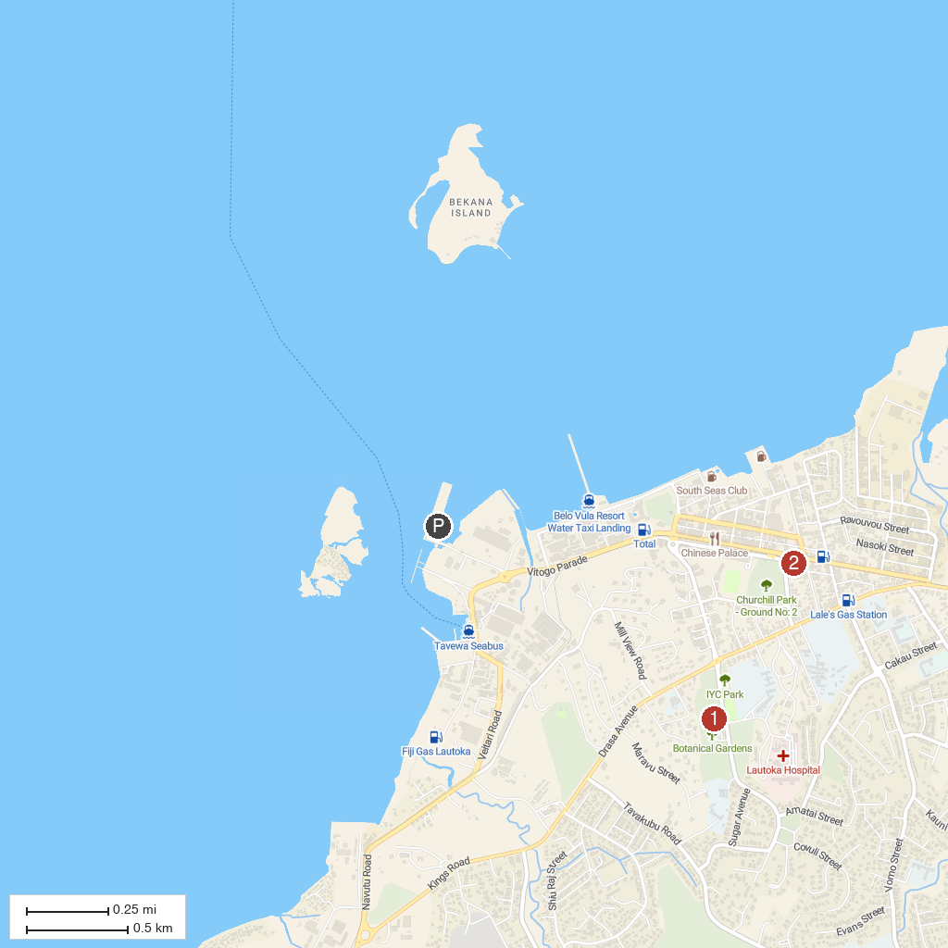
MAP KEY
1. Lautoka Botanical Gardens | 3. Koroyanitu National Heritage Park
2. Lautoka Jame Masjid | 4. Sabeto Hot Springs and Mud Pool
P. Cruise port / terminal
Map © MapTiler © OpenStreetMap contributors · cruiseports.org

