Lavrion, Attica, Greece
A working Attica port with silver-mining history, yacht-marina energy, and the Temple of Poseidon close by. Lavrion is calmer than Piraeus and better suited to a relaxed Sounion-and-seafood shore day.
⚓ Docked (cruise pier) · 🕒 Typical call: 7-10 hrs · 💵 Euro (€) · 🗣️ Greek / English common
✍️ MY DAY IN PORT (FILL IN)
Ship / Date
In port | arrive ______ · all aboard ______
Booked excursion
Notes / meeting point
GETTING ASHORE
- Docking: Ships berth alongside in the port's cruise sector; tendering is unusual
- Walk to center: About 10-15 minutes on foot to the fish market, marina, cafes, and tavernas
- Best For: Cape Sounion, ancient mining history, easy seafood lunch, low-stress Greek town time
- Don't Miss: Temple of Poseidon at Cape Sounion, about 10 km south of the port
GETTING AROUND
- 🚕 Taxi: €60–€70 — Official metered taxis wait outside the port terminal. Daytime fare to central Athens is approximately €65; night rates
- 📱 Rideshare: ✅ Uber
TOP THINGS TO DO
- Temple of Poseidon at Cape Sounion — The region's signature sight: a 5th-century BC temple on a cliff above the Aegean, with open sea views and a dramatic approach…
- Ancient Theater of Thorikos — One of Greece's oldest known stone theaters sits north of Lavrion near the ancient mining area.
- Lavrion Mining Heritage — Lavrion's silver mines helped fund classical Athens, and the town still shows its industrial past in mineral collections…
- KAPE Beach or Passa Limani — For a swim day, head south toward Sounion for clear-water coves and beach-bar options.
- Fish Market Tavernas — Stay in town for grilled octopus, sardines, calamari, Greek salad, and cold beer near the central market and marina.
BEST WALKS
- Port to Fish Market and Marina: 1.5-2 km · 30-45 min · flat · easy — Walk from the cruise berth toward the town center, browse the fish market area, continue along the…
- Lavrion Town Mining Relics: 1-2 km · 30 min · easy town streets — A simple in-town wander for passengers staying close to the ship: look for Lavrion's mining-era…
- Thorikos Ruins: Short site walk · uneven ground · taxi needed — Take a taxi to the Ancient Theater of Thorikos, then walk the open archaeological landscape at your…
cruiseports.org/lavrion · Confirm terminal & all-aboard time with your ship

Lavrion, Attica, Greece — Port Map
Red = walkable sights · Amber = excursions farther out · P = cruise terminal
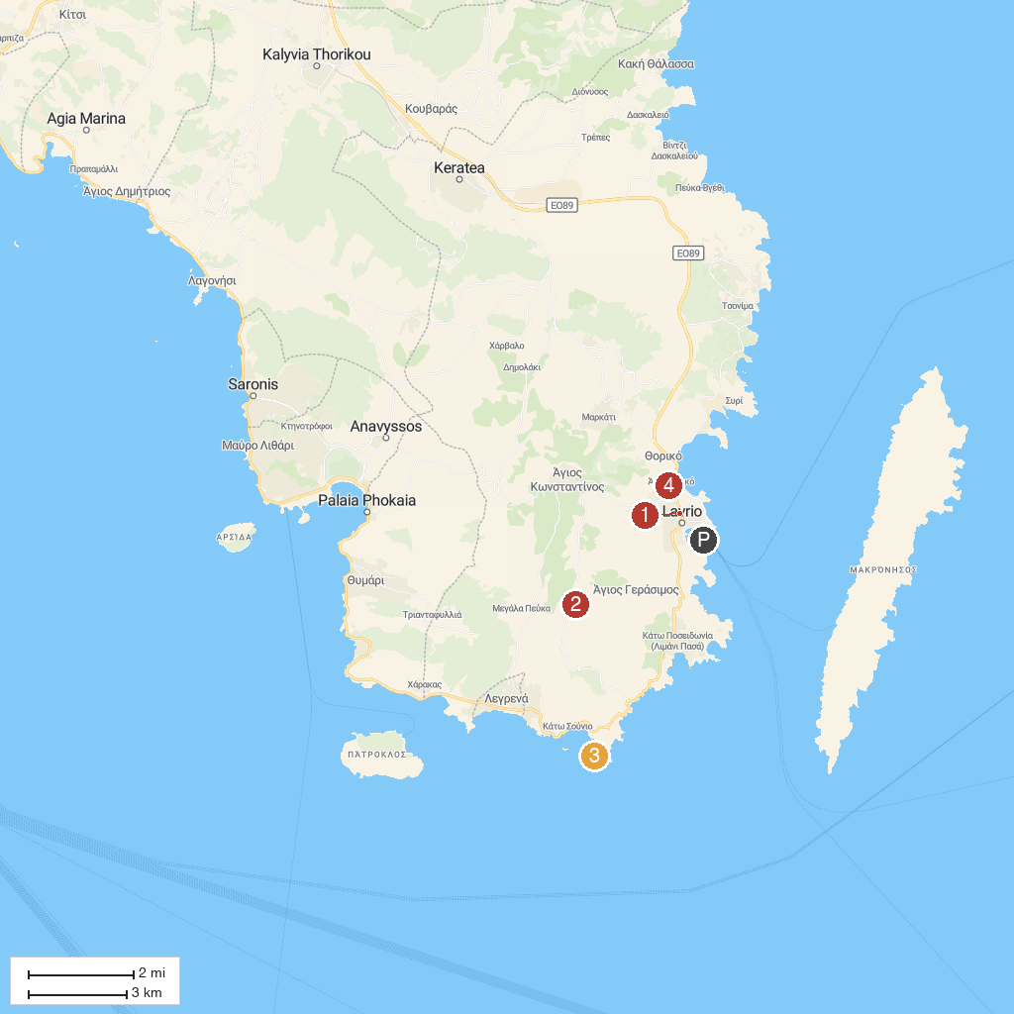
MAP KEY
1. Lavrio Archaeological Museum | 3. Temple of Poseidon at Sounion
2. Ancient Silver Mines of Lavrion | 4. Technological Cultural Park of Lavrion
P. Cruise port / terminal
Map © MapTiler © OpenStreetMap contributors · cruiseports.org

