Le Marin, Martinique, France
The yachting capital of the southern Caribbean, Le Marin pairs a buzzing French marina with white-sand beaches, sugar-cane rum distilleries, and a centuries-old Jesuit church — all poured into an authentic Creole-French island town.
⚓ Tender port (no pier) · 🕒 Typical call: 6-8 hrs · 💶 Currency: Euro (€) · 🗣️ French & Antillean Creole
✍️ MY DAY IN PORT (FILL IN)
Ship / Date
In port | arrive ______ · all aboard ______
Booked excursion
Notes / meeting point
GETTING ASHORE
- Docking: Tender — ships anchor in the bay; tender boats land at Marina du Marin
- Walk to center: 10-15 min from tender dock to town center
- Best For: Beaches, rum tasting, sailing atmosphere, Creole cuisine
- Don't Miss: Grande Anse des Salines (most beautiful beach in Martinique) & Église Saint-Étienne
GETTING AROUND
- 🚕 Taxi: €29–€100+ — Government-regulated taxis are available at the port. Fares to Sainte-Anne run ~€29–€47; Fort-de-France is ~€100. Confir
- 📱 Rideshare: ❌ not available
TOP THINGS TO DO
- Grande Anse des Salines — Often called the most beautiful beach in Martinique, Salines delivers a sweeping arc of golden sand, leaning palms, and views…
- Plage de la Pointe Marin — Calm, shallow, family-friendly beach at the southern entrance to Le Marin bay.
- Distillerie La Mauny Rum Tour — An active agricultural rum distillery in Rivière-Pilote, about 15 min from Le Marin.
- Catamaran Sail & Snorkel — Local operators at the marina offer day sails to Martinique's southern coves, often including snorkel stops, a swim at La…
- Mangrove Kayak Excursion — Paddle through the protected mangrove ecosystem of the Bassin de Carénage — crabs, herons, and tropical fish in a calm, sheltered…
BEST WALKS
- Marina to Town Center: 0.6 mi / 1 km — 10-15 min — Flat — Walk east along the waterfront boulevard from the tender dock through the marina, past waterfront…
WEATHER · DAYLIGHT · MONEY
Month | High °F | Low °F | Rainy days
May | 83 | 78 | 17
Jul | 83 | 78 | 25
Sep | 84 | 79 | 21
Daylight: May 5:36AM–6:23PM · Jul 5:42AM–6:36PM · Sep 5:52AM–6:04PM
cruiseports.org/le-marin · Confirm terminal & all-aboard time with your ship

Le Marin, Martinique, France — Port Map
Red = walkable sights · Amber = excursions farther out · P = cruise terminal
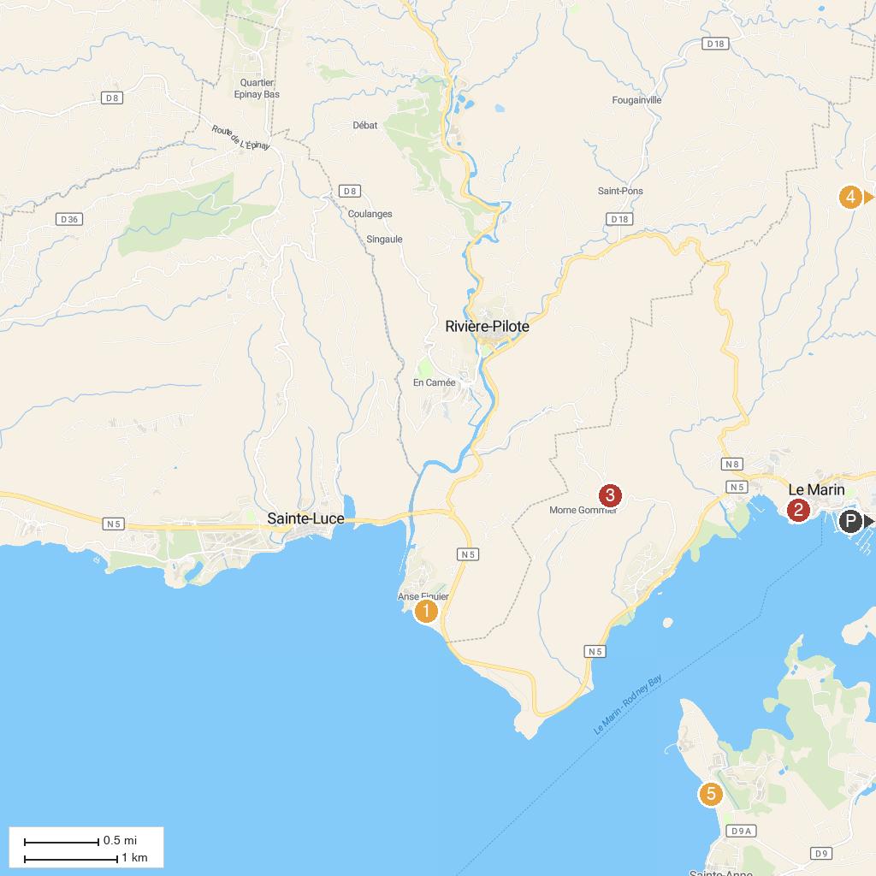
MAP KEY
1. Ecomuseum of Martinique | 4. Jardin Creole Ecotours
2. Église Saint-Étienne du Marin | 5. Plage Municipale de Sainte-Anne
3. Point de vue du Morne Gommier
P. Cruise port / terminal
Map © MapTiler © OpenStreetMap contributors · cruiseports.org

