Limassol, Cyprus
Cyprus's cosmopolitan harbour city pairs a magnificent ancient coastline — Aphrodite's mythic birthplace, hilltop Kourion, Crusader castles — with a lively promenade, excellent wine, and one of the eastern Med's most capable cruise terminals.
⚓ Docked (cruise terminal) · 🕒 Typical call: 8-10 hrs · 💶 Euro (EUR) · 🗣️ Greek (English widely spoken)
✍️ MY DAY IN PORT (FILL IN)
Ship / Date
In port | arrive ______ · all aboard ______
Booked excursion
Notes / meeting point
GETTING ASHORE
- Docking: Alongside at Limassol Cruise Terminal (DP World), New Port — no tendering
- Walk to center: 3-4 km to Old Town; shuttle bus or taxi recommended
- Best For: Ancient ruins, medieval history, wine tasting, beach days
- Don't Miss: Kourion Archaeological Site and Aphrodite's Rock (Petra tou Romiou)
GETTING AROUND
- 🚕 Taxi: €6–€8 — Metered taxis are plentiful at the cruise terminal. The city center is 3–4 km away; day rate fares typically run €6–€8.
- 📱 Rideshare: ✅ Bolt
- 🚌 Hop-on hop-off: ✅ · from 15
TOP THINGS TO DO
- Kourion Archaeological Site — One of Cyprus's crown jewels: a Greco-Roman city perched on a cliff above the sea.
- Aphrodite's Rock (Petra tou Romiou) — The legendary birthplace of Aphrodite — a dramatic sea stack rising from turquoise water on the coastal highway.
- Limassol Old Town & Castle — The 16th-century Limassol Castle — where Richard the Lionheart married Berengaria of Navarre — houses the Cyprus Medieval Museum.
- Troodos Wine Villages (Omodos) — Head into the Troodos foothills to the UNESCO-listed village of Omodos — cobblestone streets, the Monastery of the Holy Cross…
- Limassol Marina & Molos Promenade — A self-guided walk along the palm-lined Molos seafront promenade to the luxury Limassol Marina — superyachts and boutique cafes.
BEST WALKS
- Old Town to Molos Promenade: 2.5 km · 30-40 min · Flat & easy — From Limassol Castle, walk east through the Old Town market streets, past the Old Port, and along…
- Amathus Ancient City Ruins: Self-guided · 1 hr on site · 11 km east of center — The ruins of ancient Amathus sit right beside the coast road — an open-air site with an agora and…
WEATHER · DAYLIGHT · MONEY
Month | High °F | Low °F | Rainy days
May | 79 | 64 | 3
Jul | 90 | 75 | 0
Sep | 87 | 73 | 0
Daylight: May 5:45AM–7:43PM · Jul 5:46AM–8:01PM · Sep 6:31AM–6:54PM
cruiseports.org/limassol · Confirm terminal & all-aboard time with your ship

Limassol, Cyprus — Port Map
Red = walkable sights · Amber = excursions farther out · P = cruise terminal
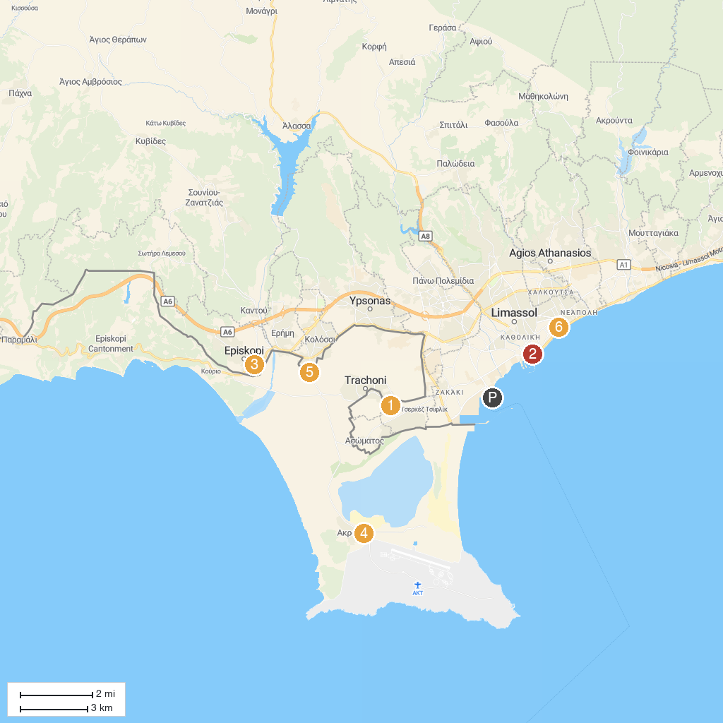
MAP KEY
1. Fasouri Watermania Waterpark | 5. Κourion Ancient Amphitheater
2. Lemesos Castle - Cyprus Medieval Museum | 6. Kolossi Castle
3. Arizona Luna Park | 7. Limassol Municipal Garden
4. Akrotiri Environmental Education Centre | 8. Archaeological Site of Amathous
P. Cruise port / terminal
Map © MapTiler © OpenStreetMap contributors · cruiseports.org

