Lisbon, Portugal
Pastel hills, hand-painted tiles, soulful fado, and the world's best custard tarts — from the main terminal, Alfama's medieval lanes rise directly above your gangway.
⚓ Docked (no tendering) · 🕒 Typical call: 8–12 hrs · 💶 Euro (EUR) · 🗣️ Portuguese · English widely spoken
✍️ MY DAY IN PORT (FILL IN)
Ship / Date
In port | arrive ______ · all aboard ______
Booked excursion
Notes / meeting point
GETTING ASHORE
- Docking: Santa Apolónia or Alcântara terminal
- To Alfama: 10–15 min walk (Santa Apolónia)
- Best For: Tiles · Trams · Tarts · History
- Don't Miss: Belém & pastéis de nata
GETTING AROUND
- 🚕 Taxi: €10–€15 — Official metered taxis queue outside the terminals. Journey to Praça do Comércio or Baixa takes 10–20 minutes depending
- 📱 Rideshare: ✅ Uber, Bolt
- 🚌 Hop-on hop-off: ✅ · from €47
TOP THINGS TO DO
- Alfama & São Jorge Castle — Lisbon's oldest quarter — tangled lanes, viewpoint miradouros, the Sé Cathedral (1147), and the Moorish hilltop castle.
- Belém — Tower, Monastery & Pastéis — UNESCO Jerónimos Monastery and Belém Tower flank the river, plus the Monument to the Discoveries and the original Pastéis de…
- Historic Tram 28 Ride — The quintessential Lisbon experience — a vintage yellow tram grinding through Graça, Alfama, and Estrela.
- Sintra Palaces Day Trip — Fairytale palaces in misty hills 40 min from Lisbon — the colorful Pena Palace and the mystical Quinta da Regaleira with its…
- Lisbon Food & Wine Tour — Sample pastéis de nata, petiscos (Portuguese tapas), ginjinha cherry liqueur, bacalhau (salt cod), and local wines in Baixa and…
BEST WALKS
- Terminal → Alfama → Portas do Sol viewpoint: ~2 km · 1.5 hrs · moderate (hilly) — Climb straight from the gangway into Alfama's ancient lanes to the Portas do Sol and Santa Luzia…
- Baixa & Praça do Comércio waterfront: ~2 km · 1–1.5 hrs · easy (flat) — Flat, grand downtown: the vast riverfront Praça do Comércio, the triumphal Rua Augusta arch, and…
- Belém waterfront walk: ~2.5 km · 1.5 hrs · easy (flat) — If docking at Alcântara or arriving by Tram 15E, stroll the scenic Tagus riverside from the…
WEATHER · DAYLIGHT · MONEY
Month | High °F | Low °F | Rainy days
May | 73 | 58 | 5
Jul | 81 | 65 | 1
Sep | 78 | 64 | 5
Daylight: May 6:24AM–8:41PM · Jul 6:24AM–9:00PM · Sep 7:18AM–7:44PM
cruiseports.org/lisbon · Confirm terminal & all-aboard time with your ship

Lisbon, Portugal — Port Map
Red = walkable sights · Amber = excursions farther out · P = cruise terminal
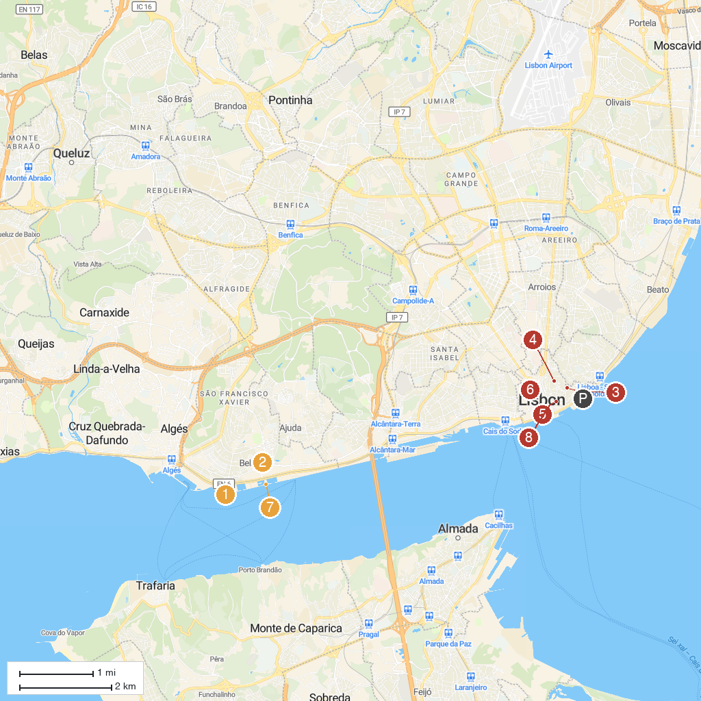
MAP KEY
1. Torre de Belém | 5. Praça do Comércio
2. Mosteiro dos Jerónimos | 6. Elevador de Santa Justa
3. Alfama | 7. Padrão dos Descobrimentos
4. Castelo de São Jorge | 8. Sé de Lisboa
P. Cruise port / terminal
Map © MapTiler © OpenStreetMap contributors · cruiseports.org

