Greenwich, London, England
Greenwich is where the world's time begins and Britain's seafaring history comes alive. Tender ashore to a UNESCO World Heritage Site, then hop a Thames river boat for Big Ben in under 40 minutes.
⚓ Tender port · 🕒 Typical call: 8-12 hrs · 💷 Currency: British Pound (GBP) — go cashless, contactless everywhere · 🗣️ Language: English · 🏛️ UNESCO World Heritage Site
✍️ MY DAY IN PORT (FILL IN)
Ship / Date
In port | arrive ______ · all aboard ______
Booked excursion
Notes / meeting point
GETTING ASHORE
- Docking: Tender — ships moor at Greenwich Ship Tier (mid-river); ~5-min tender to Greenwich Pier
- Walk to centre: Cutty Sark 1 min · Greenwich Market 3 min · Royal Observatory 15-20 min (steep hill)
- Best For: History, maritime heritage, easy day trip to central London
- Don't Miss: Standing on the Prime Meridian line at the Royal Observatory
GETTING AROUND
- 🚕 Taxi: £55–£70 — Licensed black cabs queue at Greenwich Pier for cruise passengers. Fixed-fare private transfers to Central London also a
- 📱 Rideshare: ✅ Uber, Bolt
- 🚌 Hop-on hop-off: ✅
TOP THINGS TO DO
- Royal Observatory & Prime Meridian — Climb Greenwich Park's hill to stand astride the Prime Meridian at longitude 0°.
- Cutty Sark & Old Royal Naval College — Step aboard the world's only surviving Victorian tea clipper — walk the decks and beneath the copper-clad hull.
- National Maritime Museum & Queen's House — Free entry to the world's largest maritime museum, featuring Admiral Nelson's bullet-holed coat and a gilded royal barge.
- London City Day Trip via Thames Clipper — Ride the scenic Uber Boat river bus from Greenwich Pier past Canary Wharf and the Tower of London to Westminster.
- Greenwich Market & Historic Pubs — Greenwich Market operates daily under its Victorian roof with global street food stalls — Ethiopian, Asian noodles, Portuguese…
BEST WALKS
- Greenwich Heritage Loop: 2.5 km · ~1 hr · Easy to moderate — Walk from the pier past the Cutty Sark, through the grounds of the Old Royal Naval College, into…
- Riverside Stroll to the Trafalgar Tavern: 1 km · ~20 min · Easy — Head east along the riverbank from the pier, past the old Greenwich Power Station and the classical…
WEATHER · DAYLIGHT · MONEY
Month | High °F | Low °F | Rainy days
May | 63 | 46 | 9
Jul | 72 | 54 | 9
Sep | 67 | 50 | 9
Daylight: May 5:08AM–8:45PM · Jul 5:03AM–9:12PM · Sep 6:38AM–7:15PM
cruiseports.org/london-greenwich · Confirm terminal & all-aboard time with your ship

Greenwich, London, England — Port Map
Red = walkable sights · Amber = excursions farther out · P = cruise terminal
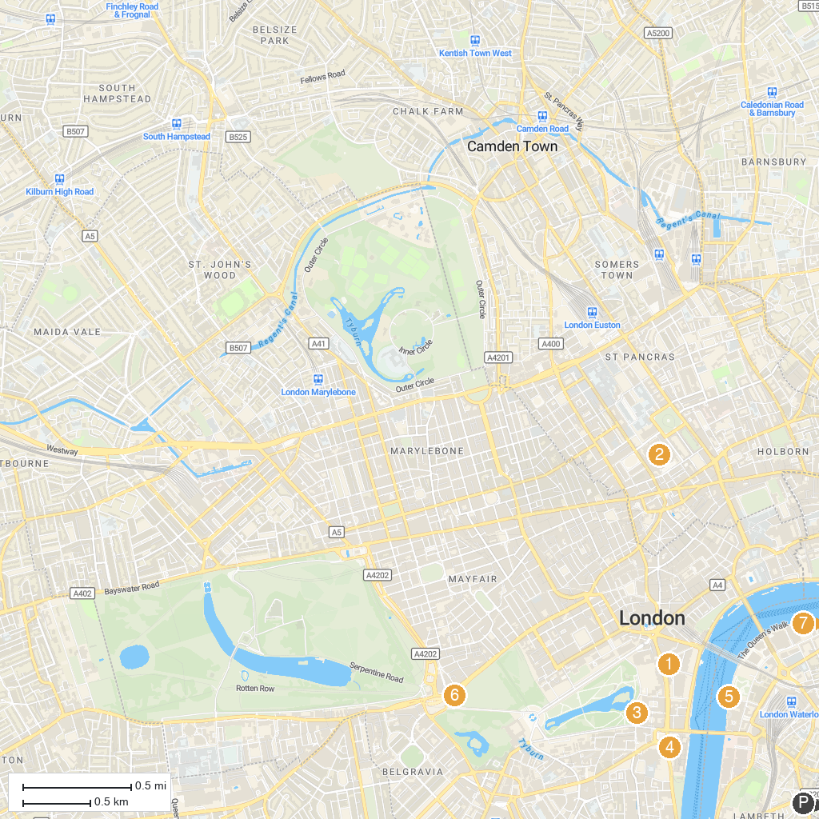
MAP KEY
1. Old War Office Building | 5. Statue of Oliver Cromwell
2. Primrose Hill | 6. London Eye
3. The British Museum | 7. Bomber Command Memorial
4. Churchill War Rooms | 8. Tower of London
P. Cruise port / terminal
Map © MapTiler © OpenStreetMap contributors · cruiseports.org

