Tilbury, Essex, England
London's only deep-water purpose-built cruise terminal sits 22 miles east of the capital on the historic Thames — the same dock where the Empire Windrush arrived in 1948 and Elizabeth I rallied her troops against the Armada.
⚓ Pier (no tendering) · 🕒 Typical call: 8–10 hrs · 💷 British Pound (£) · 🗣️ English · 🚂 Train to London: ~45 min
✍️ MY DAY IN PORT (FILL IN)
Ship / Date
In port | arrive ______ · all aboard ______
Booked excursion
Notes / meeting point
GETTING ASHORE
- Docking: Pier — ships dock alongside a 348 m floating stage; no tender needed
- Walk to London: Not walkable — take the c2c train from Tilbury Town (1 mi from pier) to London Fenchurch Street, ~45 min
- Best For: London sightseeing, Tudor history at Tilbury Fort
- Don't Miss: Tilbury Fort, the 17th-century artillery fortress a short walk from the terminal, and the Tower of London by train
GETTING AROUND
- 🚕 Taxi: £10–£20 — Local Thurrock taxis and minicabs (e.g. Grays Cab Line, Thurrock Taxi Cab) cover nearby towns. Pre-booking is recommende
- 📱 Rideshare: ✅ Uber
TOP THINGS TO DO
- London City Highlights — Take the c2c train to Fenchurch Street and walk 5 minutes to the Tower of London and Tower Bridge.
- Tilbury Fort — A 17th-century artillery fortress built to defend London from seaborne attack — Elizabeth I gave her famous Armada speech near…
- Greenwich by Train — Connect via London to Greenwich for the Cutty Sark, the Royal Observatory and the Prime Meridian, the National Maritime Museum…
- Black Cab London Tour — Private London Black Cab tours pick up at the terminal and cover the major landmarks — Buckingham Palace, Big Ben, Tower Bridge…
- Windsor Castle — A full-day excursion to Windsor Castle, the oldest and largest occupied castle in the world and an official residence of the…
BEST WALKS
- Terminal to Tilbury Fort: 0.8 mi | 15 min | Flat riverside path — Exit the terminal and follow the Thames riverfront path east.
- Tower of London Riverside (in London): ~1 mi | Flat | After the train into town — From Fenchurch Street it's a 5-minute walk to the Tower of London.
WEATHER · DAYLIGHT · MONEY
Month | High °F | Low °F | Rainy days
May | 62 | 47 | 11
Jul | 73 | 58 | 11
Sep | 67 | 54 | 9
Daylight: May 5:07AM–8:43PM · Jul 4:59AM–9:08PM · Sep 6:34AM–7:12PM
cruiseports.org/london-tilbury · Confirm terminal & all-aboard time with your ship

Tilbury, Essex, England — Port Map
Red = walkable sights · Amber = excursions farther out · P = cruise terminal
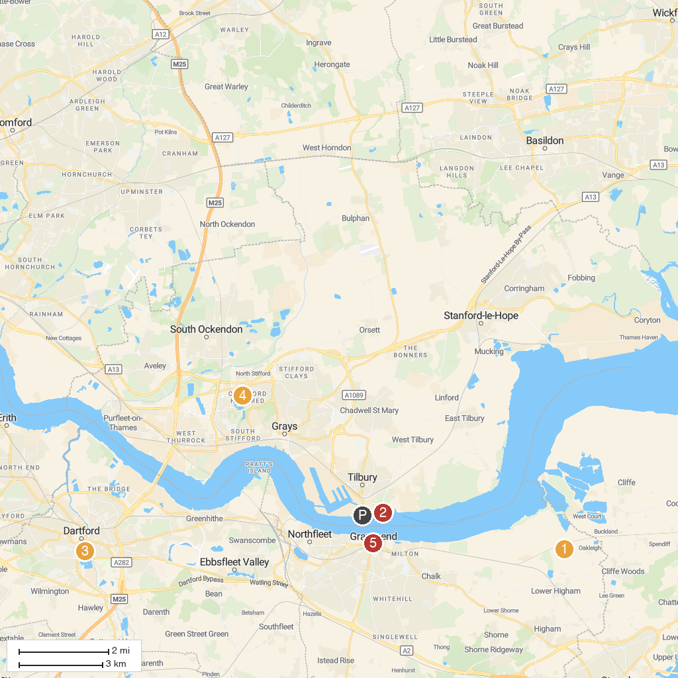
MAP KEY
1. St Mary's Church | 5. Rochester Castle
2. Tilbury Fort | 6. Fort Amherst Heritage Trust
3. HMS Ocelot | 7. Chafford Gorges Nature Park
4. Central Park | 8. Heritage Quarter
P. Cruise port / terminal
Map © MapTiler © OpenStreetMap contributors · cruiseports.org

