Lorient, Brittany, France
Lorient is Brittany's maritime powerhouse — rebuilt from WWII rubble into a modern sailing capital, with colossal U-boat bunkers, a world-class sailing museum, and a water bus to a sun-drenched island just offshore.
⚓ Pier (commercial quay) · 🕒 Typical call: 8-10 hrs · 💶 Euro (€) · 🗣️ French (some English at tourist sites) · 🚢 Shuttle to city center
✍️ MY DAY IN PORT (FILL IN)
Ship / Date
In port | arrive ______ · all aboard ______
Booked excursion
Notes / meeting point
GETTING ASHORE
- Docking: Pier — Quai de Kergroise commercial port; shuttle to center
- Walk to Center: ~2 km (25 min flat walk) or free/low-cost shuttle
- Best For: WWII history, sailing culture, island day trips, Breton food
- Don't Miss: Keroman Submarine Base (La Base) and Cité de la Voile Éric Tabarly
GETTING AROUND
- 🚕 Taxi: €15–€20 — Taxis from the port to city center take about 10–15 minutes. Stands are available at the port entrance or you can book b
- 📱 Rideshare: ✅ Uber, Bolt
TOP THINGS TO DO
- Keroman Submarine Base (La Base) — The most intact WWII German U-boat base in the world.
- Cité de la Voile Éric Tabarly — France's premier interactive sailing museum, dedicated to offshore racing legend Éric Tabarly and the world of ocean competition.
- Île de Groix Day Trip — A 45-min ferry from Lorient drops you on this car-free Breton island with wild Atlantic beaches, coastal hiking trails, and the…
- Port-Louis Citadel & East India Company Museum — Cross the harbor by water bus (about €1.50) to the 16th-century Spanish-built citadel at Port-Louis.
- Carnac Megaliths — Some 3,000 prehistoric standing stones stretching across the landscape — the largest megalithic site on earth.
BEST WALKS
- City Center & Marina Stroll: 1.5 km • Flat • 30 min — From the city center shuttle drop-off near Hôtel de Ville, walk down to the Port de Plaisance…
- La Base Waterfront Walk: 1 km circuit • Easy • 30 min — After visiting La Base, walk the perimeter of the K-bunkers along the waterfront.
WEATHER · DAYLIGHT · MONEY
Month | High °F | Low °F | Rainy days
May | 63 | 51 | 12
Jul | 71 | 60 | 8
Sep | 68 | 57 | 8
Daylight: May 6:35AM–9:44PM · Jul 6:31AM–10:07PM · Sep 7:51AM–8:25PM
cruiseports.org/lorient · Confirm terminal & all-aboard time with your ship

Lorient, Brittany, France — Port Map
Red = walkable sights · Amber = excursions farther out · P = cruise terminal
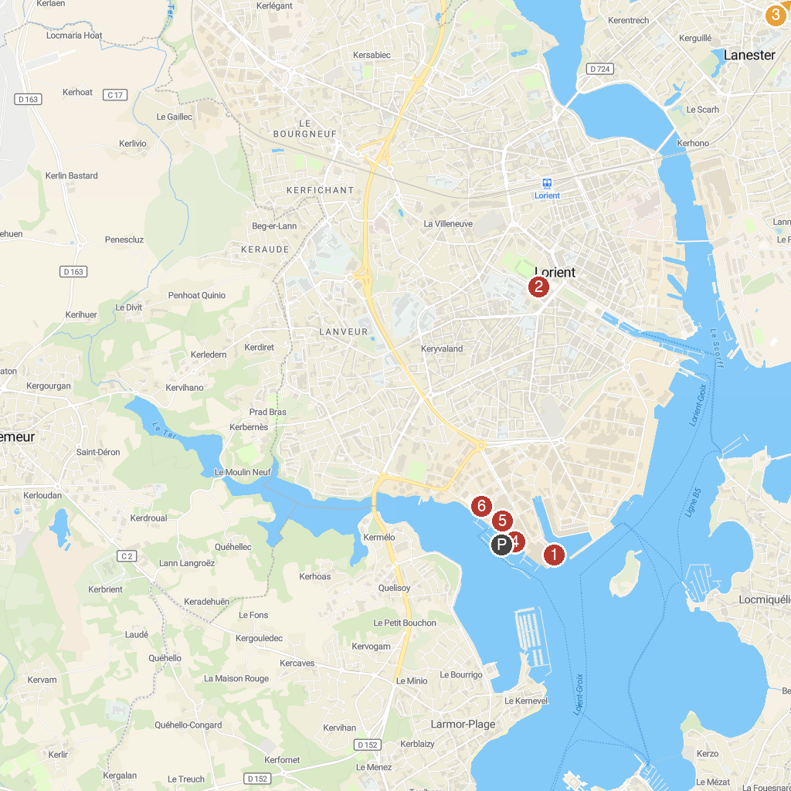
MAP KEY
1. Base de Sous-Marins | 5. Sous-marin Flore-S645
2. Aquatic Centre du Moustoir | 6. Pouldu House Museum in the footsteps of Gauguin
3. National Haras of Hennebont | 7. Cité de la Voile Eric Tabarly
4. Submarine Museum of Lorient | 8. Beach Bellangenet
P. Cruise port / terminal
Map © MapTiler © OpenStreetMap contributors · cruiseports.org

