Ludwigshafen am Rhein, Rhineland-Palatinate, Germany
An industrial Rhine city that punches above its weight — with a world-class art museum, a buzzy waterfront mall, and a direct line to Heidelberg's romantic castle just 20 minutes away.
⚓ Docked (river pier) · 🕒 Typical call: 8–10 hrs · 💶 Currency: Euro (€) · 🗣️ Language: German · 🍷 Palatinate wine country nearby
✍️ MY DAY IN PORT (FILL IN)
Ship / Date
In port | arrive ______ · all aboard ______
Booked excursion
Notes / meeting point
GETTING ASHORE
- Docking: River cruise pier on the Rhine, walk-off directly
- Walk to Centre: Rhein-Galerie mall ~5 min on foot; city centre ~10 min
- Best For: Day trip to Heidelberg, wine tasting, art lovers
- Don't Miss: Wilhelm Hack Museum's giant Joan Miró facade mosaic
GETTING AROUND
- 🚕 Taxi: €10–20 — Taxis are available at the port. Short city-center rides run €10–15; cross-river trips to Mannheim cost roughly €15–20.
- 📱 Rideshare: ✅ Uber, Bolt
TOP THINGS TO DO
- Heidelberg Castle & Old Town — Germany's most romantic ruin looms above a perfectly preserved baroque old town on the Neckar River.
- Wilhelm Hack Museum — A heavyweight modern-art collection — Mondrian, Kandinsky, Lichtenstein, Warhol — in a museum best known for its colossal 55 m…
- Palatinate Wine & Village Tour — The Deutsche Weinstraße (German Wine Route) passes through rolling vineyards just south of the city.
- Mannheim Baroque Palace — Just across the Rhine bridge, Mannheim's vast baroque palace — one of the largest in Europe — houses a university today but opens…
- Rhine Promenade & Ebert Park Stroll — Follow the revitalised Rheinufer promenade north from the pier past cafes, sculptures, and river views.
BEST WALKS
- Rhine Promenade Walk: 2.5 km · 35 min · Flat — From the pier, head north along the Rhine promenade past the Rhein-Galerie, riverside cafes, and…
- City Centre & Art Loop: 3 km · 45 min · Flat — From the waterfront, walk inland past Berliner Platz to the Wilhelm Hack Museum, then loop back via…
WEATHER · DAYLIGHT · MONEY
Month | High °F | Low °F | Rainy days
May | 67 | 50 | 11
Jul | 80 | 61 | 11
Sep | 71 | 54 | 9
Daylight: May 5:42AM–9:03PM · Jul 5:36AM–9:27PM · Sep 7:02AM–7:38PM
cruiseports.org/ludwigshafen-am-rhein · Confirm terminal & all-aboard time with your ship

Ludwigshafen am Rhein, Rhineland-Palatinate, Germany — Port Map
Red = walkable sights · Amber = excursions farther out · P = cruise terminal
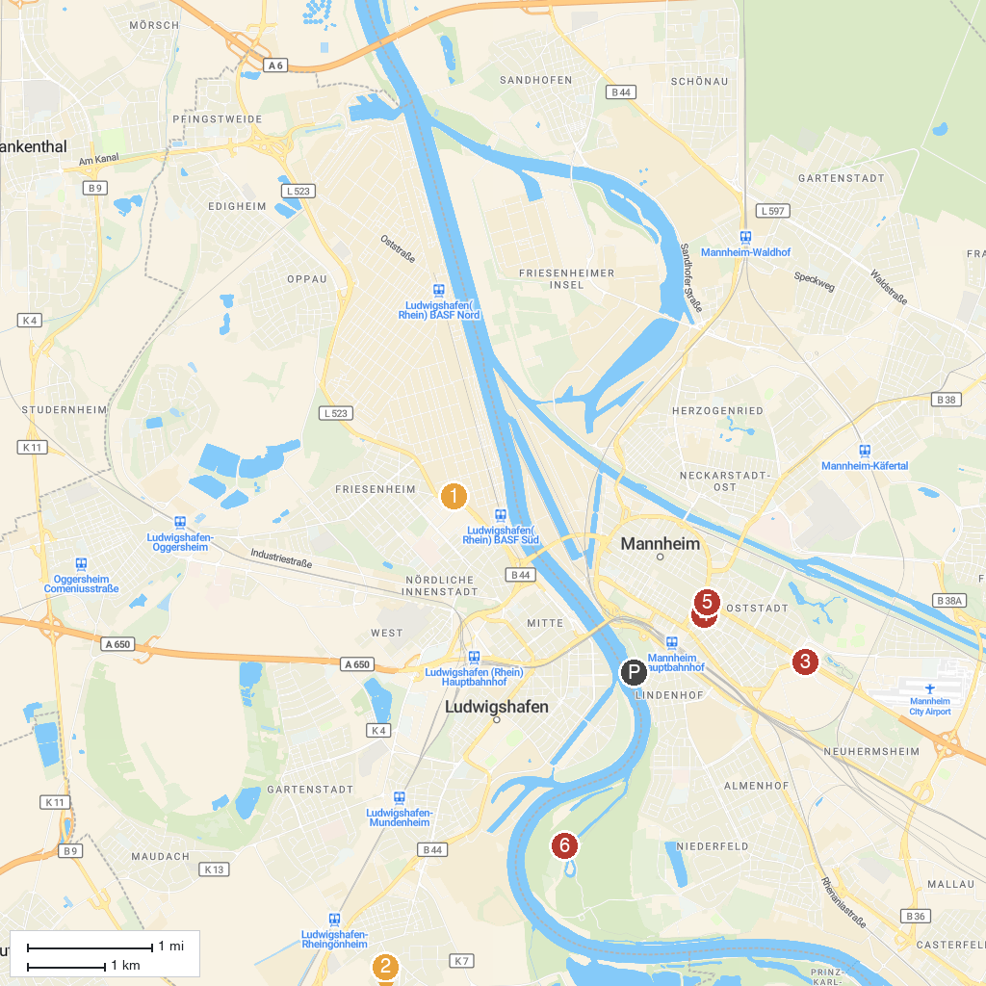
MAP KEY
1. Mosque in The Palace Garden | 5. Planetarium Mannheim
2. BASF Visitor Center | 6. Kunsthalle Mannheim
3. WBL - Wild Park Rheingönheim | 7. Wasserturm Mannheim
4. Schwetzingen Palace | 8. Reißinsel
P. Cruise port / terminal
Map © MapTiler © OpenStreetMap contributors · cruiseports.org

