Luxembourg City, Luxembourg
Perched on sheer sandstone cliffs above two river canyons, Luxembourg City is the Grand Duchy's capital — a UNESCO World Heritage fortress town where medieval casemates, free glass elevators, and world-class dining coexist in surprising harmony.
⚓ River cruise (Moselle dock towns) · 🕒 Typical call: 7-9 hrs · 💵 Currency: Euro (€) · 🗣️ Languages: Luxembourgish, French, German, English · 🚌 Free public transport nationwide
✍️ MY DAY IN PORT (FILL IN)
Ship / Date
In port | arrive ______ · all aboard ______
Booked excursion
Notes / meeting point
GETTING ASHORE
- Docking: River ships moor at Grevenmacher or Remich (~30 min by coach to city)
- Walk to center: Not walkable from dock — bus or coach transfer required
- Best For: History, UNESCO fortifications, wine, European culture
- Don't Miss: Chemin de la Corniche & the Bock Casemates
GETTING AROUND
- 🚕 Taxi: €90–120 — Taxis from the main Moselle mooring at Remich (approx. 22 km). Per-vehicle fare; best shared among 3–4 passengers.
- 📱 Rideshare: ✅ Uber
- 🚌 Hop-on hop-off: ✅
TOP THINGS TO DO
- Bock Casemates — Seventeen kilometers of subterranean tunnels carved into the sandstone cliffs, once housing up to 1,200 soldiers along with…
- Chemin de la Corniche Walk — Often called 'Europe's most beautiful balcony,' this free pedestrian promenade runs along the top of the ancient ramparts with…
- The Grund Neighbourhood — A quiet fairytale valley of 14th-century stone houses, small bridges, and weeping willows hugging the Alzette River — feels like…
- Grand Ducal Palace & Notre-Dame Cathedral — The official town residence of Grand Duke Henri flanks the old town center.
- MUDAM — Museum of Modern Art — Designed by I.M.
BEST WALKS
- Old Town & Corniche Loop: 2–3 km · 1-2 hrs · Easy (use free lifts for descent) — Start at Place Guillaume II, walk to the Grand Ducal Palace, then follow the Chemin de la Corniche…
WEATHER · DAYLIGHT · MONEY
Month | High °F | Low °F | Rainy days
May | 63 | 46 | 12
Jul | 74 | 56 | 10
Sep | 67 | 50 | 9
Daylight: May 5:50AM–9:13PM · Jul 5:44AM–9:37PM · Sep 7:11AM–7:48PM
cruiseports.org/luxembourg-city · Confirm terminal & all-aboard time with your ship

Luxembourg City, Luxembourg — Port Map
Red = walkable sights · Amber = excursions farther out · P = cruise terminal
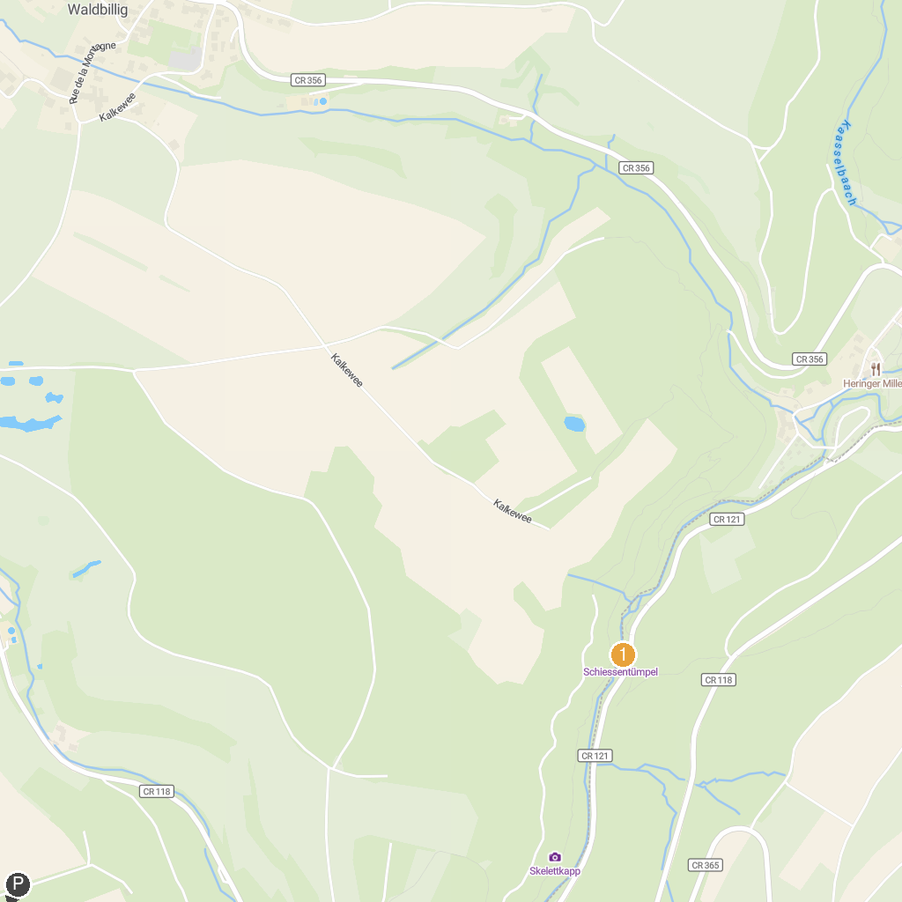
MAP KEY
1. Mudam Museum of Modern Art | 5. Musée d'Histoire(s) Diekirch
2. Château de Septfontaines | 6. Useldange Castle
3. Schiessentümpel Waterfall | 7. Aquatower Berdorf
4. Musée Automobile - Conservatoire National de Véhicules Historiques | 8. Pont Grande-Duchesse Charlotte
P. Cruise port / terminal
Map © MapTiler © OpenStreetMap contributors · cruiseports.org

