Lysekil, Västra Götaland, Sweden
Sweden's west-coast gem perched where the Gullmarn Fjord meets the Skagerrak — a quiet town of pink granite cliffs, colourful wooden houses, and world-class cold-water seafood.
⚓ Pier (most ships) or tender (large vessels) · 🕒 Typical call: 6–8 hrs · 💵 Swedish Krona (SEK) — nearly cashless · 🗣️ Swedish (English spoken universally)
✍️ MY DAY IN PORT (FILL IN)
Ship / Date
In port | arrive ______ · all aboard ______
Booked excursion
Notes / meeting point
GETTING ASHORE
- Docking: Pier at Anderssons Kaj, South Harbour; very large ships may anchor and tender
- Walk to centre: ~1.3 km from pier, flat 15-min stroll
- Best For: Coastal scenery, fresh seafood, relaxed Swedish town charm
- Don't Miss: Stångehuvud Nature Reserve and a räkmacka (shrimp sandwich) on the harbour
GETTING AROUND
- 🚕 Taxi: €7–11 — Local taxis available at the port; ~5-minute ride to town center. Best for those preferring not to walk or carrying lugg
TOP THINGS TO DO
- Stångehuvud Nature Reserve — The must-do in Lysekil.
- Seal Safari by Boat — Local operators run 2-hour archipelago boat trips to spot harbour seals basking on outer skerries.
- Havets Hus — House of the Sea — One of Scandinavia's finest saltwater aquariums, right on the waterfront.
- Ferry to Fiskebäckskil — Board the passenger ferry Carl Wilhelmson for a ~15-minute crossing of the Gullmarn Fjord to the postcard village of…
- Gamlestan & Lysekil Church — Wander 19th-century wooden houses in Gamlestan (Old Town), then climb to the neo-Gothic church — one of Bohuslän's largest, built…
BEST WALKS
- Harbour to Old Town & Lysekil Church: 2 km · 30–40 min · Easy — From the South Harbour, head north along the waterfront to Norra Hamnen promenade, then weave…
- Town Centre to Stångehuvud Nature Reserve: 4 km round trip · 1–1.5 hrs · Moderate — Head west from Kungstorget along Stångevägen to reach the reserve.
WEATHER · DAYLIGHT · MONEY
Month | High °F | Low °F | Rainy days
May | 59 | 46 | 12
Jul | 68 | 58 | 13
Sep | 62 | 53 | 14
Daylight: May 4:48AM–9:34PM · Jul 4:33AM–10:05PM · Sep 6:44AM–7:33PM
cruiseports.org/lysekil · Confirm terminal & all-aboard time with your ship

Lysekil, Västra Götaland, Sweden — Port Map
Red = walkable sights · Amber = excursions farther out · P = cruise terminal
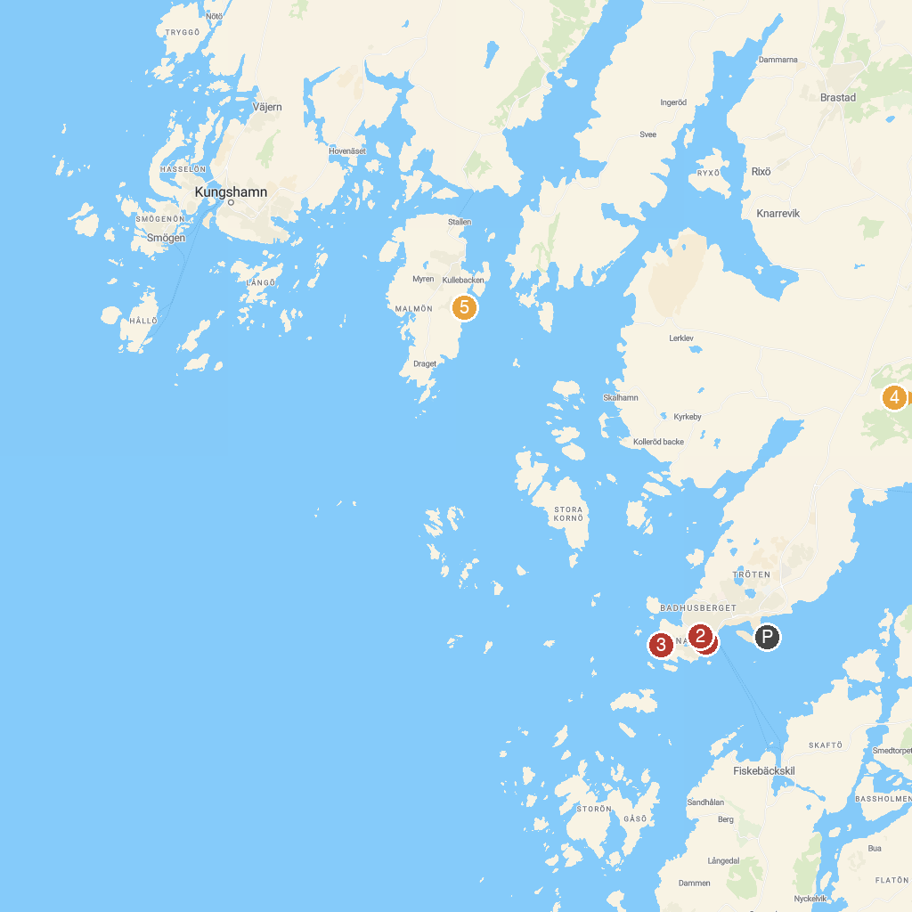
MAP KEY
1. Lysekils Kyrka | 4. Backa Rock Carvings
2. Lysekils utsiktstorn | 5. Dykplats Fossen Camping
3. Stångehuvuds nature reserve | 6. Pärlane strand
P. Cruise port / terminal
Map © MapTiler © OpenStreetMap contributors · cruiseports.org

