Mackinac Island, Michigan, USA
No cars, no rush — just horse-drawn carriages, a 660-foot Victorian porch, and the sweetest fudge in the Great Lakes. Mackinac Island is a living time capsule that cruise passengers adore.
⚓ Tender (anchor offshore) · 🕒 Typical call: 6–8 hrs · 💵 USD · 🗣️ English · 🚲 Bike-friendly island
✍️ MY DAY IN PORT (FILL IN)
Ship / Date
In port | arrive ______ · all aboard ______
Booked excursion
Notes / meeting point
GETTING ASHORE
- Docking: Tender — ships anchor in the straits; small boats ferry you to the island dock
- Walk to center: 0 min — tender drops you on Main Street
- Best For: History lovers, cyclists, fudge fans, horse-carriage rides
- Don't Miss: Fort Mackinac, the Grand Hotel porch, and a warm fudge sample from Murdick's
GETTING AROUND
- 🚕 Taxi: $9–$12 per adult — Radio-dispatched horse-drawn cabs operate 24 hours daily in summer. Must be called — cannot be hailed. Cash only; half-p
- 📱 Rideshare: ❌ not available
TOP THINGS TO DO
- Horse-Drawn Carriage Island Tour — The classic Mackinac experience — a 1.5–2 hour guided carriage tour stops at Arch Rock, the Avenue of Flags, Surrey Hill, and the…
- Fort Mackinac — Built by the British during the American Revolution, this preserved fort sits on the island's limestone bluffs with sweeping…
- Bike the M-185 Perimeter Loop — M-185 is the only motor-vehicle-free state highway in the USA.
- The Grand Hotel — Since 1887, the Grand Hotel's 660-foot porch — the world's longest — has defined Mackinac elegance.
- Mackinac Island Fudge Trail — Watch fudge-makers throw and shape warm slabs of fudge on cold marble through large shop windows — then sample.
BEST WALKS
- Waterfront to Fort Mackinac: 0.3 miles / 10–15 min uphill | Easy–Moderate — Walk from the tender dock up Market Street to Marquette Park, then climb the stairs or ramp to Fort…
- Main Street Fudge & Shopping Stroll: 0.5 miles / 20–30 min | Easy — Walk the length of Main Street from the ferry docks west toward Market Street, ducking into fudge…
WEATHER · DAYLIGHT · MONEY
Month | High °F | Low °F | Rainy days
May | 47 | 39 | 10
Jul | 67 | 60 | 9
Sep | 63 | 56 | 11
Daylight: May 6:06AM–9:03PM · Jul 6:03AM–9:24PM · Sep 7:17AM–7:48PM
cruiseports.org/mackinac-island · Confirm terminal & all-aboard time with your ship

Mackinac Island, Michigan, USA — Port Map
Red = walkable sights · Amber = excursions farther out · P = cruise terminal
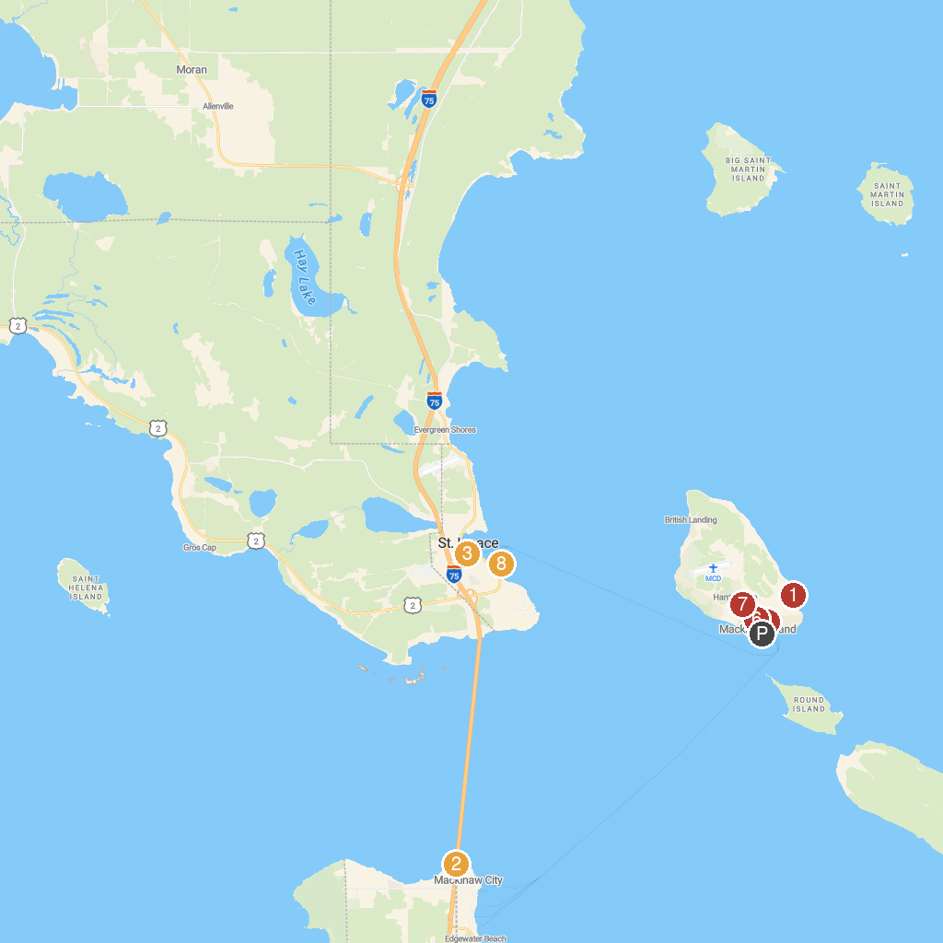
MAP KEY
1. Arch Rock | 5. Marquette Park
2. Colonial Michilimackinac | 6. Michigan Governor's Summer Residence
3. Fort de Buade Museum | 7. Wings of Mackinac
4. 3D Maze of Mirrors | 8. Wawatam Lighthouse
P. Cruise port / terminal
Map © MapTiler © OpenStreetMap contributors · cruiseports.org

