Magdalen Islands, Quebec, Canada
A windswept archipelago in the Gulf of St. Lawrence, the Magdalen Islands stun with crimson sandstone cliffs, endless white-sand beaches, and a fiercely proud Acadian fishing culture that shows up on every plate.
⚓ Pier (small ships) / Tender (large ships) · 🕒 Typical call: 8-10 hrs · 💵 Canadian Dollar (CAD) · 🗣️ French (English widely spoken) · 🌬️ Windy — dress in layers
✍️ MY DAY IN PORT (FILL IN)
Ship / Date
In port | arrive ______ · all aboard ______
Booked excursion
Notes / meeting point
GETTING ASHORE
- Docking: Small/expedition ships dock at Cap-aux-Meules pier; large ships tender from anchor
- Walk to center: 5-10 min from pier/tender dock to Cap-aux-Meules town center
- Best For: Beaches, sea caves, local seafood, Acadian culture
- Don't Miss: Pot-en-pot seafood pie, sea-cave kayaking, La Grave historic site
GETTING AROUND
- 🚕 Taxi: CAD $15–$30+ — Taxis (Taxi Des Iles) meet ships at Cap-aux-Meules dock. Fares are relatively high due to island distances; sharing with
- 📱 Rideshare: ❌ not available
TOP THINGS TO DO
- Sea-Cave Kayaking — Paddle into the spectacular red sandstone arches and caves carved into the cliffs of Cap-aux-Meules Island.
- La Grave Historic Site — The archipelago's oldest commercial fishing site (Havre-Aubert Island) and a designated Quebec heritage site, La Grave is a…
- Dune du Sud Beach & Red Cliffs — Drive to Havre-aux-Maisons for this sheltered beach backed by dramatic red sandstone cliffs honeycombed with tidal caves.
- Seafood & Artisan Tasting — The islands produce some of Canada's finest lobster, Pied-de-Vent cheese, smoked herring from Fumoir d'Antan, and craft beer at À…
- Entry Island Hike — The only inhabited island not connected by road, English-speaking Entry Island looks like a piece of Scottish Highlands dropped…
BEST WALKS
- Sentier du Littoral — Coastal Trail: 3 km · Easy · 45-60 min — A paved coastal path from the Cap-aux-Meules waterfront winding south along the cliffs.
- Cap-aux-Meules Town Stroll: 1.5 km · Easy · 30 min — Walk the town center from the pier to Gourmande de Nature bistro for local lunch or gelato, browse…
WEATHER · DAYLIGHT · MONEY
Month | High °F | Low °F | Rainy days
May | 44 | 39 | 12
Jul | 64 | 60 | 11
Sep | 62 | 57 | 11
Daylight: May 5:30AM–8:37PM · Jul 5:26AM–8:59PM · Sep 6:45AM–7:18PM
cruiseports.org/madeleine-magdalen-islands · Confirm terminal & all-aboard time with your ship

Magdalen Islands, Quebec, Canada — Port Map
Red = walkable sights · Amber = excursions farther out · P = cruise terminal
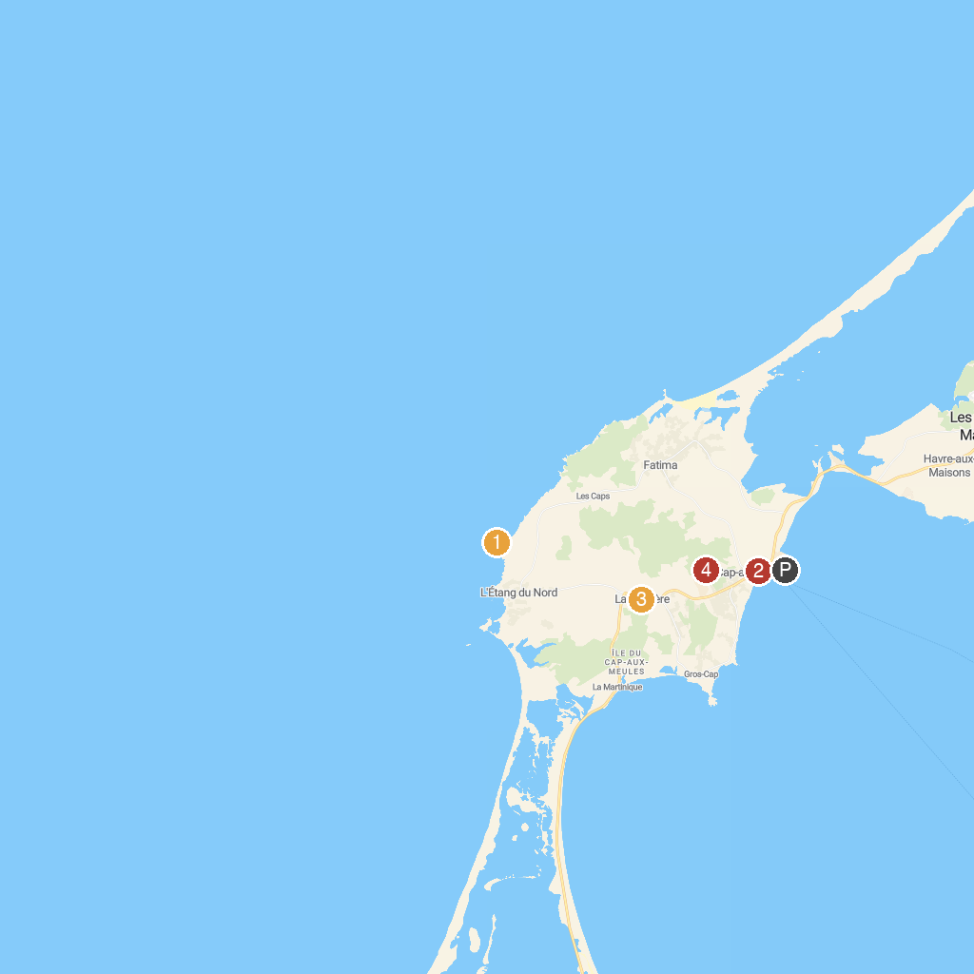
MAP KEY
1. Cape Lighthouse | 3. Église catholique de Saint-Pierre-de-La Vernière
2. Concours des Châteaux de Sable des Iles de la Madeleine | 4. Parc des Buck
P. Cruise port / terminal
Map © MapTiler © OpenStreetMap contributors · cruiseports.org

