Málaga, Andalusia, Spain
Picasso's birthplace sits beneath a Moorish fortress, Roman theatre at its base — and you're already in the thick of it. The Alhambra is two hours away if you plan ahead; Ronda's clifftop gorge is closer.
⚓ Docked (pier — no tendering) · 🕒 Typical call: 8–10 hrs · 💶 Euro (EUR) · 🗣️ Spanish · English widely spoken
✍️ MY DAY IN PORT (FILL IN)
Ship / Date
In port | arrive ______ · all aboard ______
Booked excursion
Notes / meeting point
GETTING ASHORE
- Docking: Terminals A/B (Muelle de Levante) or Palmeral/Muelle Uno
- To Calle Larios: 10 min (Muelle Uno) · 25 min or shuttle (Terminals A/B)
- Best For: History · Art · Andalusia day trips
- Don't Miss: Alcazaba, Picasso Museum, Atarazanas Market
GETTING AROUND
- 🚕 Taxi: €9–€12 — Official taxis queue just outside the cruise terminal. The ride to Plaza de la Marina (city center) takes about 10 minut
- 📱 Rideshare: ✅ Uber, Bolt, Cabify
- 🚌 Hop-on hop-off: ✅ City Sightseeing Málaga
TOP THINGS TO DO
- Alcazaba & Gibralfaro Castle — Málaga's 11th-century Moorish fortress is one of the best-preserved in Spain, with layered ramparts, garden courtyards, and city…
- Picasso Museum & Casa Natal — The Museo Picasso Málaga occupies the 16th-century Palacio de Buenavista and holds 200+ works donated by Picasso's family…
- Granada & the Alhambra — The Alhambra palace complex — Nasrid palaces, Generalife gardens, Alcazaba fortress — is 90 minutes by road.
- Ronda — Clifftop City & Puente Nuevo — Perched above a 100-metre gorge, Ronda is one of Andalusia's most dramatic towns.
- El Caminito del Rey — A spectacular restored cliff path through the El Chorro gorge, about 50 km north of Málaga.
BEST WALKS
- Waterfront to Alcazaba loop: ~3 km · 1.5–2 hrs · easy to moderate (uphill at end) — Walk west along the Palmeral promenade into Plaza de la Marina, up Calle Marqués de Larios to the…
- Old town art & tapas circuit: ~2.5 km · 1.5 hrs · easy — From Calle Larios through the Cathedral square, to the Picasso Museum on Calle San Agustín, then to…
- Seafront stroll to La Malagueta: ~1.5 km · 30 min · easy, flat — A flat walk east from Muelle Uno along the Paseo Marítimo to Málaga's main urban beach.
WEATHER · DAYLIGHT · MONEY
Month | High °F | Low °F | Rainy days
May | 75 | 62 | 4
Jul | 87 | 73 | 0
Sep | 81 | 69 | 4
Daylight: May 7:10AM–9:18PM · Jul 7:10AM–9:36PM · Sep 8:00AM–8:24PM
cruiseports.org/malaga · Confirm terminal & all-aboard time with your ship

Málaga, Andalusia, Spain — Port Map
Red = walkable sights · Amber = excursions farther out · P = cruise terminal
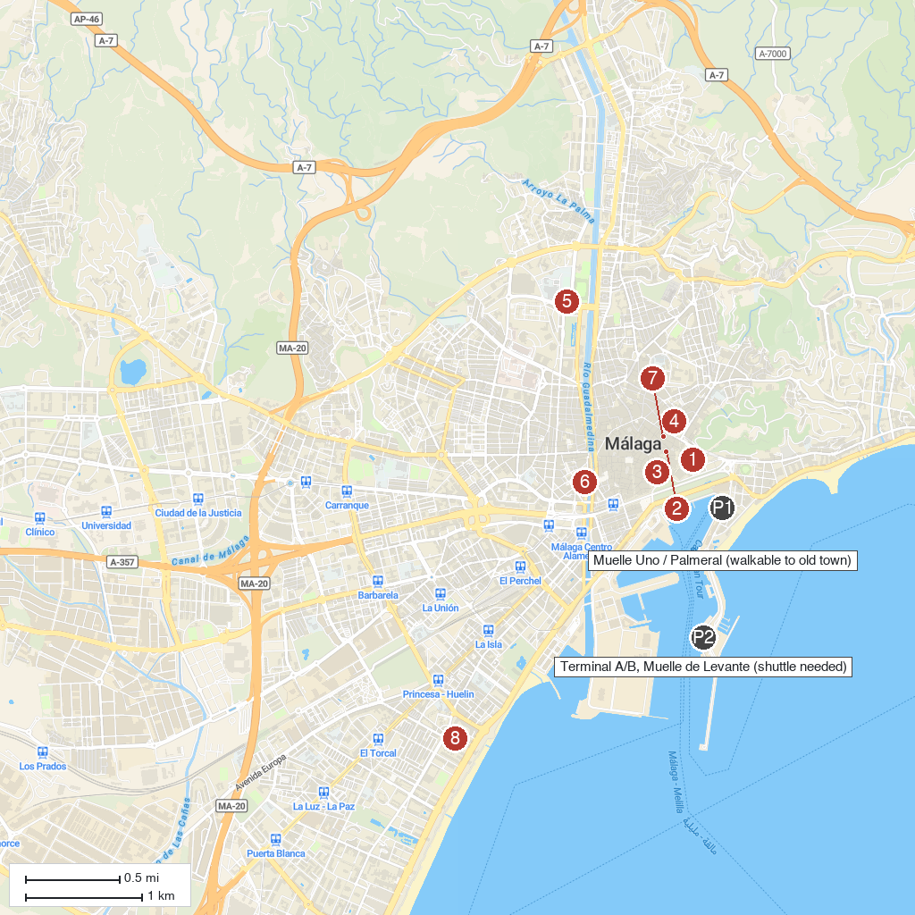
MAP KEY
1. Alcazaba | 5. Principia Science Center
2. Museo Picasso Málaga | 6. Iglesia de Santo Domingo de Guzmán
3. Santa Iglesia Catedral Basílica de la Encarnación de Málaga | 7. El Hammam Open Space & SPA
4. Museo Casa Natal de Picasso | 8. Museo Automovilístico de Málaga
P. Cruise port / terminal
Map © MapTiler © OpenStreetMap contributors · cruiseports.org

