Malmö, Skåne, Sweden
Once a shipbuilding giant, Malmö has reinvented itself as a forward-thinking, multicultural city where a medieval castle sits beside futuristic architecture — all connected to Copenhagen by one of Europe's most iconic bridges.
⚓ Pier (Frihamnen) · 🕒 Typical call: 8-10 hrs · 💵 Swedish Krona (SEK) — nearly cashless · 🗣️ Swedish (English widely spoken) · 🌉 35 min to Copenhagen by train
✍️ MY DAY IN PORT (FILL IN)
Ship / Date
In port | arrive ______ · all aboard ______
Booked excursion
Notes / meeting point
GETTING ASHORE
- Docking: Pier — Frihamnen (Freeport), berths 601/602
- Walk to Center: ~1.5 km / 15-20 min walk — easily walkable, or take the shuttle
- Best For: Architecture, history, beaches, cross-border day trip to Copenhagen
- Don't Miss: Turning Torso, Ribersborg beach sauna, Malmöhus Castle
GETTING AROUND
- 🚕 Taxi: SEK 120–150 to city center — Short ride (~2–3 km) to the city. Agree on a fixed price before departing; metered fares start at SEK 62.50 plus SEK 28/
- 📱 Rideshare: ✅ Uber, Bolt
TOP THINGS TO DO
- Malmöhus Castle & Museums — The oldest surviving Renaissance castle in the Nordic countries houses the Malmö Museum, an art collection, and a small aquarium…
- Västra Hamnen & Turning Torso — Walk the Western Harbour's waterfront boardwalk past innovative sustainable architecture.
- Ribersborg Beach & Kallbadhus Sauna — Malmö's beloved 2.5 km sandy beach is a short walk from the castle.
- Lilla Torg & Old Town Wander — Malmö's little square is ringed by colourful 16th-century half-timbered houses and buzzing café terraces.
- Day Trip to Copenhagen — Malmö's greatest party trick: Copenhagen is 35 minutes by train across the Öresund Bridge.
BEST WALKS
- City Centre to Ribersborg Beach Loop: ~5 km | 1.5-2 hrs | Easy, flat — From Stortorget, head west through Kungsparken to Malmöhus Castle, then continue along the canal to…
- Lilla Torg to Västra Hamnen Waterfront: ~3 km one way | 1 hr | Easy — Stroll from Malmö's charming medieval square through the city to the award-winning sustainable…
WEATHER · DAYLIGHT · MONEY
Month | High °F | Low °F | Rainy days
May | 59 | 48 | 10
Jul | 70 | 59 | 12
Sep | 64 | 55 | 11
Daylight: May 4:57AM–9:12PM · Jul 4:46AM–9:41PM · Sep 6:40AM–7:24PM
cruiseports.org/malmo · Confirm terminal & all-aboard time with your ship

Malmö, Skåne, Sweden — Port Map
Red = walkable sights · Amber = excursions farther out · P = cruise terminal
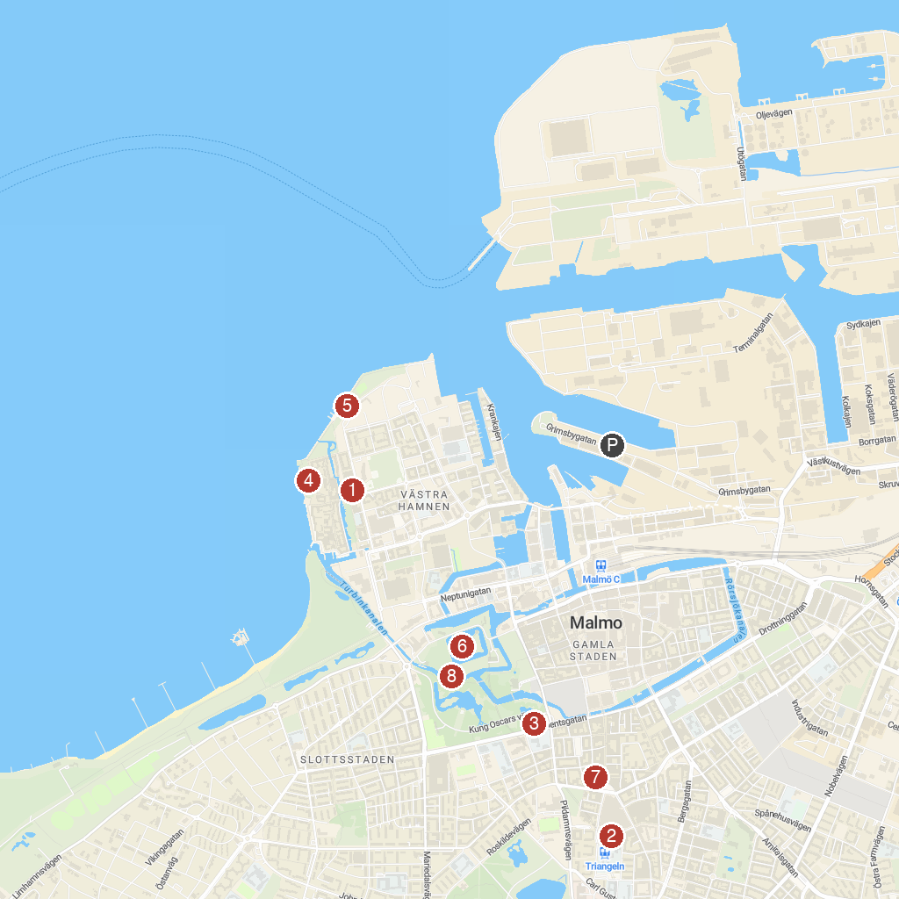
MAP KEY
1. Turning Torso | 5. Scaniaparken
2. St. John's Church | 6. Malmo Museum
3. Malmö City Library | 7. The Alley
4. Dania Park | 8. Castle Mill
P. Cruise port / terminal
Map © MapTiler © OpenStreetMap contributors · cruiseports.org

