Mannheim, Baden-Württemberg, Germany
Where Carl Benz built the first car and Karl Drais invented the bicycle, Mannheim's unique chessboard street grid and monumental Baroque palace make it one of the Rhine's most underrated stops.
⚓ Docked (river pier) · 🕒 Typical call: 8-10 hrs · 💶 Currency: Euro (€) · 🗣️ Language: German · 🚊 Tram network available
✍️ MY DAY IN PORT (FILL IN)
Ship / Date
In port | arrive ______ · all aboard ______
Booked excursion
Notes / meeting point
GETTING ASHORE
- Docking: River pier — no tender. Ships dock at Rhine or Neckar quay, walkable to center.
- Walk to center: 15–25 min on foot to Wasserturm; tram available from quay.
- Best For: History, innovation, Baroque architecture, day trip to Heidelberg.
- Don't Miss: Spaghettieis at Eis Fontanella — the original inventor's family still serves it.
GETTING AROUND
- 🚕 Taxi: €8–15 to city center — Taxis are metered (start ~€3.80 + ~€2/km). Short ride from the dock to the central Paradeplatz area.
- 📱 Rideshare: ✅ Uber, Bolt
TOP THINGS TO DO
- Mannheim Baroque Palace — One of Europe's largest Baroque palaces (second only to Versailles), the Schloss anchors the city grid.
- Wasserturm & Friedrichsplatz — Mannheim's signature landmark: a 60-metre Neo-Baroque water tower (1886–1889) set within one of Europe's grandest Art Nouveau…
- Luisenpark — Consistently voted one of Europe's most beautiful parks: Chinese tea house (the largest in Europe), butterfly house, gondoletta…
- Technoseum — Birthplace of the Car & Bicycle — Mannheim is where Karl Drais built the world's first bicycle (1817) and Carl Benz unveiled the first automobile (1885).
- Reiss-Engelhorn Museums — Four interconnected museum buildings with 1.2 million objects spanning world cultures, archaeology, antiquity, and art history…
BEST WALKS
- Grid City Stroll: Palace to Wasserturm: ⏱ 45–60 min · 🚶 Flat · 📷 Highlights — Walk Mannheim's famous chessboard centre from the Baroque Palace at the A1 anchor all the way…
- Neckar Riverside Walk: ⏱ 30–45 min · 🌊 Waterfront · ☀️ Relaxed — A leafy stroll along the Neckarwiese, Mannheim's massive riverside meadow.
WEATHER · DAYLIGHT · MONEY
Month | High °F | Low °F | Rainy days
May | 67 | 50 | 11
Jul | 80 | 61 | 11
Sep | 71 | 54 | 9
Daylight: May 5:42AM–9:03PM · Jul 5:36AM–9:27PM · Sep 7:02AM–7:38PM
cruiseports.org/mannheim · Confirm terminal & all-aboard time with your ship

Mannheim, Baden-Württemberg, Germany — Port Map
Red = walkable sights · Amber = excursions farther out · P = cruise terminal
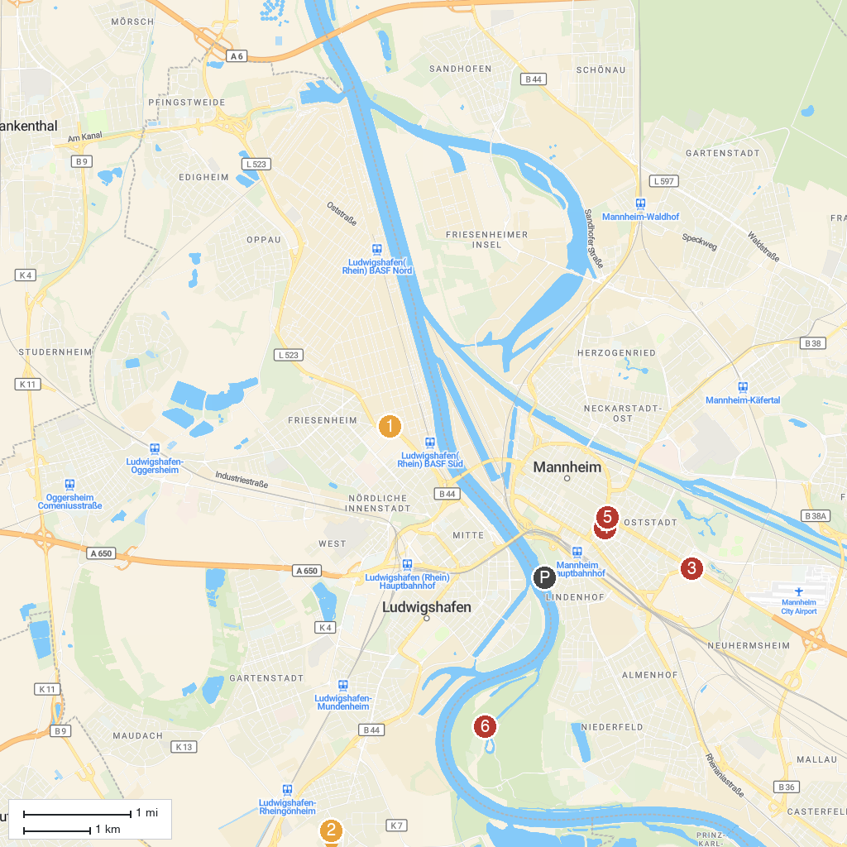
MAP KEY
1. Mosque in The Palace Garden | 5. Planetarium Mannheim
2. BASF Visitor Center | 6. Kunsthalle Mannheim
3. Schwetzingen Palace | 7. Wasserturm Mannheim
4. WBL - Wild Park Rheingönheim | 8. Reißinsel
P. Cruise port / terminal
Map © MapTiler © OpenStreetMap contributors · cruiseports.org

