Manta, Ecuador
Ecuador's tuna capital and Pacific gateway — a laid-back port city backed by cloud-forest reserves, where the world's finest hats are woven by hand in a nearby hilltop village.
⚓ Docked at Puerto de Manta cruise terminal · 🕒 Typical call: 7–9 hrs · 💵 US Dollar (USD) — Ecuador uses American currency · 🗣️ Spanish · English limited outside hotels
✍️ MY DAY IN PORT (FILL IN)
Ship / Date
In port | arrive ______ · all aboard ______
Booked excursion
Notes / meeting point
GETTING ASHORE
- Docking: Puerto de Manta cruise terminal
- To center: 5-min walk to Malecón / Playa El Murciélago
- Best For: Culture · Beaches · Cloud Forest
- Don't Miss: Montecristi Panama hat workshops
GETTING AROUND
- 🚕 Taxi: $1.50–$5 USD — Official yellow taxis wait outside the port terminal and at Plaza Cívica. Fares are low but agree on the price before yo
- 📱 Rideshare: ✅ Uber
TOP THINGS TO DO
- Montecristi — Birthplace of the Panama Hat — Despite the name, the Panama hat was always Ecuadorian — named after the canal workers who wore them.
- Pacoche Cloud Forest — Howler Monkeys & Mist — The Pacoche Marine and Coastal Wildlife Refuge is one of the last coastal cloud forests in Ecuador.
- Tuna Fleet & Fish Market Tour — Manta is Ecuador's undisputed tuna capital — the largest tuna-fishing fleet on the Pacific coast operates from this harbor.
- Playa El Murciélago & the Malecón — Playa El Murciélago (Bat Beach) is Manta's signature urban beach — a long crescent of dark Pacific sand backed by the lively…
BEST WALKS
- Malecón & Playa El Murciélago Stroll: 1.5 km · 30 min · Easy — Walk north along the Malecón esplanade from the cruise terminal to Playa El Murciélago.
- Tarqui Fish Market & Artisan Docks: 2 km · 45 min · Easy — Head east along the harbor to the Tarqui fishing district, where the tuna fleet anchors and the…
- Centro Cultural & City Market: 1 km · 40 min · Easy — A short walk inland from the Malecón leads to Manta's city market and the Centro Cultural, where…
WEATHER · DAYLIGHT · MONEY
Month | High °F | Low °F | Rainy days
May | 80 | 72 | 9
Jul | 78 | 69 | 2
Sep | 79 | 68 | 1
Daylight: May 6:17AM–6:21PM · Jul 6:27AM–6:31PM · Sep 6:15AM–6:21PM
cruiseports.org/manta · Confirm terminal & all-aboard time with your ship

Manta, Ecuador — Port Map
Red = walkable sights · Amber = excursions farther out · P = cruise terminal
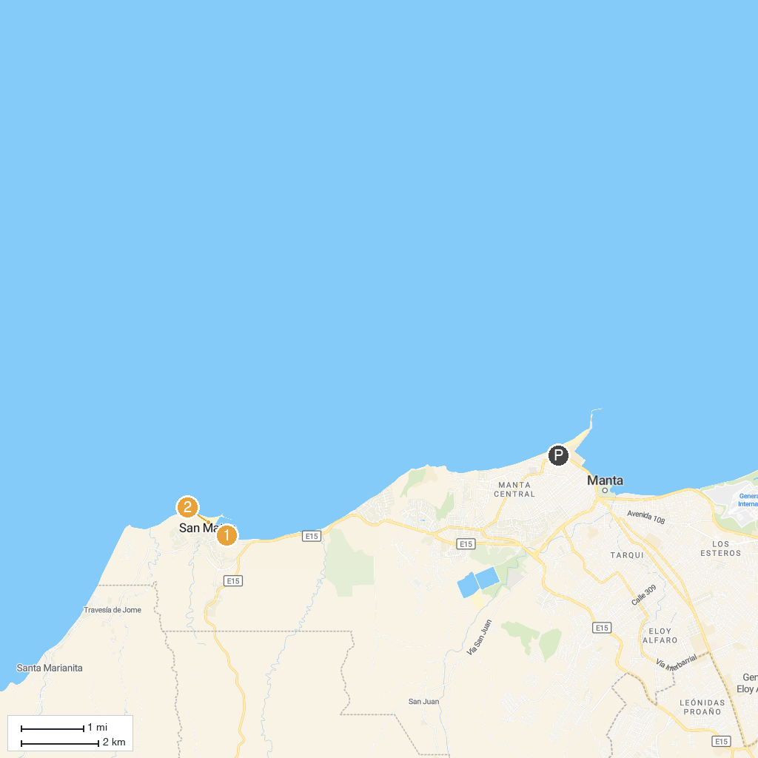
MAP KEY
1. Playa Santa Marianita | 3. Carpas playa San Mateo
2. Playa Bonita- San Mateo | 4. Refugio de Vida Silvestre y Marino Costera Pacoche
P. Cruise port / terminal
Map © MapTiler © OpenStreetMap contributors · cruiseports.org

