Manzanillo, Colima, Mexico
The Sailfish Capital of the World keeps it real — no glitzy tourist strip, just a vibrant downtown plaza, sheltered coves of calm water, and flavors you won't find anywhere else in Mexico.
⚓ Pier (docked) · 🕒 Typical call: 8-10 hrs · 💵 Mexican Peso (USD accepted) · 🗣️ Spanish
✍️ MY DAY IN PORT (FILL IN)
Ship / Date
In port | arrive ______ · all aboard ______
Booked excursion
Notes / meeting point
GETTING ASHORE
- Docking: Pier — Muelle Fiscal, central downtown
- Walk to center: 5-10 min to Jardín Álvaro Obregón
- Best For: Authentic Mexico, beaches, local food
- Don't Miss: Tuba drink from a vendor on the Malecón
GETTING AROUND
- 🚕 Taxi: $8–$12 USD — Official port taxis are available dockside to downtown (El Centro). Agree on a fare before departure — around 105–120 MX
- 📱 Rideshare: ✅ Uber
TOP THINGS TO DO
- Las Hadas Resort Day Pass — The all-white Moorish-style resort that starred in the movie '10' with Bo Derek.
- Playa La Audiencia Swim & Snorkel — A sheltered cove on the Santiago Peninsula with exceptionally calm, clear water.
- Comala & Colima City Day Trip — Comala is a Pueblo Mágico with white-washed buildings, artisan shops, and views of the active Colima Volcano.
- Cuyutlán Turtle Sanctuary — About 45 minutes south, El Tortugario protects sea turtles, iguanas, and crocodiles.
- Sport Fishing — Sailfish Capital — Manzanillo earned its 'Sailfish Capital of the World' title for a reason.
BEST WALKS
- Downtown Plaza & Malecón Stroll: Easy · 45-60 min · flat — Walk from the pier to the iconic giant blue sailfish sculpture, then into Jardín Álvaro Obregón for…
WEATHER · DAYLIGHT · MONEY
Month | High °F | Low °F | Rainy days
May | 87 | 73 | 2
Jul | 88 | 77 | 15
Sep | 86 | 76 | 21
Daylight: May 6:22AM–7:24PM · Jul 6:28AM–7:38PM · Sep 6:45AM–6:59PM
cruiseports.org/manzanillo · Confirm terminal & all-aboard time with your ship

Manzanillo, Colima, Mexico — Port Map
Red = walkable sights · Amber = excursions farther out · P = cruise terminal
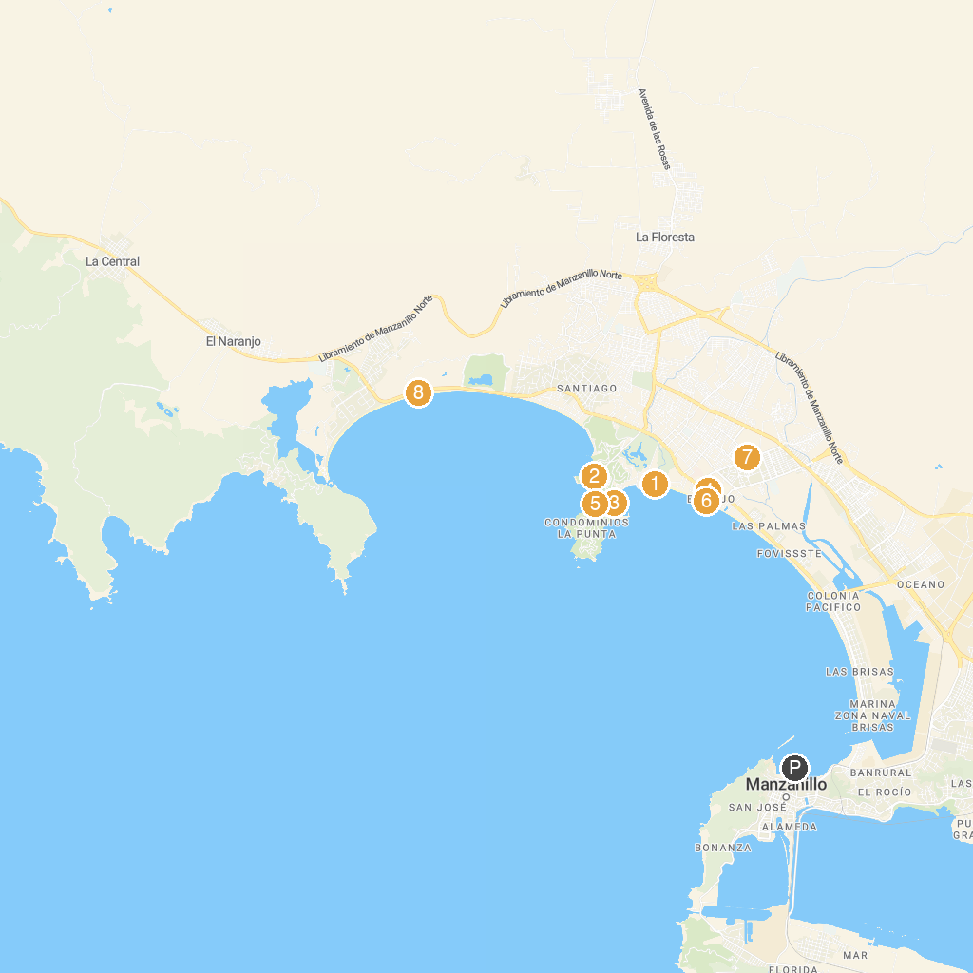
MAP KEY
1. Playa Salagua | 5. Playa Club de Yates
2. Playa la audiencia | 6. Tortugario Manzanillo
3. Playa Las Hadas | 7. Parque Metropolitano
4. Casino Riviera | 8. "Los Arcos" Playa Miramar
P. Cruise port / terminal
Map © MapTiler © OpenStreetMap contributors · cruiseports.org

